


وزارة التعليم

الإدارة العامة للتعليم بمنطقة ......................
مدرسة .........................................
التاريخ: / / 1447هـ
الصف: الرابع الابتدائي
الزمن: ساعتان
المادة: اللغة الإنجليزية

أسئلة اختبار مادة اللغة الانجليزية للصف الرابع الابتدائي
للعام الدراسي 1447 هـ
الفصل الدراسي الثاني
عدد الأوراق : 4

اسم الطالبة : ........................................................................
رقم الجلوس : .........................................................................
اليوم : ...............................................
التاريخ : .......... / ........... / 1447 هـ
الزمن : ...........................

 | Questions | Mark | Student's mark
Q1 | General Questions | 8
Q2 | Controlled Writing | 7
Q3 | Reading Short Sentences | 5
Q4 | Grammar | 7
Q5 | Vocabulary | 8
Q6 | Orthography (spelling) | 5
Total : |  | 40
المصححة : ...............................................................التوقيع :.....................................
المراجعة : ...............................................................التوقيع :.....................................

معلمة المادة :

......................................................

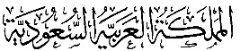
وزارة التعليم
الإدارة العامة للتعليم بمنطقة ......................
مدرسة .........................................
التاريخ: / / 1447هـ
الصف: الرابع الابتدائي
الزمن: ساعتان
المادة: اللغة الإنجليزية

الدرجة رقماً |  | الدرجة كتابة |  | اسم المصحح | توقيعه | اسم المراجع | توقيعه
الدرجة رقماً | 40 | الدرجة كتابة | درجة فقط
اختبار اللغة الإنجليزية نهائي – الدورالاول – للصف الرابع – الفصل الدراسي الثاني 1447هـ

8
General Questions:
- What’s your favourite animal? |  | I like winter.
- What does Reema have? |  | Yes, I do.
- What did you do on your vacation? |  | It is moving slowly.
- What is the weather like today? |  | I work at the zoo.
- Where do you work? |  | It is very hot.
- How is the tortoise moving? |  | I went riding on my bike.
- Do you need a doctor? |  | She has a headache.
- What’s your favourite season? |  | I love rabbits.
  - Match the questions with the correct answers:

- Controlled Writing:

7
  - Rearrange the words to form sentences:
      - is – fast – The lion – moving
……………………………………………..
- should – the medicine – take – Omar
……………………………………………..
- very strong – is – The wind – today
……………………………………………..
  - B. Read and write. Use the words in the box:
cold – cage – kangaroo – x-ray
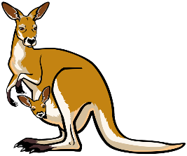  This animal jumps and has big legs.  ………………….…. | 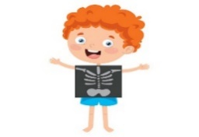  Fahad is having an ………………….…. | 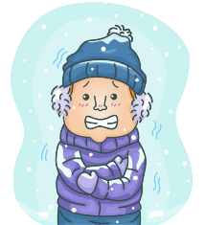  He is in the ……………. climate. | 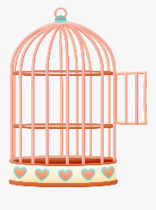  In zoos, some birds often live in this.  ………………….….

III. Reading Short Sentences:

5
  - Read the sentences then match them with the correct pictures:
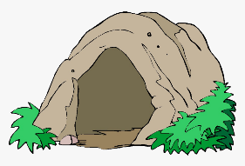 |  | 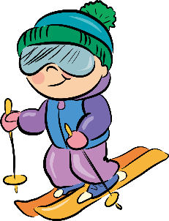 |  | 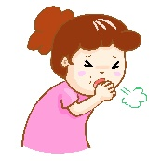
a-_We visit a cave.  b-_We walk in the forest. |  | a-I’m going to go cycling.  b-I’m going to go skiing. |  | a-_He has an earache.  b-_He has a cough.
 | 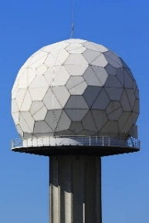 |  | 
 | a- They go to the weather dome.  b- They go to the movies. |  | a-_He is a vet.  b-_He is a zookeeper.

- Grammar:
  - Choose the correct answer:

7
    - You ( should – shouldn’t ) drink a lot of water. It’s good for your body.
    - They are going to ( go – went – going ) swimming next week.
    - I want to ride my bike. You ( must – mustn't ) wear a helmet.
    - The cheetah is the ( fast – faster – fastest ) animal in the world.
    - He went ( to shop – shopping ) yesterday.
    - What ( am – is – was ) the weather like yesterday?
    - Horses are ( friendly – more friendly – most friendly ) than cats.

- Vocabulary:

8
  - Write the words under the correct pictures:
1– flashlight 2– dragon 3– medicine 4– giraffe
5– umbrella 6– band aid 7– lion 8- sunglasses

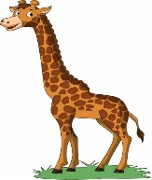 |  | 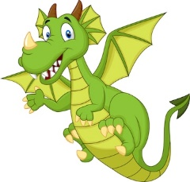 | 
 |  |  | 

5
- Orthography:
sh – r – fr – u – g
  - Fill in the missing letters:

 |  |  | 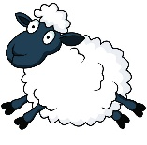   | 
  s__ n | c__ y | dan__er | __ __ eep | __ __og


المملكة العربية السعودية الصف: الرابع الابتدائي
وزارة التعليم الفترة الدراسية: الثانية
المدرسة الإبتدائية ........................ العام الدراسي 1447 هـ
الزمن: ساعتان
الاختبار النهائي لمادة اللغة الإنجليزية – الصف الرابع الابتدائي – الفترة الدراسية الثانية (الدور الأول) لعام 1447 هـ
عزيزتي الطالبة:
- استعيني بالله ثم اجيبي عن الأسئلة
- فضلا تأكدي من كتابة اسمك الرباعي ورقم الجلوس
- الإجابة باللون الأزرق فقط

اسم الطالبة رباعيا
رقم الجلوس: |  | الصف: الرابع الابتدائي | المادة: اللغة الإنجليزية
اليوم: | التاريخ: / 1 / 1448 هـ

المدققة وتوقيعها | المراجعة وتوقيعها | المصححة وتوقيعها | الدرجة كتابة | الدرجة رقما | السؤال
 |  |  | فقط |  | General  Questions
 |  |  | فقط |  | Guided  Composition
 |  |  | فقط |  | Reading  Short Sentence
 |  |  | فقط |  | Grammar
 |  |  | فقط |  | Vocabulary
 |  |  | فقط |  | Orthography
 |  |  | فقط | 40 | المجموع


Kingdom of Saudi Arabia 4th Elementary Grade
Ministry of Education Time: Two Hours
……….. Elementary School Number of papers: 3 . Final Exam – Second Term – 1447 AH
- General Questions:
/ 7
  - Match the questions with the correct answers:
A |  | B
1. What’s your favorite season? |  | I work at the zoo.
2. Where do you work? |  | Yes, I do.
3. What can you do at the beach? |  | I can swim there.
4. Do you need a doctor? |  | I like spring.
  - Choose the correct answer:
/ 7
1. What is the weather like today?
a- It is very hot. | b- It was windy.
2. How is the tortoise moving?
a- It is moving fast. | b- It is moving slowly.
3. Could you ride a horse?
a- No, I couldn’t. | b- No, I can’t.
- Guided Composition:
  - Complete the paragraph about Your Favorite Season. Use the words from the box.
family – sunny – summer – swim – weather – green – enjoy
My Favorite Season
My favorite season is ……………. I like it because it is warm and …………….. The sky is blue and the trees are …………….. The ……………. is hot and nice. I like to ……………. and eat ice cream in summer. I ……………. spending time with my ……………. outside.

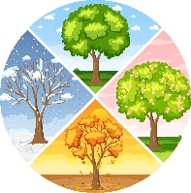

- Reading Short Sentences:
/ 7
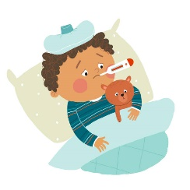

  - Read the sentences then match them with the correct pictures:
 |  | 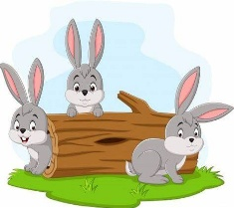 | 
a-_It is a lake.  b-_It is a waterfall. | a-_I am ill.  b-_I am all right. | a-_I like parrots.  b-_I like rabbits. | a-_It is summer.  b-_It is winter. | a-I’m going to go cycling.  b-I’m going to go skiing.
  - Look at the text and choose the correct option.
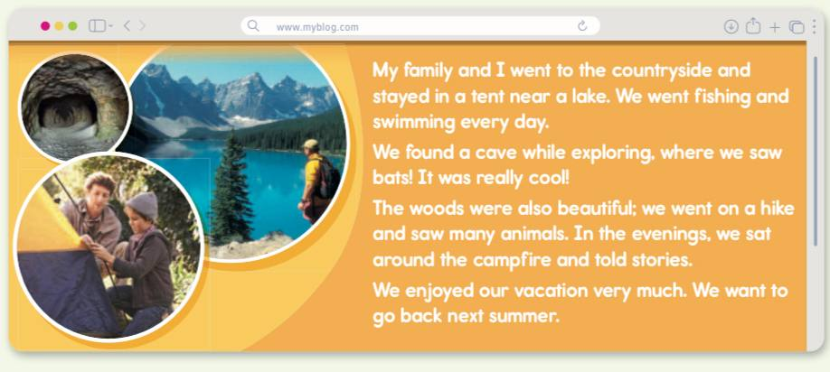
    - This text is from:
      - a book.
      - a website.
      - a newspaper.

    - The text is about:
a- a football game.
b- a school trip.
c- a family vacation.

- Grammar:
/ 7
  - Choose the correct answer:
    - He decided (play – to play – playing) soccer.
    - Is there (anything – something – everything) to eat? I’m very hungry.
    - The mouse is (fast – faster – fastest) than the frog.
    - It was October (who – when – where) I visited Jeddah
    - You (have to – don’t have to – shouldn’t) brush your teeth.
    - What (am – is – was) the weather like yesterday?
    - I could (read – reads – reading) when I was 2.

- Vocabulary:
/ 7
  - Write the words under the correct pictures:
flashlight – dragon – melting – giraffe – medicine



  - Circle the correct answer:
1- The opposite of ‘put on’: take care – take off – take out
2- The opposite of ‘dangerous’: safe – clean – huge

- Orthography:
/ 5
  - Choose the correct missing letters:
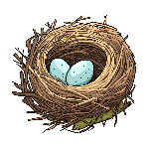  __est |  | 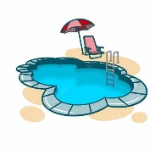  __ool |  | 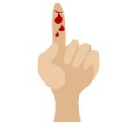  c__t |  | 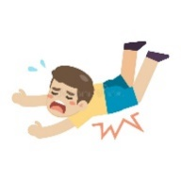  f__ll |  |   s__art
w | n | p | b | a | u | a | o | n | m
  bra__e |  |   pan__a |  | 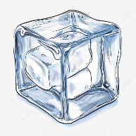  i__e |  |   rai__ |  |   s__ow
v | f | b | d | c | s | l | n | h | n

END OF QUESTIONS
BEST OF LUCK
Ms. Tahani AlGhamdi


40

اختبار نهاية الفصل الثاني ( الدور الأول )
للعام الدراسي 1447هـ
المادة /اللغة الانجليزية
الصف :رابع (.......)
زمن الإجابة / ساعتان
التاريخ : 12/7/1443 هـ

المملكة العربية السعودية
وزارة التعليم
الإدارة العامة للتعليم ب…

الدرجة كتابة :

اسم الطالب ……………………………………………………………………….……………………………………………رقم الجلوس …………………………

Match the questions to their answers:


1-Which places in nature do you like visiting? It is a new city near Tuwaiq.
2- What is Qiddiya? I like to visit to the desert.
3- How often are you sick? My favorite animal is the tiger.
4- What’s your favorite animal? I sometimes get sick.
5- What does your favorite animal eat? My favorite animal eats meat.
6- Where do kangaroos live? They live more than 50 years.
7- How long do elephants live? They live in Australia.
8- What weather do you like? I love rainy weather.

Put ()or():

- Ahmed has a headache.
2- Dr. Sullivan works at the zoo.
3- Giraffes are tall.
4- i doctor should go.
5- It’s to going cold be.
6- Is it snow Friday going to?
7- What’s your favorite season?

Choose the correct answer:


1. The cave is dark. 3. I couldn’t swim. 5. It is hot today.
How is the cave? Could he swim? How is the weather today?
a sick b dark a Yes b No a hot b rainy

2. Omar went to the lake. 4.He should see a doctor.
اقلب الورقة
Where did Omar go? Where should he go?
a desert b lake a doctor b dentist

Choose the correct answer:

- I …... hiking in the forest. a wanted to b love
- We wanted ………. football. a to play b playing
- Could you climb a tree? Yes, I …….. a could b couldn’t.
- You …… quiet in the hospital. a have to be b shouldn’t
- This is the hospital …… my dad works. a where b that
- Rabbits are …… than elephants. a more small b smaller
- Fatmah is the ……. student in class. a most smart b smartest

Match the words to the correct pictures:

1 mountain 2 rainy 3 island 4 X-ray 5 backache 6 cage 7 asleep 8 cloudy

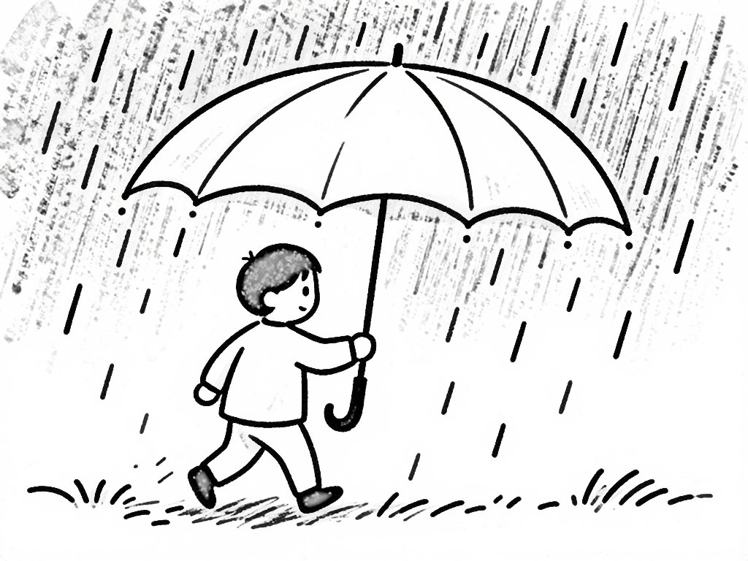

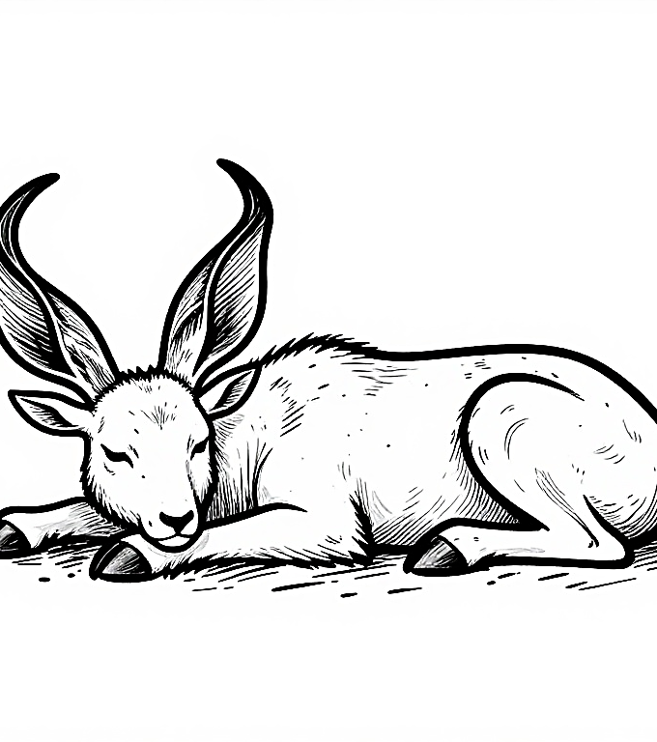
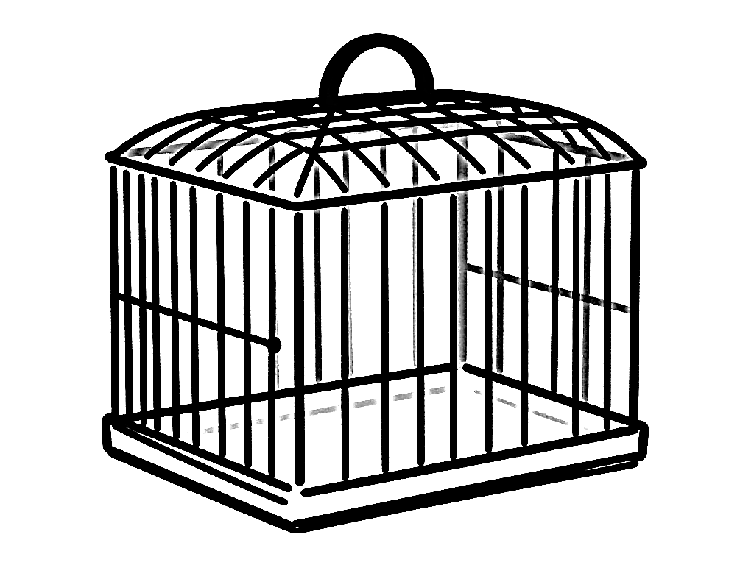
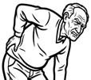
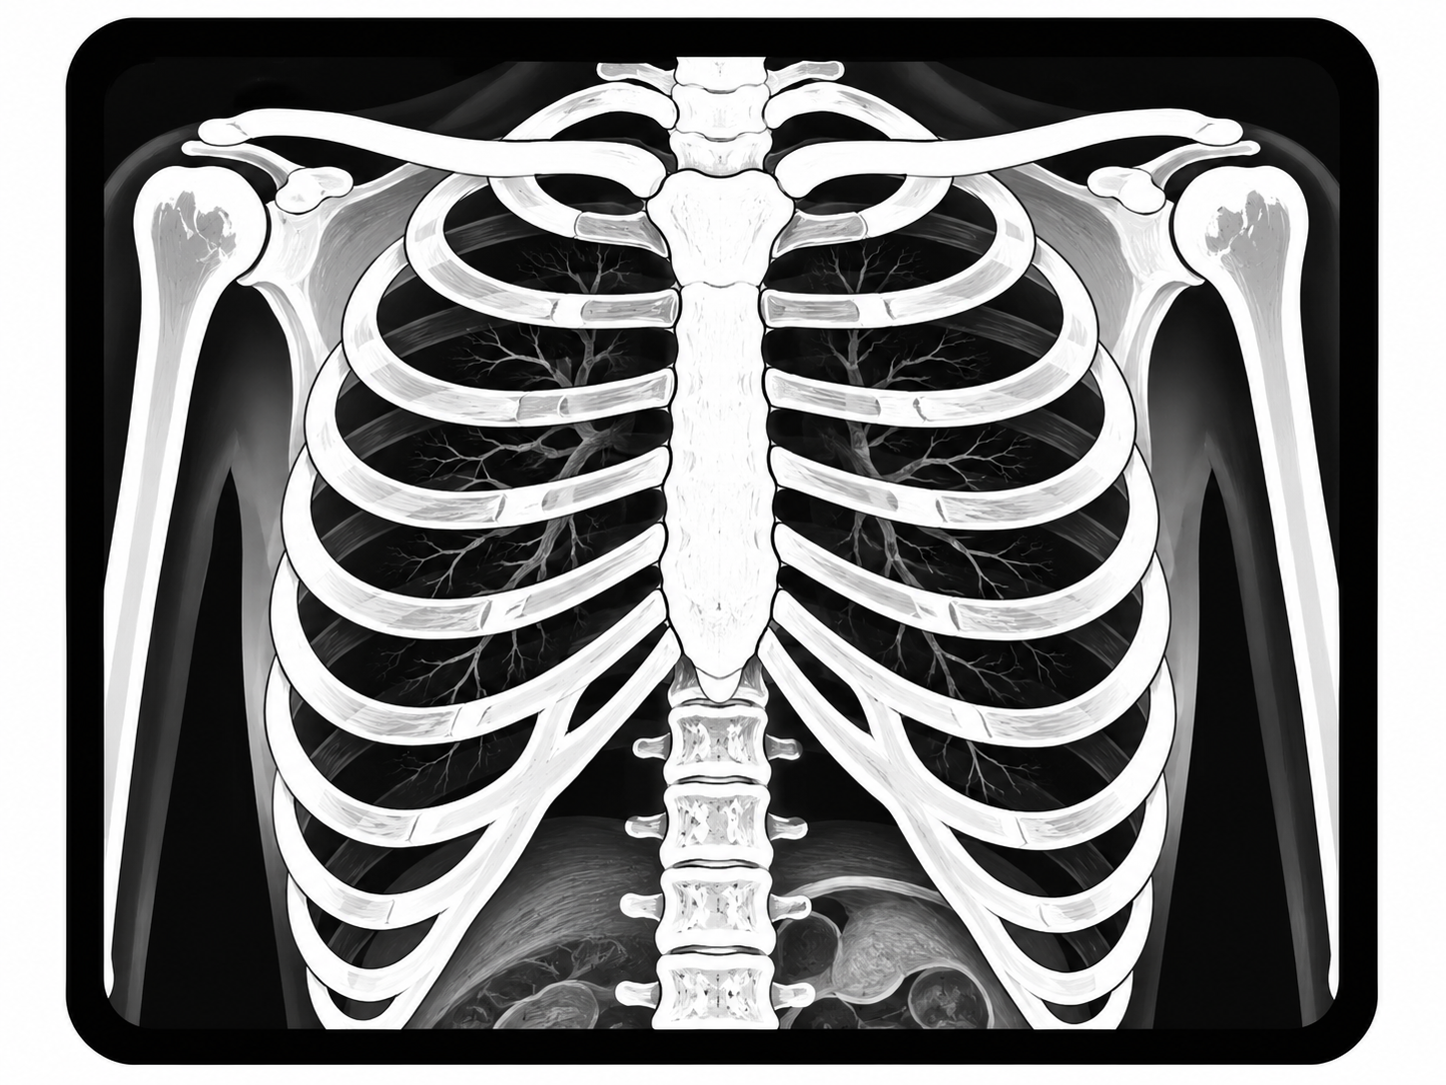
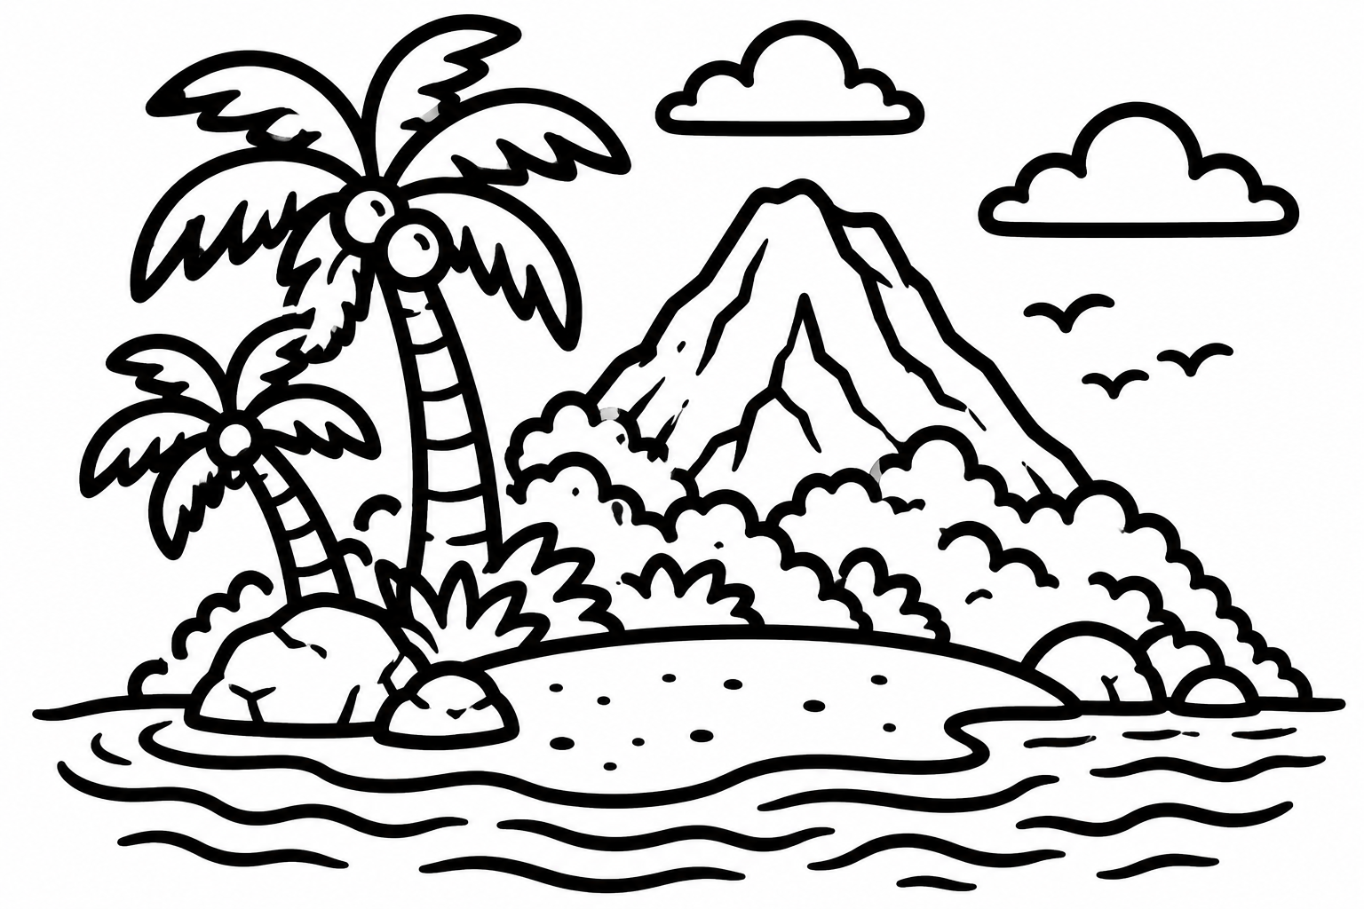


Circle the missing letter:

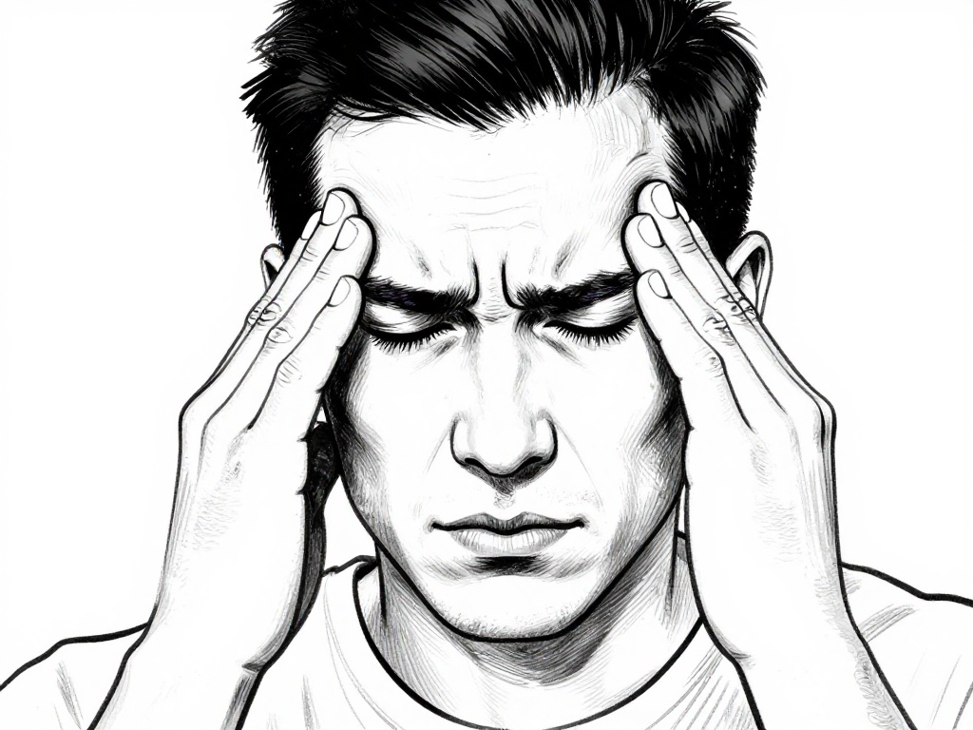
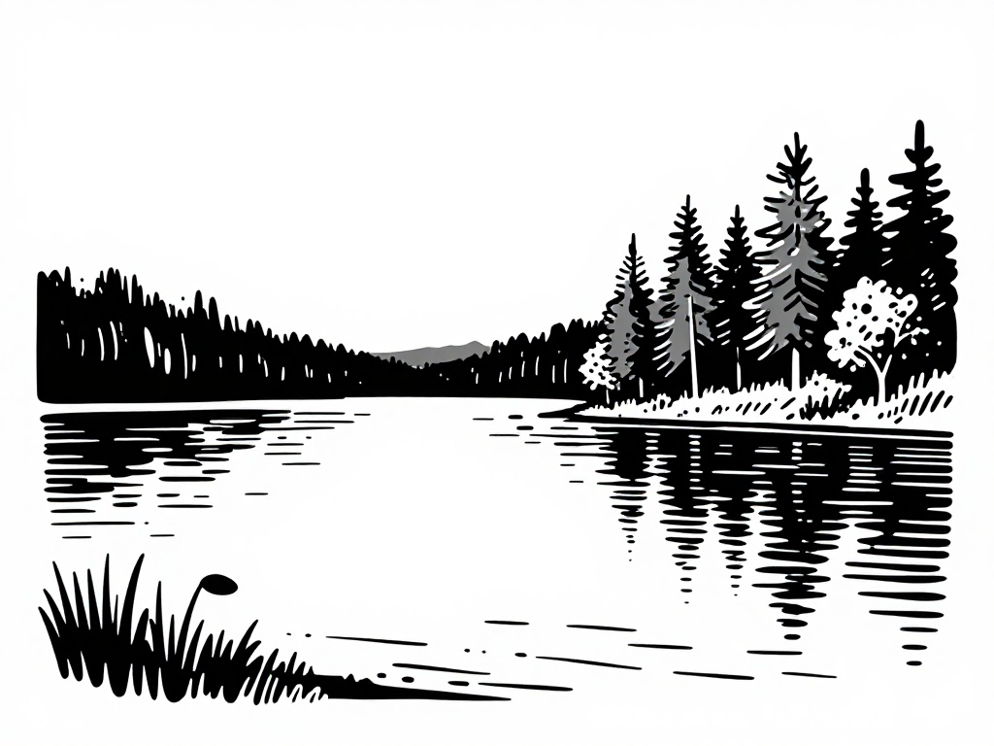  La__e  k  w | hea__ache  d  t | 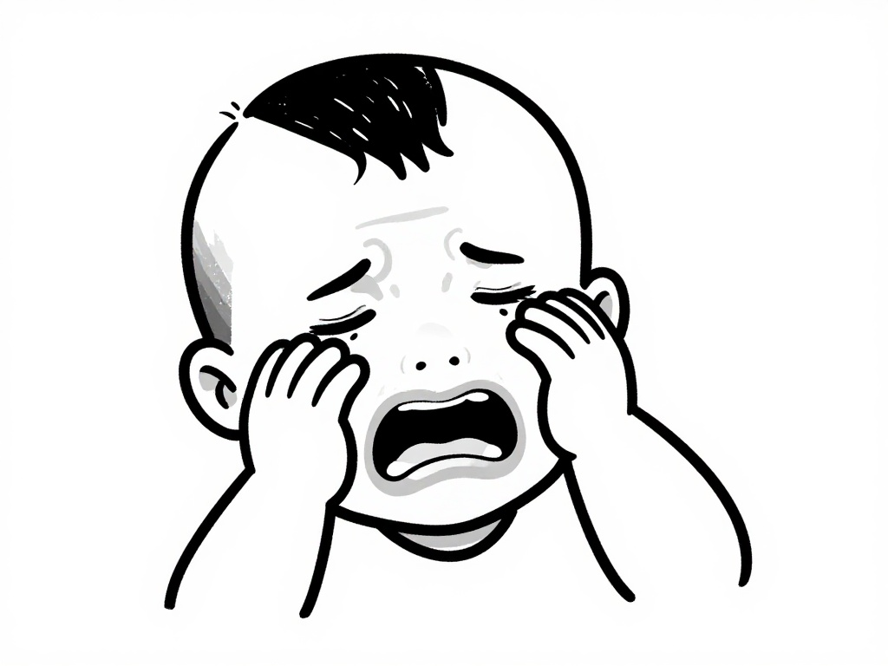  c__y  m  r | 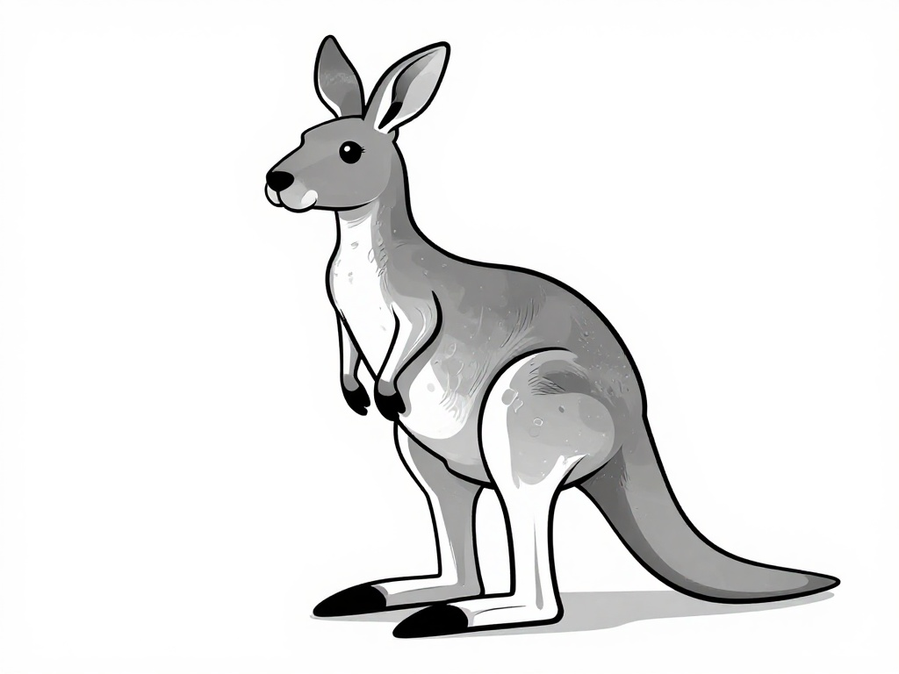  kan__aroo  e  g |   s__ow  s  n
انتهت الأسئلة

أ.........................

