
المملكة العربية السعودية الصف: الثالث متوسط
وزارة التعليم السنة الدراسية: الثانية
المدرسة ............................... العام الدراسي 1447 هـ
الزمن: ساعتان
الاختبار النهائي لمادة اللغة الإنجليزية – الصف الثالث متوسط – السنة الدراسية الثانية (الدور الأول) لعام 1447 هـ
عزيزتي الطالبة:
- استعيني بالله ثم اجيبي عن الأسئلة
- فضلا تأكدي من كتابة اسمك الرباعي ورقم الجلوس
- الإجابة باللون الأزرق فقط

اسم الطالبة رباعيا
رقم الجلوس: |  | الصف: الثالث متوسط | المادة: اللغة الإنجليزية
اليوم: | التاريخ: / 1 / 1448 هـ

المدققة وتوقيعها | المراجعة وتوقيعها | المصححة وتوقيعها | الدرجة كتابة | الدرجة رقما | السؤال
Guided
Composition
 |  |  |  |  | Reading Comprehension
 |  |  |  |  | Grammar
 |  |  |  |  | Vocabulary
 |  |  |  |  | Orthography
 |  |  |  | 40 | المجموع

Kingdom of Saudi Arabia 3rd Intermediate Grade
Ministry of Education Time: Two Hours
………………. Intermediate School Number of papers: 3
Final Exam – Second Term - 1447 AH
- Guided Composition:
Use the following word bank to write a paragraph about How to Deal with Culture Shock.
Word bank: (practice – patient – follow – culture – gesture – learn)

8
_________________________________
___________________________________________________________________________________________________________________________________________________________________________________________________________________________________________________________________________________________________________________________________________________________________________________________________________________________________________________________________________________________________________________________________________________________________________________________________________________________________________________________________________________________________________________________________________

9
- Reading Comprehension:
Read the passage and answer the questions below:
My name is Juliette Brown. I am ten years old. I live in London with my family. I am a student at St. James’s School. We live in a small house. My mother’s name is Lizzie. She is thirty-five years old. She is a teacher. She works in a small school in London. My father’s name is Tom. He is forty-two years old. He is a doctor in a big hospital. I have got a brother, Hans. He is eight years old. I have a sister, Mary. She is six years old. We have breakfast at half past seven in the morning. My father and my mother go to work by car. I go to school on foot with my brother and sister. We come home at four o’ clock in the afternoon, we do our homework, and we play computer games, or we watch TV. We have dinner at eight o’clock in the evening together. My mother is a good cook! My favorite food is pizza! My mother likes spaghetti, Hans likes hot chocolate, my sister likes fish and chips, and my father’s favorite food is salad. At nine, we go to bed.

- Choose the correct answer:
  - Lizzie is ……….…. years old.
- 35 | - 53 | - 42 | - 24
  - Juliette’s father works at …………
- school | - store | - hospital | - bank

  - How many siblings does Juliette have?
- 2 | - 3 | - 4 | - 5
  - The children go to school ……….
- by car | - by bus | - by bike | - on foot
  - Juliette’s family have dinner at ……….
- 8:12 | - 8:15 | - 8:00 | - 8:30
  - Mary’s favorite food is …………
a- pizza | b- spaghetti | c- salad | d- fish

- Check ( T ) or ( F ):
- Juliette lives in London with her family. ( )
- Juliette’s mother is a doctor. ( )
- Hans is six years old. ( )

9
- Grammar:
- Choose the correct answer:
- A clown is a person ………… makes children laugh.
- who | - which | - when | - where
- My brother was watching TV while he …………... dinner.
- eat | - eats | - ate | - was eating
- I haven’t washed the clothes …………
- just | - yet | - since | - for
- I can’t stop …………... tea and coffee.
- drank | - drinking | - drinks | - drink
- I wish I ……….. in a big house in the city.
- live | - lives | - lived | - living
- By the time we arrived at the station, the bus ………….
- leave | - left | - had left | - leaving
- He eats pizza, ……………?
- don’t he | - doesn’t he | - didn’t he | - isn’t he
- You ………. honk your horn. It’s a hospital area.
- must | - mustn’t | - should | - shouldn’t
- Mona is a good cook. She cooks ………….
- good | - better | - best | d- well

- Vocabulary:

9
- Write the words under the pictures:
nail polish – farmer – mud – airshow – chopsticks – pedal cab

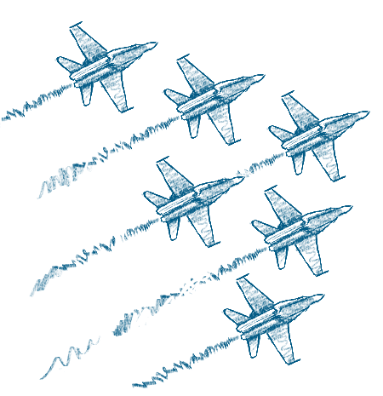
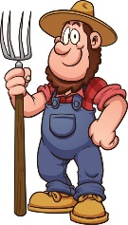
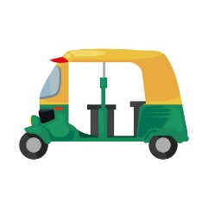
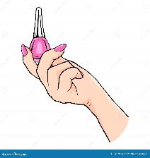
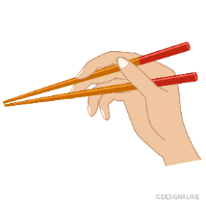

___________ ___________ ___________ ___________ ___________

- Classify the words:
stop – trunk – screwdriver – knife

Things used for cooking | Parts of the car | Traffic signs | Things used for repairing

- Orthography:

5
  - Choose the correct missing letters:
- I caught him trying to s__eal my bike.
- b | - d | - p | - t
- A p__rsuasive person is someone who gets other to do what he wants or thinks.
- a | - e | - i | - u
- A neph__w is a son of one's brother or sister.
- e | - i | - o | - u
- The twins often bor__ow each other's clothes.
- r | - o | - a | - w
- Please help me to remo__e the table to the corner.
- f | - v | - r | - t

END OF QUESTIONS
BEST OF LUCK
Ms. Tahani AlGhamdi



Time : 1½ hours Kingdom of Saudi Arabia
Ministry of Education 280 Third Grade
Administration of Education in AL ………. English Language 4 pages ………. Intermediate school
Final Exam 2nd term 1 session 1447 H
بديل اختبار مادة اللغة الإنجليزية للفصل الدراسي الثاني _ الدور الأول _ عام 1447 هـ للصف الثالث متوسط
Student's Name …………………………………… Class:…………
Q1: 8 Q2: 9 Q3: 9 Q4: 9 Q5: 5 Total : 40 Q. No
Mark No
Mark l.
Corrected by revised by: checked by:

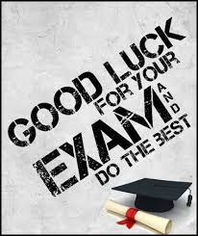
عزيزتي الطالبة :
1- استعيني بالله وأجبي عن كل الأسئلة.
2- تأكدي أن عدد الأوراق (4).
3- الاختبار سهل وواضح وممتع.

8
Composition
Ideas Voc.&G. M. &P.

Write a short paragraph not less than 30 words about : ( Bad Behaviors )
Helping words : ( Chew - manner - behavior - disgusting - change – habit – Because – fly )

………………………………………………………………………………………………………………………………………………………………………………………………………………………………………………………………………………………………………………………………………………………………………………………………………………………………………………………………………………………………………………………………………………………………………………………………………………………………………………………………………………………………………………………………………………………………………………………………………………………………………………………………………………………………………………………………………………………………………………………………………………………………………………………………………………………………………………………………………………………………………………………………………………………………………………………………………………………………………………………………………

Page 1

9
Reading

Read the following passage, then answer the questions :

In China, his nickname is "Little Giant" . In the west, they call him "Great Wall". Yao Ming was born in 1980, in Shanghai, China. His parents were both tall. Their beds were extra-long, and their clothes and shoes were special sizes. His dad was a successful basketball player.

A- Choose the correct answer ;
1/ Yao Ming was born in ( 1980 – 2000 – 1442 )
2/ In the west, they call him " ( Little Giant – Great Wall – Yao )

B- Complete the following sentence :
1/ Their …………………………… and …………………………. were special sizes.
2/ Their ……………………. were extra-……………………
C- True or False :
1/ In China, his nickname is "Little Giant" ( )
2/ His dad was a successful football player. ( )
3/ His parents were both short. ( )

9
Grammar

A- Choose the correct answer :

1/ Have you done your homework (already – just - yet ) ?
2/ A doctor is a person ( who – where – why ) help sick people .
3/ The coffee was (so – such – many) hot that I couldn't drink it .
4/ If you heat the ice , it ( melts – melting – melted ) .
5/ ( Watching – Watches – Watched ) TV is a bit boring .
Page 2

B: Do as shown between brackets :
1- not / rich / Faisal / is . ( reorder )
……………………………………………………………………………………..……………
2/ We decided to travelling to Abha . ( Correct )
……………………………………………………………………..…………………………….
3/ My brother was watching TV . he was eating dinner . ( Use while) ……………………………………………………………………………………………………
4/ You should eat when you're driving . ( Make it negative) ……………………………………………………………………………………………………

9
Vocabulary

A: Write the word under the picture :
( Shampoo – pedal cab - camera – chopsticks - money – frying pan )
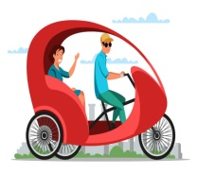

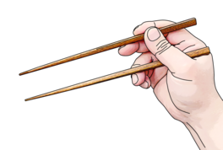

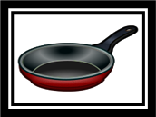

…………… …………… ……………. ……………… ………………

B: Complete the sentences :

(Jeddah - triplets – novelty – title – talkative – funny )
1/ Someone who makes you laugh is ……………………....
2/ A……………….person is someone who speaks a lot .
3/ In Mexico, all university graduates have a ……………...
4/ ………………. is something new and interesting .
5/ ……………. Three children born at the same time .

C: Circle the odd word :
1/ Japan - China - hot - India .
2/ Taxi - car - bus - garden .
Page 3

D: Match the words with their meaning :

( A ) ( B )
1- I'm doing 60 ………. a - phone
2- call up ………. b - I'm driving 60k per hour.
3- No kidding …….…

5
Spelling

A: Choose the correct spelling :


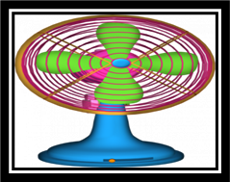
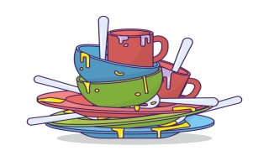


( thef – thief – theef) (fan - vaan- vin ) ( dshs – desh – dishes ) ( ersho – aershoo – airshow )

B: Write the correct letter :

1 – sel…ish ( f - o – m ) 2 - la…y ( b – y – z ) 3 - ….ustom ( h – c – o )

4 - Pollutio… ( n – j – o ) 5 – dange… ( r – d – o ) 6 - broo…… ( m – l – e )
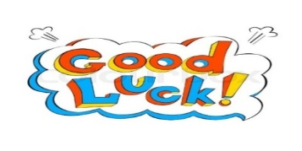
End of Questions
Your teacher ...
Majedah AlSubayel

Page 4

المملكة العربية السعودية الصف: ثالث متوسط
وزارة التربية و التعليم مادة : اللغة الإنجليزية
المتوسطة ... بجدة الزمن: ساعتان
أسئلة اختبار الفصل الدراسي الثاني للعام 1447هـ
عدد الصفحات : 4 عدد الأسئلة :5

40
40

SG3 Units 7 to 12

نموذج للمعلمين والمعلمات
اساسي
++++++++++++++++++++++++++++++++++++++++++++++++++++++++

8
I-Composition:

* Future schools create future leaders

*Write a paragraph about The School in the Future. Give your opinion about it. You may use these guide words:
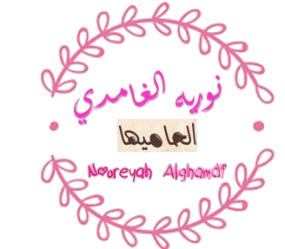
| technology | robots | projects | creativity | science | future jobs | smart classrooms |
للمعلم والمعلمة لتسهيل العمل
عليهم في العملية التعليمية
تاريخ انتاج-إجازة الحج
الاحد30-11-1447
االاحد17 مايو 2026
من جبال ابها

__________________________________________________________________
__________________________________________________________________
__________________________________________________________________
__________________________________________________________________
__________________________________________________________________
__________________________________________________________________
__________________________________________________________________
__________________________________________________________________
1 mark each

96

II-Comprehension:
Read the passage and answer the questions below:
Ahmed has two brothers, Sami and Omar. Sami likes football, and Omar enjoys reading science books. Ahmed moved to another city last year. At first, he felt nervous because everything was different. The people spoke in a different way, and the food tasted unusual to him. However, Ahmed slowly made new friends at school. His classmates were friendly and helpful. One day, Ahmed joined a school project about traffic safety. He learned many important rules about driving carefully and helping others on the road. He also learned that people from different cultures may behave differently, but everyone likes respect and kindness. After a few months, Ahmed felt happy in his new city. He enjoyed learning about new customs and traditions. He believed that living in a new place helped him become more confident and responsible.
Multiple Choice ( 1- 30)
Comprehension (1-5)
Choose the correct answer :
1- The passage is mainly about … …………….
d. new books |  | c- new cultures | b-school life | a-traffic rules
2- The underlined pronoun ( him ) in line (3) refers to ………………..
d. Omar |  | c- Khaled | b-Sami | a- Ahmed
3- Ahmed joined a project about …………………………..
d. cooking |  | c- traffic safety | b- health | a- sports
4- the opposite of ≠ (different) is …………………
d. same |  | c-slow | b- happy | a-safe
5- His classmates were ………………………..
d. lazy |  | c. rude | b. friendly | a- noisy
False\True | Put ( T ) or ( F ) (1-4)
 | 1- Ahmed moved to a new country.
 | 2- Ahmed stayed unhappy in the new city.
 | 3- Ahmed has two brothers.
 | 4- Ahmed became more confident and responsible.

III-Grammar:/Multiple Choice: ( 6 to 14 ) Choose the correct answer

6- You like this book, ……………………….?
d- aren’t you | c- are you | b- don’t you | a- do you
7. Drivers ………………………… stop at red lights.
d-may | c-could | b-should | - must
8- Sara was studying …………………. her brother was sleeping
d-while | c- because | - but | - so
9- I have ………………….. finished my homework.
d- already | c- yet | - never | - ago
10- If it rains tomorrow, we ………………………..stay home.
d-have | c-were | b-will | - are
11- I’d rather ………………… tea than coffee.
d- drank | c- drinks | - drinking | - drink
12. They enjoy ________ football after school.
d- played | c- playing | b-plays | - play
13. We didn't expect …………………………..so late.
d. arriving | c. to arrive | b. arrived | a. arrive
14. The man ________ helped me was very kind.
d. when | c. where | b. who | a. which
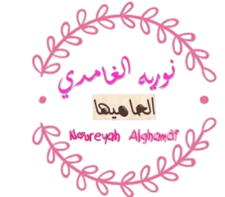

9776
IV-Vocabulary:/Multiple Choice: ( 15 to 20 )
Choose the correct words:

15- My grandmother follows old ________ and traditions.
d- customs | c- projects | b- garages | a- roads
16- It's so hot please turn the ………. on.
d- broom | c- saucer | b- pan | a- fan
17. Students must ………………. the school rules.
d- speed | c- watch | b- obey | a- pass
18. They are a good …………………………… to fly with.
d- airline | c- pedal cab | b- attraction | a- event
19. I never ………………my dog raw meat.
d- feed | c- mind | b- imagine | a- suggest
20. The ……………….. grows vegetables and fruit.
d- driver | c- farmer | b- doctor | a- pilot

Vocabulary – Pairing Question ( 1 to 6 )

1 | This annoys me very much. |  | A | a tool for cutting
2 | Take care of yourselves. |  | B | a machine that cleans floors
3 | The boy tried to spear the fish in the river. |  | C | the opposite of quickly
4 | The gun was a fake |  | D | not real
5 | Drive slowly. |  | E | to make someone angry
6 | Give me the knife. |  | F | to pick something up
 |  |  | G | to look after

576

V-Orthography (Spelling): ( 21 to 30 )

21 | My father used p__iers and a screwdr__ver to fix the chair.
21 | a. (t-e) | b. (l-i) | c. (q-o) | d. (m-a)
22 | The house has a beautiful e__terior and a modern int__rior.
22 | a. (x-e) | b. (k-o) | c. (f-a) | d. (n-u)
23 | The s__lly and tal__ative boy made everyone laugh.
23 | a. (u-p) | b. (a-r) | c. (e-g) | d. (i-k)
24 | Use the mirr__r to a__oid accidents while driving.
24 | a. (i-n) | b. (u-s) | c. (o-v) | d. (a-p)
25 | The l__wyer adju__ted the papers before the meeting.
25 | a. (a-j) | b. (i-t) | c. (u-r) | d. (a-s)
26 | The por__er walked through the cr__wded hall.
26 | a. (d-e) | b. (t-o) | c. (b-i) | d. (k-a)
27 | Poll__tion can invol__e many health problems.
27 | a. (u-v) | b. (a-w) | c. (i-f) | d. (e-l)
28 | The edit__r gave the writer a nice compli__ent.
28 | a. (e-j) | b. (o-m) | c. (a-s) | d. (u-z)
29 | The papers were kept safely in the glo__e compartment w__ll.
29 | a. (p-u) | b. (h-a) | c. (v-e) | d. (m-o)
30 | The v__cuum clea__er makes the floor clean quickly.
30 | a. (u-y) | b. (e-r) | c. (i-x) | d. (a-n)

END OF QUESTIONS
BEST OF LUCK
T. Noureyah Alghamdi

لا أحلل من ينسبها لنفسه أو ينشرها بأسمة
او ينسب جهدي وتعبي في تحضير البوربوينت واوراق العمل وتمارين المراجعة والخطط العلاجية وغيرها لنفسه
هي للنفع العام في التعليم والتدريس وتبسيط المادة للطلاب والمعلمين

لا أحلل من ينسبها لنفسه أو ينشرها بأسمة
للمعلم والمعلمة لتسهيل العمل
عليهم في العملية التعليمية
تاريخ انتاج-إجازة الحج
الاحد30-11-1447
االاحد17 مايو 2026
من جبال ابها
او ينسب جهدي وتعبي في تحضير البوربوينت واوراق العمل
وتمارين المراجعة والخطط العلاجية وغيرها لنفسه
هي للنفع العام في التعليم والتدريس وتبسيط المادة للطلاب والمعلمين
