2nd Intermediate Grade
Time: An hour and a half
Number of papers: 3
Final Exam – Second Term - 1445 AH
- Guided Composition:

6
Use the following word bank to write a paragraph about Shopping.
Word bank: (usually – mall – prefer – because – easier – save – spend – money)
________________________
____________________________________________________________________________________________________________________________________________________________________________________________________________________________________________________________________________________________________________________________________________________________________________________________________________________________
- Reading Comprehension:
6
Read the passage and answer the questions below:
My name is John Greem, I’m English. I’m from London, but my parents are French. They are from Paris. I’m ten years old. My favorite number is 5 and my favorite color is red. My phone number is two, seven, six, double three, nine, double oh and my address is 15, Spring Street, London, England. I’ve got a pet: it’s a cat called Lilo. He’s small and black and white. I’m a student at Primary School and my favorite subject is Music because I play the piano. I like English, but I don’t like History. I’m good at Math, but I’m not good at P.E. I think that Geography is interesting.
Hi my name is Adam. I live with my family in a
big house. I have two sisters and one brother.
We share many chores with our parents. My
brother and I take the garbage out.
We also wash our father’s car twice a week. Every Friday, I
weed the garden and my brother waters the plants. I also
make my bed in the morning. My sister, Emily, sweeps the
floor every evening and washes the dishes after dinner. She
also helps Mom with shopping every Thursday. My mother
cooks for us and washes our clothes. My father fixes
anything broken at home.
Hi my name is Adam. I live with my family in a
big house. I have two sisters and one brother.
We share many chores with our parents. My
brother and I take the garbage out.
We also wash our father’s car twice a week. Every Friday, I
weed the garden and my brother waters the plants. I also
make my bed in the morning. My sister, Emily, sweeps the
floor every evening and washes the dishes after dinner. She
also helps Mom with shopping every Thursday. My mother
cooks for us and washes our clothes. My father fixes
anything broken at home.
- Choose the correct answer:
- John’s parents are …………. .
- English | - Saudi | - French | - Omani
- How old is John?
- 7 | - 8 | - 9 | - 10
- John’s phone number is ………………
- 27633911 | - 27623900 | - 27633900 | - 27933600
- Lilo is John’s ……………..
- sister | - mom | - cat | - friend
- John is a ……………..
- teacher | - student | - player | - doctor
- John hates …………….
- Math | - PE | - Geography | - History

- Grammar:

7
- Choose the correct answer:
- Faten didn’t ………her car last two weeks.
- drive | - drives | - drove | - driving
- The Ferrari is the …………. car
- expensive | - expensiver | - expensivest | - most expensive
- There ……… two cars in the garage.
- am | - is | - was | - were
- I am going to make a cake, …….. I need some eggs and flour.
- so | - because | - neither | - either
- You ………. clean your room.
- should | - should to | - should no | - shouldn’t
- ………… are the same age.
- He and me | - Him and me | - He and I | - Him and I
- That jacket is ………..
- I | - me | - my | - mine
- Farah goes ……… every Monday.
- swim | - swims | - swam | - swimming
- You ……… cheat.
- must | - must to | - must no | - mustn’t
- He has ……. Money that he could buy any house in the city.
- so | - such | - so many | - so much
- Do as shown between brackets:
- (Show agreement with the statement. Use So or Neither)
- I didn’t play football.
…………………………………………..…….
- (Complete the sentence with one or ones)
- I am eating some red apples and some green …………
- I don’t like this hat. Please show me another …………

- Vocabulary:

7
- Write the words under the pictures:
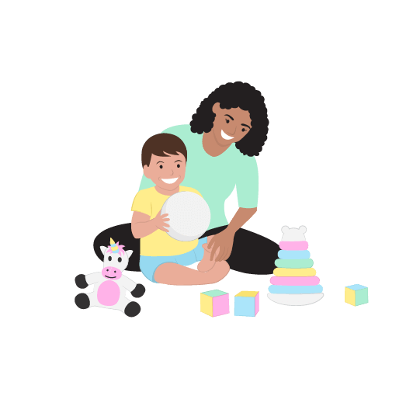
astronaut – sleepy – cough – babysit – perfume

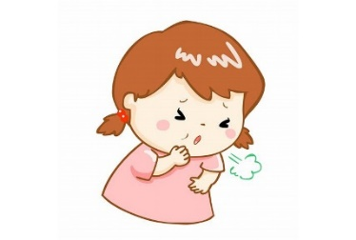
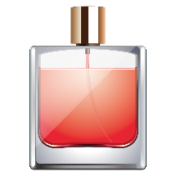

_____________ ______________ _____________ ______________
- Choose the correct answer to fill in the blank in each question:
- Ali was injured badly in the ……………..
- mess | - accident | - busy | - tired
- My teeth are very ……….. to cold water.
- precious | - beautiful | - pounds | - sensitive
- The food was absolutely ……………
- delicious | - easy | - difficult | - narrow

4
- Orthography:
- Choose the correct missing letters:
- Columbus dis__overed America in 1492.
- s | - c | - k | - g
- Don’t leave the lights on it wastes el__ctricity.
- a | - e | - i | - k
- I felt really ner__ous before the interview.
- v | - f | - s | - c
- The smell made me want to v__mit.
- a | - e | - o | - s
- There is a lot of d__st on this table.
- u | - a | - e | - i
- We use an um__rella for a protection from the rain.
- p | - t | - b | - d
- There will be a chess compe__ition next week.
- a | - t | - d | - m
- I came home late and my mother was an__ry.
- c | - k | - g | - p
END OF QUESTIONS
BEST OF LUCK
Ms. Tahani AlGhamdi

المادة: اللغة الإنجليزية
الصف: ثاني متوسط
الزمن: ساعة ونصف

اسم المصحح: | اختبار ثاني متوسط الفصل الدراسي الثاني  [ الدور الاول ]  لعام 1445ه |  |  | اسم المراجع:
التوقيع: | التحريري | الاستماع | المجموع | التوقيع:
اسم الطالب:.................................................................................................................. رقم الجلوس: ( )
Q1-Vocabulary:
A-Match the correct word for each picture:
1. vomiting – 2.sunglasses - 3. belt – 4.navigation – 5.happy – 6.scared

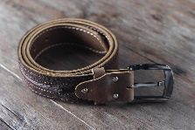
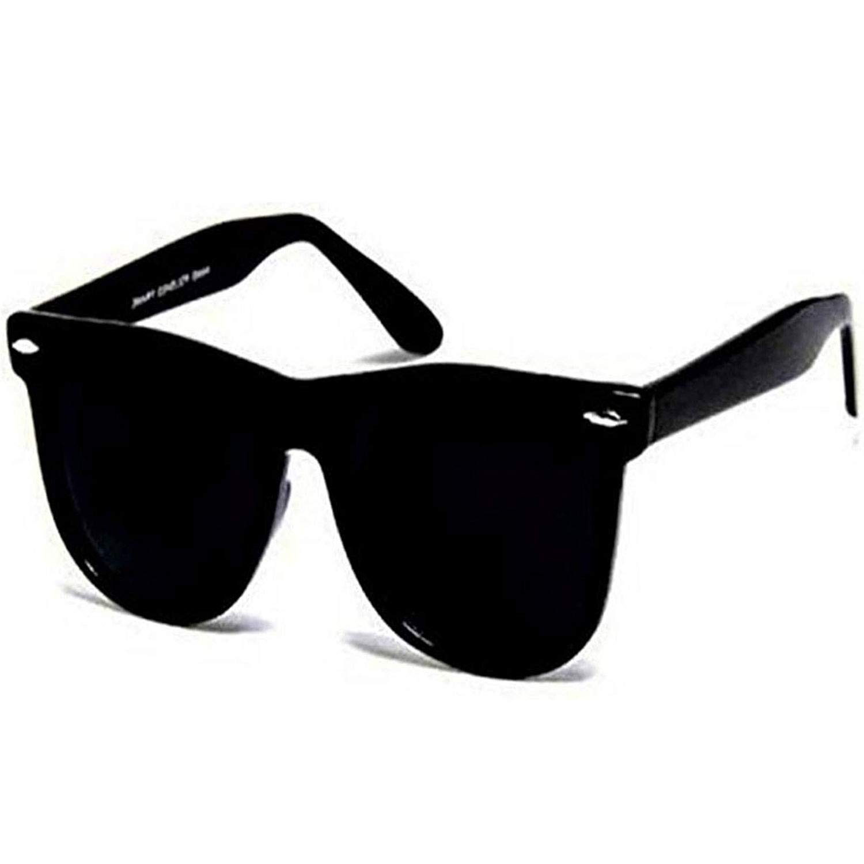

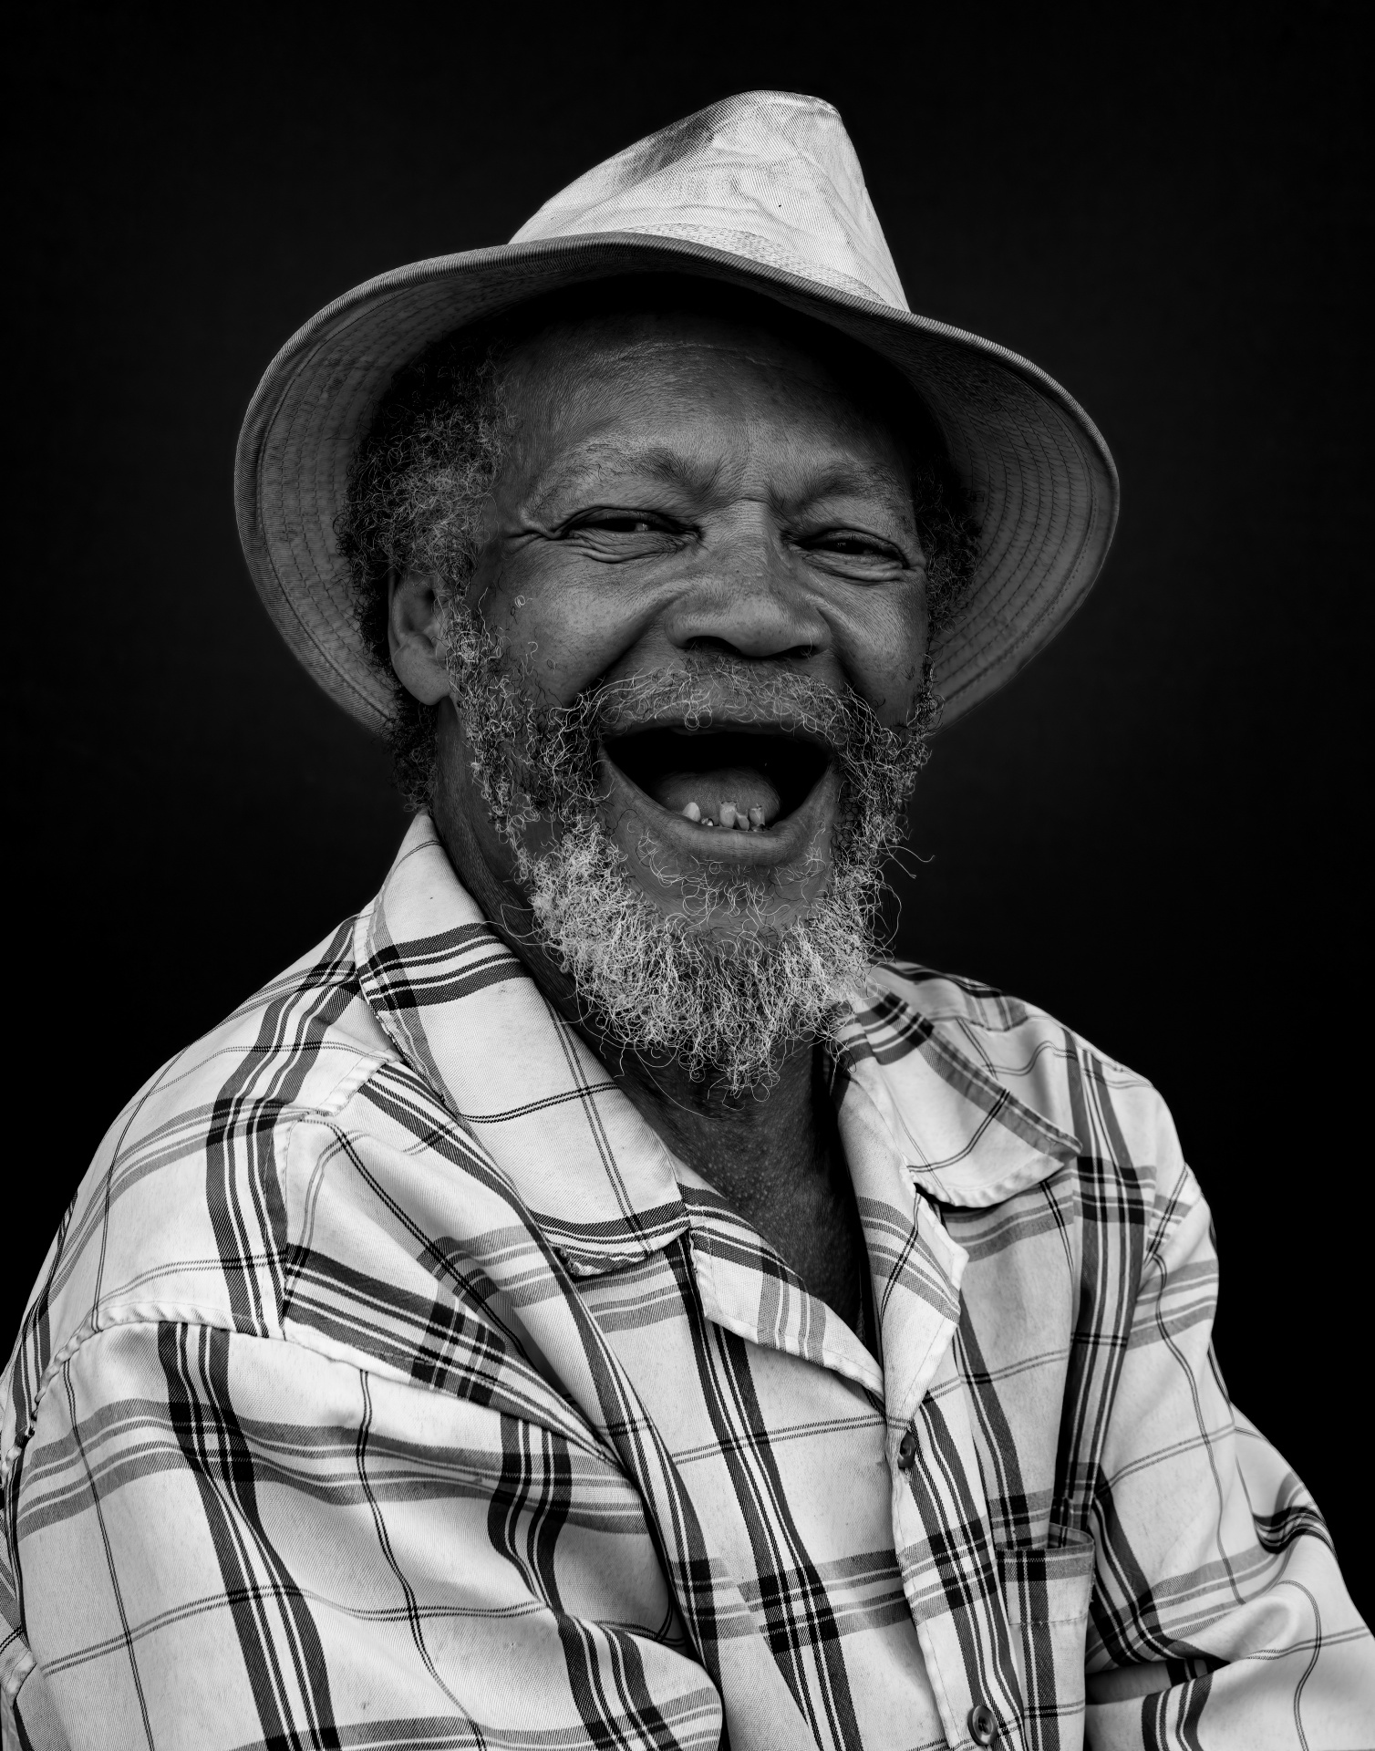
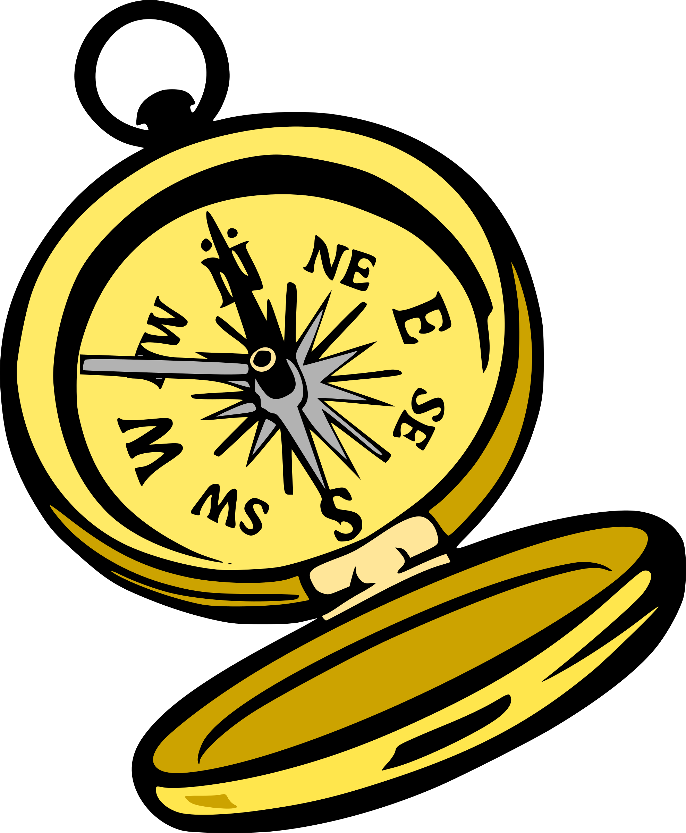

( ) ( ) ( ) ( ) ( ) ( )

6

B-Choose the missing letters:
v - t - s - f - p
5
1. fe…..er 2. foo…….. 3. Du…t 4 stu….f 5.sho……
Q2-Grammer :
A-Choose the correct words:
- ( whose - how– where ) toothbrush is this?
7
- He was the (fastest – fast – faster ) runner in 2017.
- May I ( has – have – were ) a bigger bag, please?
- My sister did not ( does – do – doing) her homework.
- Let's ( to drink – drinking – drink ) some water.
- They have to ( wearing – wore – wear ) uniform at school.
- Tom likes football.
( he – she – it ) likes football.
Q3-Composition:
Write a paragraph about ( your friend ) use the answers of these questions:
1-What is his name? 2-How is he ?
3-what he look like? 4-What color is his hair?
My friend
………………………………………………………………………………………………………………………………………………………………………………………………………………………………………………………………………………………………………………………………………………….
6
Q4-Reading:
Read the passage and answer the questions:
My day at school
I usually arrive at school before 7 a.m. Assembly is at 6:45, and we always sing the Saudi national anthem. After assembly, we go straight to the classroom. We have six classes a day. Each one lasts 45 minutes. We only leave our classroom for subjects like computer, PE, and art. School finishes at 1 p.m. There are after-school clubs. I’m a member of the football club, so I sometimes stay after school and play football.

Q3.Answer the following questions:
A – Choose the correct answer:
1-He arrives at school before (7 a.m - 6 a.m – 5 a.m – 4 a.m)
2- We have six classes a day. Each one lasts ( 10- 30 – 25 - 45) minutes
3- we always sing the( Saudi – Hindi – Egyptian – Tunisian ) national anthem
B- Write ( yes ) or ( no ) at end of each statement:
1- School finishes at 5 p.m ( )
2- He sometimes stays after school and plays football ( )
3- We leave our classroom for subjects like computer, PE, and art ( )
6

Best of luck

 |  | اختبار الفصل الدراسي الثاني  للعام الدراسي 1445 هـ | المادة | لغة انجليزية
 |  | اختبار الفصل الدراسي الثاني  للعام الدراسي 1445 هـ | الصف | الثاني المتوسط
 |  | اختبار الفصل الدراسي الثاني  للعام الدراسي 1445 هـ | الزمن | ساعة ونصف
 |  | اختبار الفصل الدراسي الثاني  للعام الدراسي 1445 هـ | الدور | الأول
الاسم: .............................................................................................................

30
1. Composition

Write a paragraph about ( yourself ) not less than 6 sentences using the following words .

6

( name – age – favorite sport – live –like )
…………………………………………………………………………………………………………………………………………………………………………………………………………………………………………………………………………………………………………………………………………………………………………………………………………………………………………………………………………………………………………………………………………………………………………………………………………………………………………………………………………………………………………………………………….

6
2. Reading Comprehension

Read the passage and answer the questions below :
Every Thursday, Mr. Saleh goes shopping. He likes to buy things from the supermarket near his house. It is a big supermarket. He buys meat, fruit, milk and vegetables for the week. Today, two of his children are going with him, Maram and Basil. Maram wants to buy biscuits for her sister Hanan. Basil wants to buy ice-cream. Basil does not have much money. He asks his father to give him some money.
Answer :
1- What does Mr. Saleh like to buy ? .....................................................................
2- Where is the supermarket ? ...............................................................
Choose :
3- Mr. Saleh likes to…………… things from a supermarket. ( buy - drink - eat )
4- Basil asks his father to give him some ( money - milk - ice-cream )
5- Today, two of his ……… are going with him. (children - friends teachers)
6- It is a ……………… supermarket. ( good - big - small )

7
3. GRAMMAR
Choose the correct words :
1- Where ( was - were - am ) the football game ?
2- ( What - Why - Who ) are you warried ?
3- He didn't see the stop sign ( so - and - because ) he caused an accident .
4- He ( go - went - goes ) swimming three times a week .
5- Why ( don't - doesn't – doing ) you put on a sweater ?
6- You ( should - must - well ) stop at the traffic light .
7- The jacket is ( too - to - two ) small for me .

7
4. Vocabulary

A-Match the meaning and the responses to the situations :
1 | stuff |  | Things in general
2 | Let down |  | Disappoint someone
3 | Nothing much |  | Not a great amount
4 | Why are you warried ? |  | Because I have a test tomorrow
B-Match the picture with words:
( Sleepy - Scared - Angry )

………………………………. ………………………… ....................................
5. orthography

Write the missing letters :

4
1-e_e ( y – a ) 2- d_st ( u - m )
3- be_ts ( l- m) 4- n_se ( o - f)
انتهت الاسئله
English Language
2nd Intermediate Grade
2nd Term Exam 1444 -2022
Time: 2 hours
The first session

Name/ …………………………………………………………… | Seat No./ ………………………

( اللهم لا سهل إلا ماجعلته سهلا وأنت تجعل الحزن إذا شئت سهلا )

Student’s Mark Written | Student’s Mark Number | Question |  | Number
Student’s Mark Written | Student’s Mark Number | Mark | Question | Number
 |  | 6 | Writing | Q1
 |  | 6 | Reading Comprehension | Q2
 |  | 7 | Grammar | Q3
 |  | 7 | Vocabulary | Q4
 |  | 4 | Orthography | Q5
 |  | 30 | Total Written Tasks

عدد الصفحات : 4 صفحات

اسم المصحح وتوقيعه :
اسم المراجع وتوقيعه :
اسم المدقق وتوقيعه :

1

Q : 1 ( Writing )

6
Write a paragraph about ( your best friend ) using the following words .
( name – age – math – science – green – rice )
My best friend is …………………… .She is ………… years old. She likes …………… subject, but she doesn`t like ………………… .Her favorite colour is ………….. . She likes to eat …………… . I love my friend.

6
Q : 2 ( Reading )
Read the following passage then answer the questions :
Maha is a student. She is 13 years old. She likes shopping. Her favorite mall is Al-Obaikan shopping center . It is in Taif . It is very big and there is a large parking. There are many dresses, flowers , and toy shops. Every Thursday, Maha and her family go shopping.
In the coffee shop , they drink cappuccino and have their lunch in the restaurant. She likes to eat beef burger. Shopping in Al-Obaikan mall is easy and interesting .
A - Answer:
1 – Is Maha a student ?
a – Yes, she is. b – Yes, it is. c – Yes, he is.
2 – How old is she ?
a – She is 10 years old. b – She is 13 years old. c – She is 15 years old.
B – Choose :
1 – She likes ( shopping – swimming – watching TV ).
2 – Her favorite mall is ( Al-Rashed – Riyadh – Al-Obaikan ) mall .
3 – It is in ( Taif – Tabouk – Jeddah ).
4 – They drink ( coffee – cappuccino – tea ) in the coffee shop.
5 – They have their ( breakfast – lunch – dinner ) in the restaurant .
6 – She likes to eat ( chicken burger – beef burger ).
C – Put ( T ) or ( F ) :
1 – There are many dresses, flowers and toy shops. ( )
2 – Shopping in Al-Obaikan mall is not easy. ( )
2

Q : 3 ( Grammar )

7
A – Choose :
1 – The driver was sleepy, ( because – so ) he didn`t see the stop sign.
2 – You should ( stay – staying ) home.
3 – They have a house. It is ( our – their ) house.
4 – Ahmad goes ( swim – swimming ) three times a week.
5 – You ( should – must ) see a doctor.
6 – Are these ( your – yours ) socks.
7 – Ali is ( tall – taller ) than Imad.
8 – I have ( so many – so much ) books on my desk.
B – Answer the questions :
1 – Whose backpack is this ?
a – It is my . b – It is mine.
2 – Which coat do you like ?
a – The green one. b – The green ones.
C – Put ( T ) or ( F ) :
1 – I have to do my homework. ( )
2 – I was scared, so he was driving too fast. ( )
Q : 4 ( vocabulary )

7
A – Put the feeling under its reaction:
( happy – sad – sleepy – angry – scared – worried )
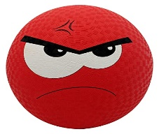
………………….. …………………… …………………… ………………….. ………………….. ……………………..
______________________________________________________________________________
3

B – Match the words with their meanings :
a – Witness. ( ) 1 – payment for costs of an accident.
b – Insurance. ( ) 2 – someone who saw an event.
c – Intersection. ( ) 3 – hurt from an accident.
d – Injury. ( ) 4 – Where two roads cross.
C – Match the illness with its symptom:
( headache – stomachache – earache – toothache )
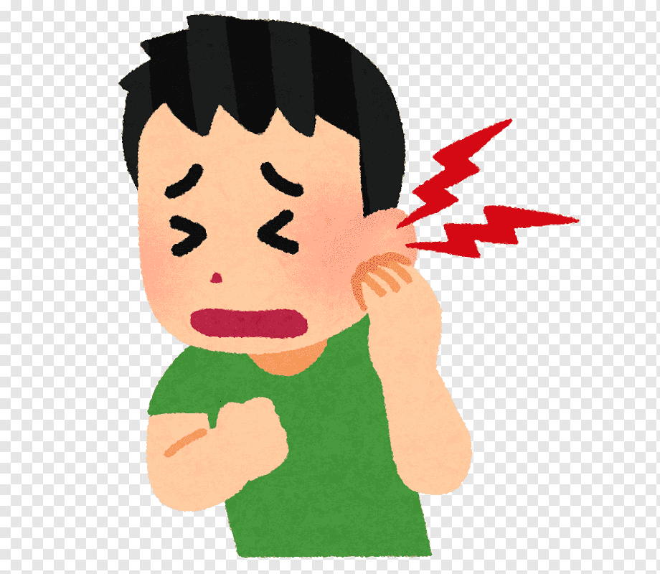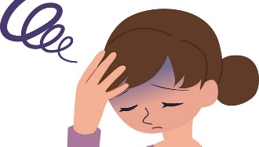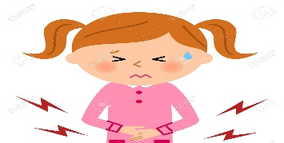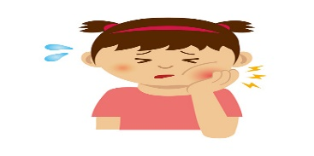
………………………………. ………………………………… …………………………….. …………………………….
-------------------------------------------------------------------------------------------------------------------------------

4
Q : 5 ( Orthography )
A : Write the missing letter :
1 - ……..ark. ( sh – ch – ph ). 2 – banan…. ( d – t – a ) .
3 - ……ale. ( n – s – q ) . 4 – bo…..ts . ( o – r – m ).
-------------------------------------------------------------------------------------------------------------------------------
B : Copy :
1 – You can break a diamond with a hammer.
……………………………………………………………………………………………………………………….
2 – The great star of Africa weighs over 540 karats.
………………………………………………………………………………………………………………………..
Good luck….
T.
(إجعل دقائق الإنتظار مليئة بالإستغفار )
4
الصف: ثاني متوسط
مادة : اللغة الإنجليزية
الزمن: ساعتان
أسئلة اختبار الفصل الدراسي الثاني للعام 1445هـ
عدد الصفحات : 4 عدد الأسئلة :5

++++++++++++++++++++++++++++++++++++++++++++++++++++++++
30
30
I-Composition: |  | 6
* The greatest wealth is health..

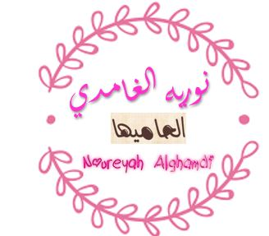
*Write a paragraph about Your Health. Give your opinion about it. Use the phrases below to guide you :

-illness that you have last time
-the symptoms that you had
-the medicine that you took
-your feeling after recovering
__________________________________________________________________
__________________________________________________________________
__________________________________________________________________
__________________________________________________________________
__________________________________________________________________
__________________________________________________________________
__________________________________________________________________
__________________________________________________________________
__________________________________________________________________

6
II-Comprehension:
1 mark each
6

Read the passage and answer the questions below:
Farah is thirteen years old. She lives in Abha. Her best friend is Lura. Farah has one sister. Her name is Sara. Farah went grocery shopping. It took her 2 hours, so she was tired. Finally, she arrived at the checkout. There Farah realized her wallet was somewhere in her bag. She took everything out, even a TV remote. The cahier looked at her: ‘Why are you carrying a remote?’ he asked. Farah smiled: ‘I took it from my sister Sara because she didn’t want to go shopping with me.’ Then Farah put her credit card into a reader. ‘I bet you won’t do it again,’ said the cashier, and started taking away everything Farah wanted to buy. Farah was shocked: ‘These are my things!’ ‘Not really’, the cahier replied, ‘you haven’t paid for them yet’. ‘Unless you have some cash on you, you won’t be able to pay with this,’ the cashier said, showing Farah a credit card reader with ‘TRANSACTION REJECTED’ on it. ‘I think your sister has blocked your card. SO, Miss, have you got any cash?’ Farah felt sad because her credit card didn't work.
Multiple Choice ( 1- 27 )
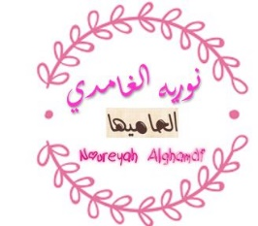
Comprehension (1-4)
Choose the correct answer :
1- The main idea of the text is … …………….
d. Farah went shopping |  | c- Trip to the zoo | b-The house is old | a-The garden
2-She in line (3) refers to…..
d. Farah |  | c- Sara | b- Lura | a- Aisha
3- the opposite of ≠ ( happy ) is………………..
d. great |  | c- low | b-sad | a-active
4- Farah's sister has blocked her credit ……………..
d. bag |  | c- card | b- remote | a- key
False\True | Put ( T ) or ( F ) (1-2)
F | 1- Farah lives in Jeddah.
T | 2-She is thirteen years old.

III-Grammar:/Multiple Choice: ( 5 to 11 )
Choose the correct words: | 1 mark each | 7

5 ..........toothbrush is this?
d- Where | c- Whose | b- How | a- Where
6- He was the ………………………… runner in 2017.
d-as fast as | c-faster | b-fast | - fastest
7-May I ……………………..a bigger bag, please?
d-have | c-having | - had | - to have
8- My sister did not .......... her homework.
d- to do | c-doing | - do | - does
9- I enjoyed the concert.
d-So do I. | c-So did I | b-Neither did I. | - Neither do I.
10- Let's ………………… some water.
d- drinks | c- drinking | - to drink | - drink
11They have to ……………………..uniform at school.
d-wears | c-wearing | b-wear | - wore

½ each

7776
IV-Vocabulary:/Multiple Choice: ( 12 to 19 )
Choose the correct words:

12- I cook by gas or ………………….
d- robotics | c- electricity | b- astronomy | a- navigation
13- It's fun to ……………..a motorcycle.
d- crash | c- invite | b- ride | a- call
14. I ……………………. because of the dust.
d- sneeze | c- rest | b- drink | a- vomit
15. Let's go ………………….to the local alley.
d- eating | c- driving | b- swimming | a- bowling
16. It is raining outside. You need your ……………………...
d- wallet | c- umbrella | b- tie | a- ring
17. ………………….. can sense blood.
d- horses | c- falcons | b- Sharks | a- Oryxes
18. Substances like oil and water are ……………………..
d- solid | c- liquid | b- plastic | a- metal
19. I recorded a ……………………… on your voicemail.
d- message | c- ticket | b- shuttle | a- form
½ each
Vocabulary: ( 1 to 6 )
Pairing Question:

1 | He likes to explore caves. | e | A | the opposite of expensive
2 | Her dress was cheap. | a | B | a set of rooms
3 | You've got a fever. | f | C | the ability to see
4 | I mow the lawn every week in summer. | g | D | the synonym of worried
5 | The suite is on the top floor. | b | E | to discover
6 | I'm feeling nervous. | d | F | a very high temperature
 |  |  | G | to cut grass using a machine

476
½ each
V-Orthography (Spelling): ( 20 to 27 )

20 | I am relie__ed that they adm__red my courage.
20 | a. (l-u) | b. (q-o) | c. (t-e) | d. (v-i)
21 | Fortunately, my mom agree to let me hang out with my friends.
21 | a. (r-a) | b. (k-i) | c. (m-o) | d. (l-e)
22 | Some p__tients don't know the symp__oms of some diseases.
22 | a. (i-m) | b. (a-t) | c. (o-v) | d. (u-z)
23 | Sarah was s__ck but she fulfilled her obli__ation to attend the important meeting.
23 | a. (u-x) | b. (a-n) | c. (i-g) | d. (e-h)
24 | They in__talled the new photos of the engagement rings of diam__nds.
24 | a. (w-a) | b. (z-e) | c. (s-o) | d. (g-i)
25 | Maria proudly wore a traditional s__irt that was a part of her cultural h__ritage.
25 | a. (h-o) | b. (j-i) | c. (m-u) | d. (k-e)
26 | The s__fari camp organized a sur__rise sundown event.
26 | a. (e-q) | b. (a-p) | c. (o-d) | d. (i-l)
27 | While rearranging the f__rniture, we found a lost sock behind the laun__ry basket.
27 | a. (o-b) | b. (i-x) | c. (u-d) | d. (e-v)

END OF QUESTIONS
BEST OF LUCK
