English Language
elementary Grade ...
1st period Exam
…………….\20
الاسم: الصف:


……\ 4 marks

General questions

A.Answer the questions
My favorite character is Spiderman. |  | What’s your favorite type of story? | 1
He was sleeping. |  | What activity do you do outside? | 2
I go rock climbing. |  | Who is your favorite story character? | 3
I like thriller stories. |  | What was your brother doing? | 4

Controlled Writing
……\ 1 marks
A-reorder.
1- a fairy tale\ I \ reading \was.
a-reading a fairy tale I was b-I was reading a fairy tale.

……\ 4 marks

Reading short sentence
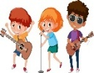 | 1- Musical actors have to sing and dance. ( )
 | 2- He feels scared when he watches horror movies. ( )
A-Put ( ✔ ) or ( X )
B. Choose the correct answer
c-surfboard | b-tent | a- fishing rod | 1- He went fishing. He took his……….
c-comedian | b-act | a- document | 2- My parents …..family vacations on video

……\ 4 marks

Grammar
A-Choose the correct answer.
c- watched | b- watch | a- watching | 1- I was ……….. a movie.
c-Is | b-Was | a-Were | 2-………they buying tickets for a concert?
c- Wrote | b- writing | a- write | 3- What about …….. a story about us?
c- sees | b- see | a- saw | 4- I didn’t ……… a bear.

Vocabulary

A.Choose the correct word under each picture
……\ 5 marks

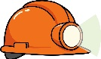 | 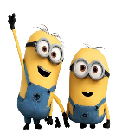 | 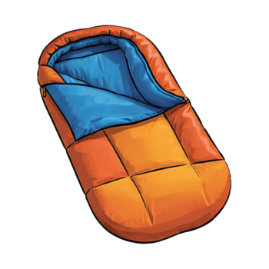 | 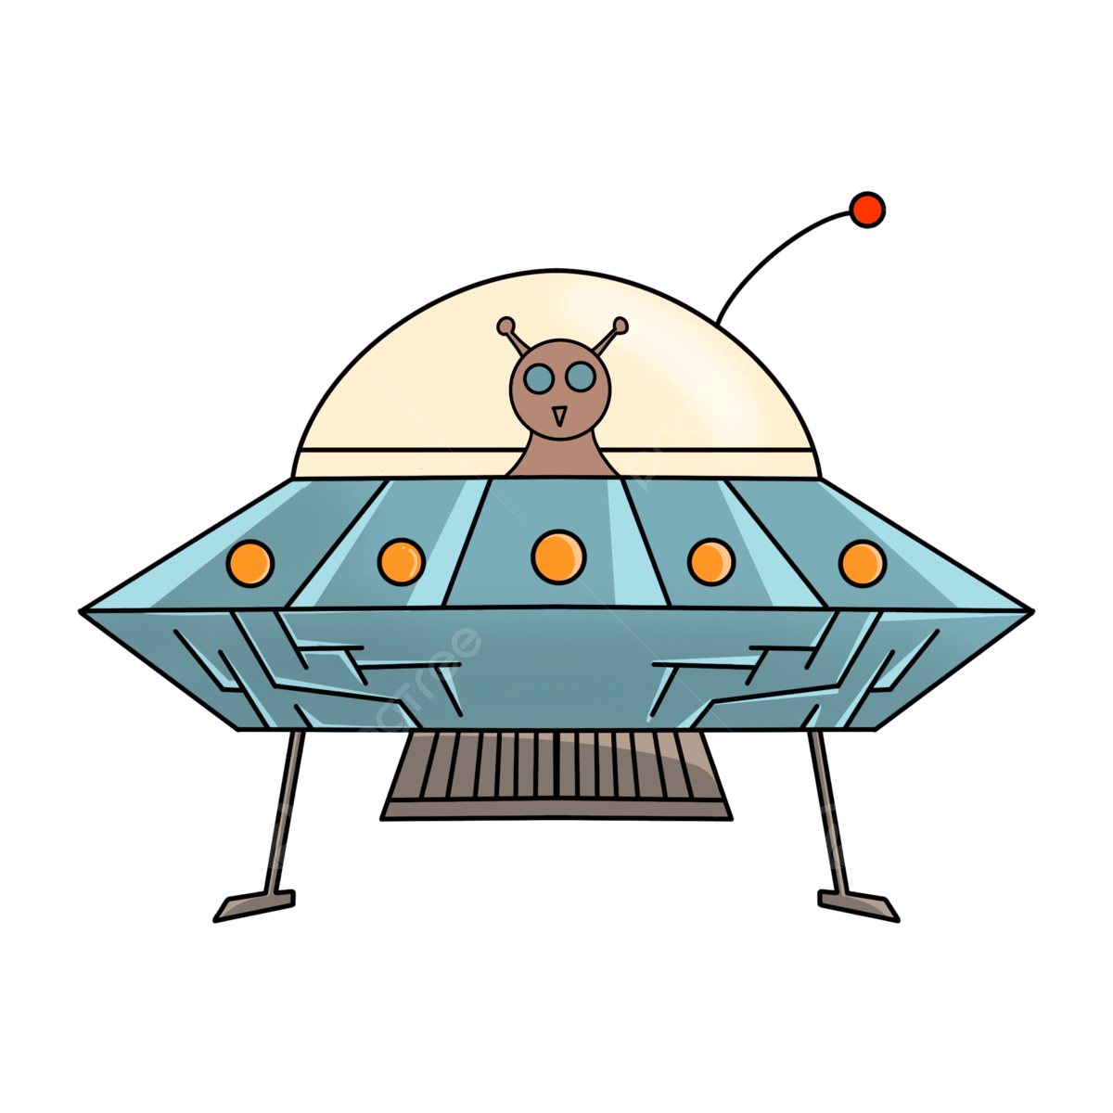 | 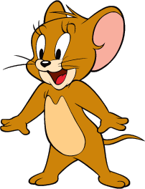
Helmet | animation | flashlight | Sci-fi | cartoon
surfboard | drama | Sleeping bag | play | horror
……\ 2 marks

Orthography
A. Fill in the missing letters

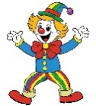

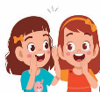


4- co……edy
( m – q - t )

2-m…..stery
( o – k – y )

( s – t - o)
3-…..iking
( d– h - t )

1- whis.…er
( p – d – f )

( s – t - o)

Your teacher:

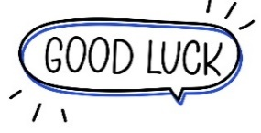
Your teacher …..:…………………………….

1
1– What is your favorite kind of story?
I. CHOOSE
A. Yes, I like B. Horror story.
2– What activity do you do outside?

A. No, I am not . B. Hiking in the. forest.
المملكة العربية السعودية |  |  | اسم الطالب/هـ ......................................
 |  |  | المادة : انجليزي
 |  |  | الزمن :
 |  |  | الصف : فصل ( )
شفهي | تحريري |  |  | المجموع
10 / | 10 / |  |  | 20 /
اختبار الفترة الأولى – الفصل الثاني 1447هـ - الصف ابتدائي
اسم الطالب / هـ الفصل /

2. CHOOSE OR
1.5

The bear was sick.
He was walking.
I was fishing .

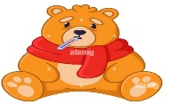




3. CHOOSE TO COMPLETE THE FOLLOWING:
1.5

Choose the word to complete the chart about types of word :
Noun | Verb | Adjective

Word | Word Class
1- comedy
2- act
3- mysterious

1
is | was | were | 1- They _____ eating in the kitchen.
seeing | saw | see | 2- I _____ a bear yesterday .
4. CHOOSE
5. CHOOSE
3

whisper - canoe - mystery

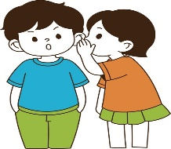 |  | 

6. CHOOSE THE CORRECT LETTERS:
2

Choose the correct letter:

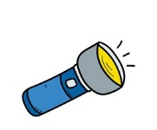 | 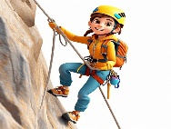 |  | 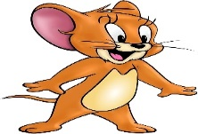
Flas_light | ing_clim | ducu_entary | toon_ca
h | d | f | r
k | b | m | s

___________________________________________________________________________________________________________________________________________________________________________________________________________________________________
Controlled writing

4

Good luck T.


Kingdom of Saudi Arabia 5th & 6th Elementary Grade

10
Ministry of Education Second Term
…… Elementary School First Exam - 1447 AH
Name: ………………………………………………………….………………. Class : …………..
- General Questions:
- Choose the correct answer:
1- What are the people in stories called?
a- climax & resolution |  |  |  |  | b- characters
2- What can you draw to plan a story?
a- a storyboard |  |  |  |  | b- a shopping list
3- How many acts in a story?
a- There are 3 acts in a story. |  |  |  |  |  | b- There are 5 acts in a story.
- Reading short sentence:
- Read the sentences then match them with the correct pictures:
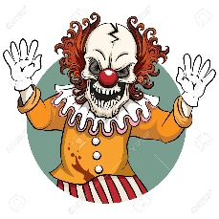 | 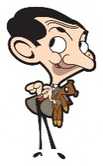 | 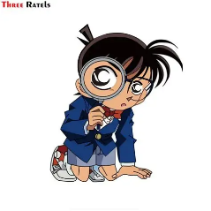 | 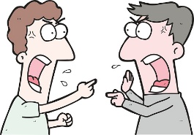
a-It is a cartoon.  b-It is a horror story. | a- It is a comedy story.  b- It is a drama. | a- It is an animation.  b- It is a mystery movie. | a-They were arguing.  b-They were agreeing.

III. Grammar:
- Choose the correct answer:
- He was ……………. a movie.
- watch |  |  | - watched |  |  |  |  | - watching
- Why don’t we ………………… a pizza?
- order |  |  | - orders |  |  |  |  | - ordered
- What about ………………. tennis?
- play |  |  | - playing |  |  |  |  | - played
V. Vocabulary:
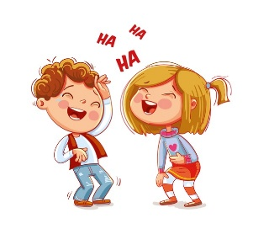
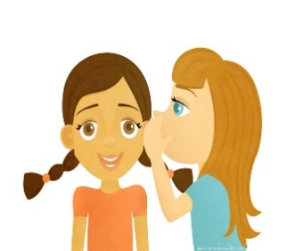
- Choose the correct answer:
 |  |  |  |  |  | 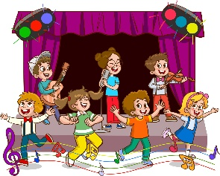
- appear  - whisper |  | - astronaut  - detective |  |  |  | - musical  - thriller |  |  | - laugh  - decide
- Fill in the blanks with the words from the box.
horror – fairy tale – drama
1- …………….…: It’s a story for children about things and characters that aren’t real.
2- …………….…: This kind of story creates a feeling of fear.
VI. Orthography:

- Choose the correct missing letters:
boo__case |  | 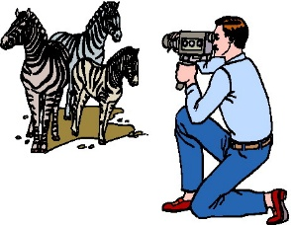  do__umentary |  |  |  | 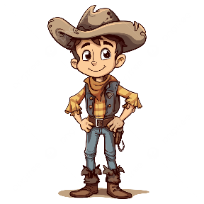  cow__oy |  |  | 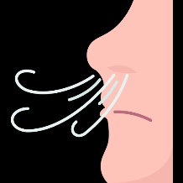  b__eath
x | k | c |  | k |  | d | b |  | r | l

BEST OF LUCK
Ms. Tahani Al-Ghamdi

