Name: ................................... Ms. Tahani
Class: 2nd Elementary / ........
Revision Sheet _ Unit ( 1 ): Wild Animals
- General Questions:
  - Match the questions with the correct answers:
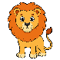  - Where’s the lion? |  | It’s a snake.
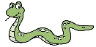  - What animal is this? |  | An elephant.
- Which animal has a long trunk? |  | It’s here.
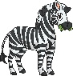  - Where’s the zebra? |  | It’s over there.
- Controlled Writing:
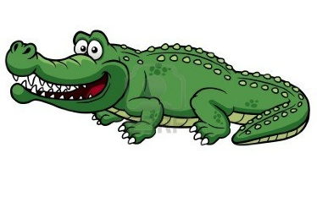
  - Rearrange the words to form sentences:
    - big – Crocodiles – teeth – have

  - Write the months of the year in the correct order:
big – long – smart – fat
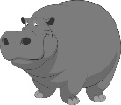
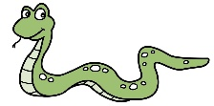
    - Hippos are
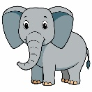
    - Snakes are
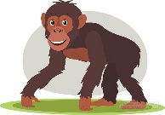
    - Elephants are
    - Chimpanzees are
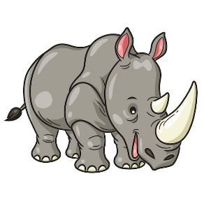 | 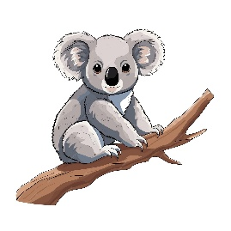 |  | 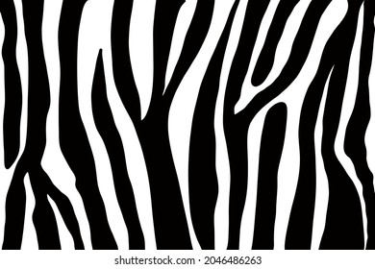 | 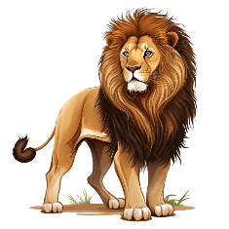
a. It’s a giraffe.  b. It’s a rhino. | a. It’s a zebra.  b. It’s a koala. | a. I will catch it by the toes.  b. I will catch it by the nose. | a. It has stripes.  b. It has trunk. | a. It’s scary.  b. It’s cute.
- Reading Short Sentence:
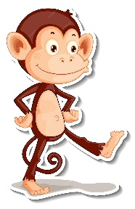
  - Read the sentences then match them with the correct pictures:
- Grammar:
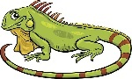
  - Choose the correct answer:
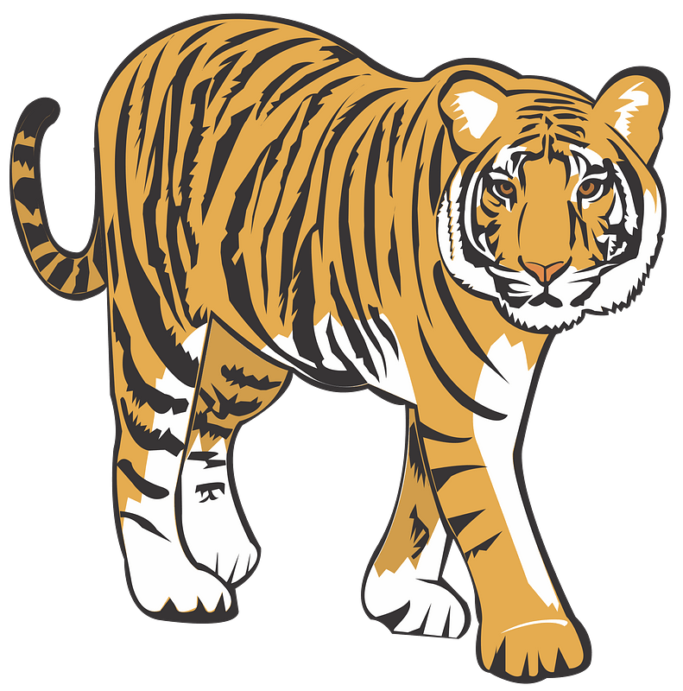
1- It is (a – an) iguana.
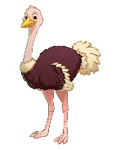
2- I will catch (a – an) tiger.
3- It is (a – an) ostrich.
- Vocabulary:
  - Write the words under the correct pictures:
giraffe – kangaroo – hyena – trunk – tail – polar bear

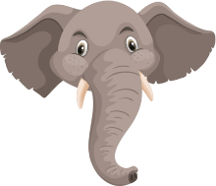 | 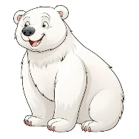 | 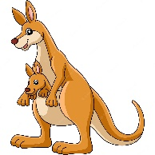 | 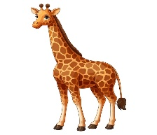 | 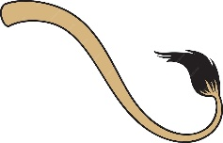 | 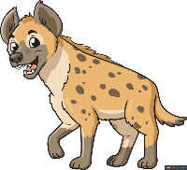

- Orthography:
A- Fill in the missing letters: B- Choose the correct missing letters:

ea / oo / u / u-e
  f_ _ther |  | 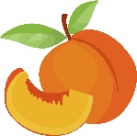  p_ _ch
ea | oo | ea | oo
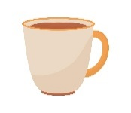  c__p |  | 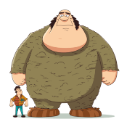  h__g__
u | u_e | u | u_e


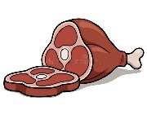
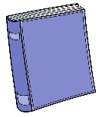

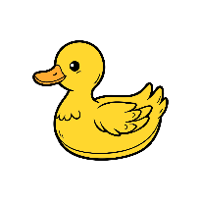
b__ __k h__ __d m__ __t
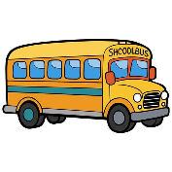
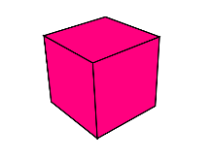

d__ck c__b__ b__s
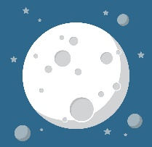 | 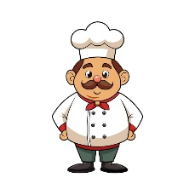 |  | 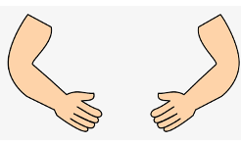  arms |  |  | 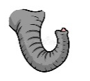  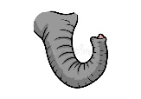  trunks |  |  | 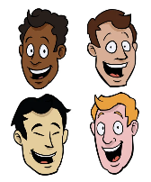  faces
moon | boot |  | /s/ | /z/ | /iz/ | /s/ | /z/ | /iz/ | /s/ | /z/ | /iz/
food | cook
C- Choose the correct answer for each picture:
Name: ................................... Ms. Tahani
Class: 2nd Elementary / ........
Revision Sheet _ Unit ( 2 ): From Here to There
- General Questions:
  - Match the questions with the correct answers:
- Where’s the train station? |  | I go by school bus.
- How do you go to school? |  | I wait.
- What do you do when you see a red light? |  | Walk straight and turn left.
- What do you do when you see a yellow light? |  | I stop.
- Controlled Writing:
  - Rearrange the words to form sentences:
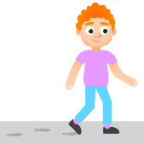
    - straight – steps – Walk – three

  - Complete the sentences with the correct word from the box:
taxi – rocket – train – bicycle
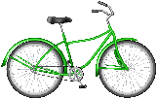

    - Take a to the school.
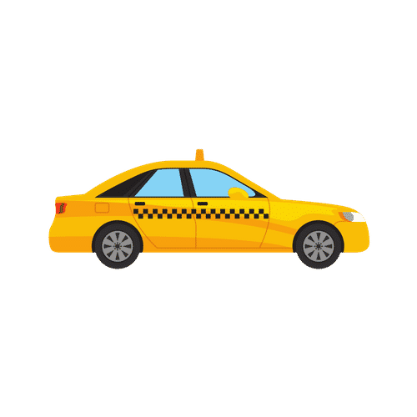
    - Take a to the moon.
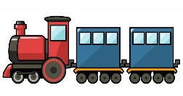
    - Take a to the hospital.
    - Take a to the airport.
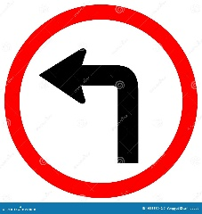 | 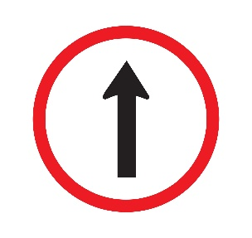 | 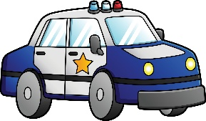 | 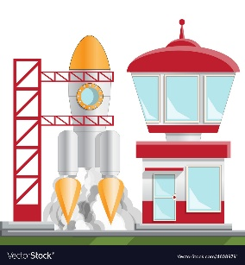 | 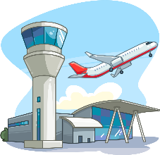
a. Turn left.  b. Turn right. | a. Close your eyes.  b. Walk straight. | a. It’s a motorbike.  b. It’s a police car. | a. It’s a space station.  b. It’s a hospital. | a. It’s a school.  b. It’s an airport.
- Reading Short Sentence:
  - Read the sentences then match them with the correct pictures:

- Grammar:
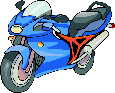
  - Choose the correct answer:
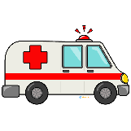
1- It is (a – an) motorbike.
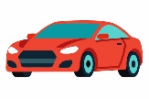
2- It is (a – an) ambulance.
3- It is (a – an) car.
- Vocabulary:
  - Write the words under the correct pictures:
step – truck – moon – hospital – traffic signal – turn right

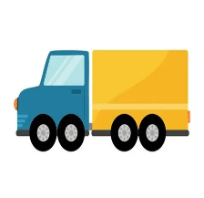
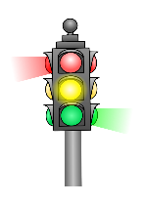
 |  |  | 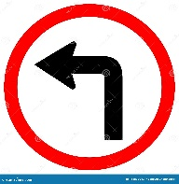 |  | 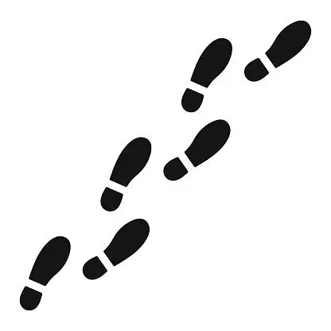

- Orthography:
A- Fill in the missing letters: B- Choose the correct missing letters:
st – ch – sh – sl – bl - fl

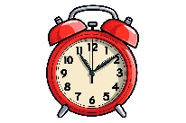  _ _ock |  |   _ _ant
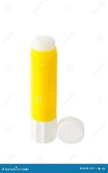  cl | gl | fl | pl
_ _ue |  | 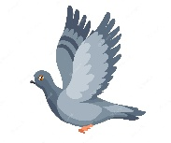  _ _y
cl | gl | fl | pl

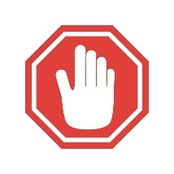




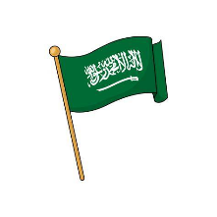
__ __ack __ __op __ __eep
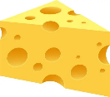

__ __ip __ __ag __ __eese
 | 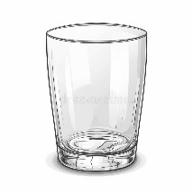 | 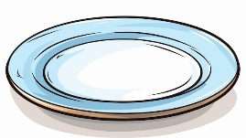 | 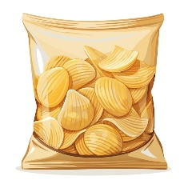 | 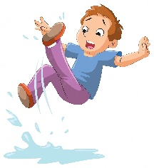
blue | class | plate | chip | sleep
black | glass | plant | ship | slip
C- Choose the correct answer for each picture:

