

English Language
Intermediate Grade 1st
1st period Exam
……….\20
Kingdom of Saudi Arabia
Ministry of Education
………………… School

Student's Name : class:

……\ 5 marks
1-Read the following passage and answer the questions below:
Omar is a doctor who works at a hospital in Saudi Arabia. He helps sick people every day and always listens carefully to his patients. Omar wears a white coat and works long hours, but he loves his job. He feels happy when his patients feel better and go home smiling.
c- doctor | b- engineer | a- teacher | 1-What is Omar’s job?
c-school | b-hospital | a-museum | 2-Where does Omar work?
c-pants | b- a white coat | a-T-shirt | 3-What does Omar wear at work?
A.Choose the correct answer.
B. C. Put ( ✓ ) or ( ✕ )
1-Omar helps sick people every day. ( ).
2-He feels sad when his patients feel better ( ).

2-Choose the correct answer.
……\ 5 marks

c- don't | b- doesn't | a- am not | 1- I ……..work in school.
c- is | b- has | a- have | 2- Faisal …………a red backpack.
c- driving | b- drives | a- drive | 3- He’s a bus driver. He………. a bus.
c- depressed | b- depressing | a- depress | 4- She is really ……. about the news.
c-doing | b-does | a-do | 5- Nawal is ……….her homework at the moment.

3-Do as shown between brackets.
……\ 2 marks
A. Correct
1- He wants to be a carpenter so he likes to build houses……………
B-(Reorder)
1- Math / quite /a difficult / is / subject
....................................................................................................................................

……\ 4 marks
4- write the correct word under each picture ( excited – carpenter – night – driver )






………………………
………………………
………………………
………………………

……\ 2 marks
5- Choose the correct answer.
1- Members learn lots of computer programs in( computer- science - archaeology) Club.
2- Ahmad’s brother works in a hospital. He’s a (reporter- flight attendant - doctor )
.

……\ 2 marks
6.Choose the missing letter.
1- He has brown eyes and …urly black hair. ( u - c - w)
2- I want to be a pilo… because I’m interested in planes. ( f - t - r )

7- write the missing letter

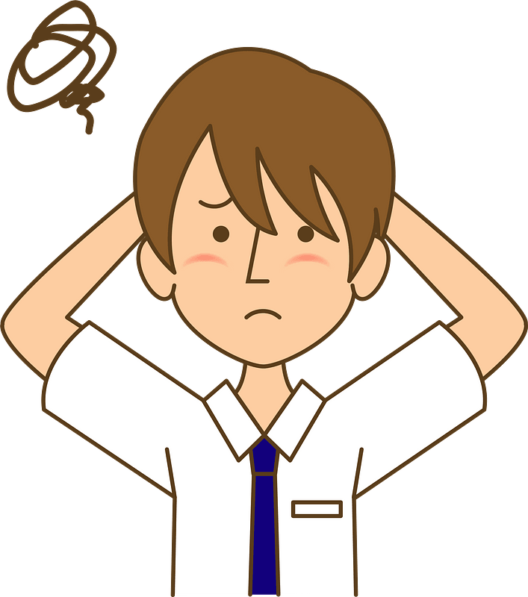

….…hotographer
Bo….…ed



Your teacher:


Kingdom of Saudi Arabia
Ministry of Education
………… Education Directorate............
…………..……………….. Intermediate School

Total
المجموع | تحريري | شفهي
20 | 10 | 10

First Period Exam _ Second Term
First Intermediate Grade

Name ………………………………… Class ………………………………
__________________________________________________________________________________________
/ 2
Comprehension

Read the following then answer the questions:

Omar Hamdan lives in Tabuk. He is sixteen years old, and he’s on the school football team. Omar is a very good player, and he’s the team’s top striker this season. Omar wants to be a professional football player. His parents support him, but they want him to go to a university.
A- Put (√ ) for true or ( ᵡ ) for false :

( ) | 1. Omar Hamdan is on the school football team.
( ) | 2. He wants to be a teacher .

B- Choose the right answer:

Tabuk | Abha | Jeddah | Riyadh | 1- Omar lives in ______.
market | broad | university | school | 2- His parents want him to go to a _____.
_________________________________________________________________
/ 2.5
Grammar

Choose the right answer:

1- He ______ for an airline .
A. work B. works C. working D. do
2 - ______ does he do? He is a bus driver.
A. What B.when C. Where D. Which
3 - They ____ English .
A. speakes B. speaks C. speak D. speaking
4 - Do you watch the film? Yes, I ________.
A. doesn't B. does C. don't D. do
5 - ______ is he taking a nap? Because he’s tired.
A. Why B. What C. Who D. How

/ 2
Vocabulary

A- Choose the best answer to fill in the blank:
1. She wants to be a _______ . She wants to help sick people .
designer | pilot | teacher | nurse
2. I want to be a flight attendant. I like to _____ and meet lots of different people .
study | play | travel | sleep
3. What’s your favorite ______, Carl? I prefer history.
school | subject | week | month
4- He _________ things clearly and also makes math fun.
explains | opens | sleeps | helps
B- Put the right word under its picture:
 |  |  |  | 
/ 2.5
smartphone - tired - science - waiter - cameraman

_______________________________________________________________________________
/ 1
Orthography

Choose the correct letter:
s | m | l | 1. My mother teaches at a pri_ary school .
d | f | t | 2. Matt has blon__ hair.

Good luck T.


Kingdom of Saudi Arabia Name: ……………………………
Ministry of education Class: 1st Intermediate Grade
10 /
…… Intermediate School Quiz (1) - 1447 Second Term
- Comprehension:
Read the passage to answer the questions below:
Max is my little cat. He is one year old. He is brown. He is very cute. He likes to play around the house. He loves to play with me. He is very smart. His favourite place to sleep is under my desk, but sometimes he sleeps in the kitchen. He loves to eat hot dogs a lot. He is a very good and funny cat. I love him.
- Choose the correct answer:
- This text is about ………………
- The writer’s family b- The writer’s cat c- The writer’s dog
- Max’s color is ………..
- black b- grey c- brown

- Check ( T ) or ( F ) :
- Max’s favourite food is burger. ( )
- Max likes to sleep under the desk. ( )

- Grammar:
- Choose:
- I like coffee (and – but – or) I don’t like tea.
- Ali and Omar (play – plays – playing) tennis.
- Leen (doesn’t watches – doesn’t watch – don’t watch) TV every night.
- (Do – Does – Are) they teach math?

- Do as shown between brackets:
1- Yara usually (write) a letter to her friend. (Correct the mistake)
……………………………………………………
2- has / black / Sara / hair (Rearrange)
…………………………………………………..

- Vocabulary:
- Classify the words:
thin – history – clinic

School subjects | Adjectives to describe people’s look | Place of work

- Write the words under the pictures:
carpenter – lawyer – confused – experiment


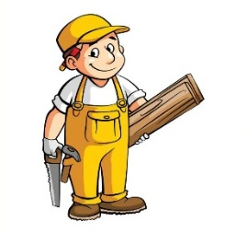


________________ __________________ ___________________

- Orthography:
- Choose the correct missing letters:
  - He is an a__tive student.
- c | - k | - x
  - She has b__ond hair and blue eyes.
- l | - r | - c
  - These stores s__ll clothes and shoes.
- a | - e | - i
  - Ali is not old enough to dri__e a car.
- f | - v | - p

Good Luck
Ms. Tahani Al-Ghamdi

