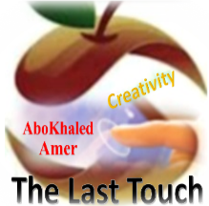

المملكة العربية السعودية
وزارة التعليم
الادارة العامة للتعليم بمنطقة: ----------
مدرسة: ثانوية --------------------------

Second Term 1447 H
ABOKHALEDAMER
0557325813
First Session Test
اسم الطالب: --------------------------------------------------------------------- الصف: الأول الثانوي
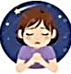
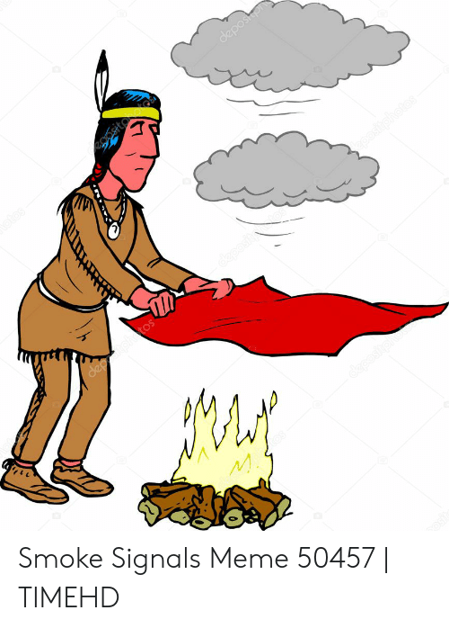

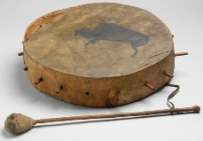
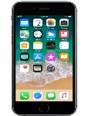
1. Match:(5M) 1. money prize – 2. cellphone – 3. smoke – 4. drum – 5. wish – 6. car

--------------------- ----------------- ------------------ -------------------
2. Match: (4M)
1- No way. | ( ) be honest and frank.
2- Let someone down. | ( ) won't allow something.
3- have a ball | ( ) disappoint.
4- Be straight. | ( ) have good time.
 | ( ) in my opinion.

3. Choose: (5M)
1. I apologize ( for – with – not ) arriving late.
2. (Because – In spite of – Although) I like ice cream; I am too full to eat any.
3. The noise was ( soon – so – that ) loud.
4. If I ( found – find – finded ) a million dollar, I would keep it.
5. I wish I ( has – have – had ) more time.
4. Do as shown: (2M)
1. i used to live in jeddah (Rewrite using Capitals) --------------------------------------------------

2.There isn't yet milk in the fridge. (Correct) ----------------------

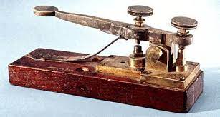

5. Fill in the missing letters: (4M) ( z – m – r – n )

e__ail teleg__aph isla__d pri__e
(2) Top Goal - YouTube End of Questions https://t.me/abokhaledamer

