
Kingdom of Saudi Arabia
Ministry of Education
………..Education Directorate
………………… secondary School
English Language
Grade 2nd secondary
1st period Exam
Second term
………\10
Student's Name : class:

Reading comprehension ✦

……\ 2 marks
1-Read the following passage and answer the questions below:
Ali went to the golf course early in the morning to practice golf. The weather was nice and calm. He held his golf club carefully and tried to hit the ball straight. At first, he missed the ball, but he did not give up. He practiced again and again, and his shots became better. By the end of the day, Ali felt happy and proud because he improved his golf skills.

1- Where did Ali go?
c- to school | b- To the golf course | a- to the park
2- What did Ali use to hit the ball?
c-puck | b-stick | a- golf club

……\ 4 marks
Grammar ✦
A. Choose the correct answer.

c-to | b- enough | a-too | 1- You are walking …………. slowly.
c- studies | b- study | a- studying | 2- She has been …………English since 2009.
c- give | b- giving | a- gives | 3- Can you ……….me your pen?
c- smart | b- smartest | a- smarter | 4- You are as ……….. as your brother.
B. Do as shown between brackets.

1.( Reorder)
a- We had a ( delicious , Indian , big ) feast for dinner last night.
……………………………………………………………..……………………………………….

2-( Use adverb of manner)
a- Sara is a good writer.
………………………………………………………………………………………………….…..

……\ 4 marks
✦ Vocabulary
A-Complete the missing words ( originated - worn )
1- We’ve had this couch too long. It’s starting to look ………………
2- The board chess ……………………..in India in the 6Th century.
B- Write the correct word under each picture

rink - skiing - canyon - barbecue

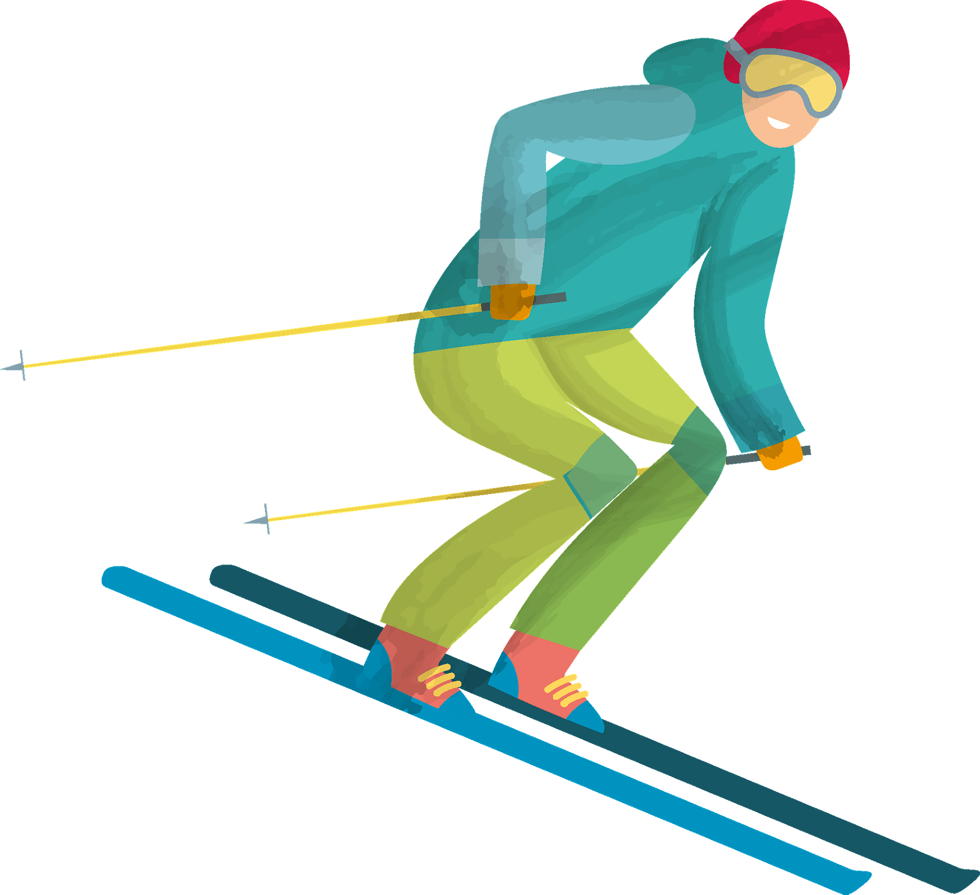

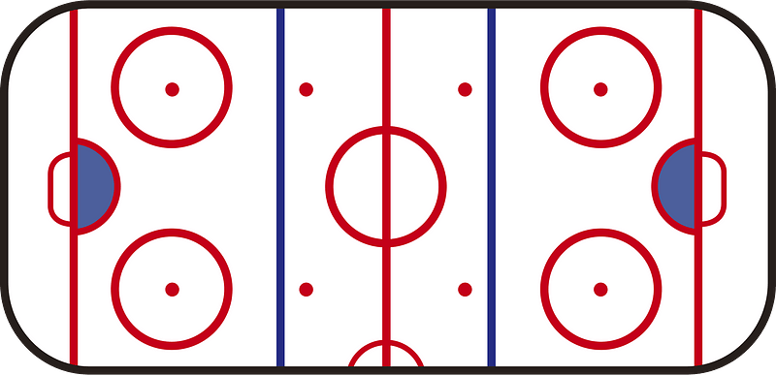

…………………………
…………………………
…………………………
…………………………

The end of the questions
Good luck
Your teacher ………………………

