


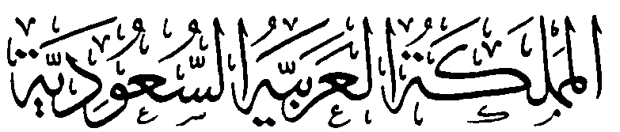
وزارة التعليم
الإدارة العامة للتعليم بمنطقة ......................
مدرسة .........................................
التاريخ: / / 1447هـ
الصف: السادس الابتدائي
الزمن: ساعة ونصف
المادة: اللغة الإنجليزية

الدرجة رقماً |  | الدرجة كتابة |  | اسم المصحح | توقيعه | اسم المراجع | توقيعه
الدرجة رقماً | 40 | الدرجة كتابة | درجة فقط
اختبار اللغة الإنجليزية نهائي – الدورالاول – للصف السادس – الفصل الدراسي الاول 1447هـ
اسم الطالب: ............................................ الفصل:

7
- General Questions:
- What is your favourite interest? |  | An architect.
- Who designs houses? |  | Voyaging because it is boring.
- What jobs do people in your community do? |  | My favourite interest is playing the guitar.
- Which activity do you not want to try? Why? |  | Teachers, doctors and engineers.
- What is your favorite dish? |  | Eat fruit & vegetables and drink water.
- He is a flight attendant, isn’t he? |  | Yes, he is.
- How can you improve your eating habits? |  | My favorite dish is pizza.
  - Match the questions with the correct answers:

- Controlled Writing:

7
B- Write the opposite of the following words:
1- happy ≠ ………………. 2- small ≠ ≠ ………………. 3- rich ≠ ……………… 4- good ≠ ……………..

  - Rearrange the words to form sentences:
    - shouldn’t – You – meals – skip
……………………………………………..
    - going to – a book – I am – read
……………………………………………..
    - works – My dad – a factory – in
……………………………………………..

- Reading Short Sentence:

7
  - Read the sentences then match them with the correct pictures:

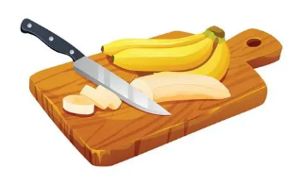 | 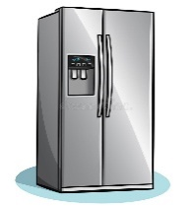 |  | 
a- Mix the ingredients.  b- Cut the bananas. | a-_It is an oven.  b-_It is a fridge. | a-He works in a factory.  b-He works in an office. | a-_He is a musician.  b-_He is a reporter.
  - Read and complete. Use the words in the box:
tidy – stage – honey - messy

  The woman has a  ………… hair. |   Add ……………………  to make a sweet snack. |   Actors act on a ……………….

- Grammar:
  - Choose the correct answer:

7
    - He (swim – swims – swam) in the ocean last summer.
    - You aren’t a doctor, (are you – aren’t you – you are)?
    - She (play – plays – played) board games on Thursdays.
    - This milk smells bad. You (had better – had better not) drink it.
    - It’s possible that we (may – might – are going to) study acting in the future.
    - He (is going to – will) play basketball tomorrow.
    - If you (eat – eats – eating) a good breakfast, you have lots of energy.

- Vocabulary:

7
  - Write the words under the correct pictures:
singer – measure – gallery – untidy – Wi-Fi – stadium – smell

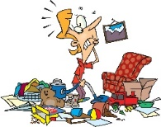 |  | 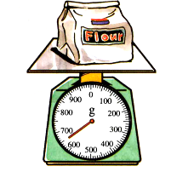 |  | 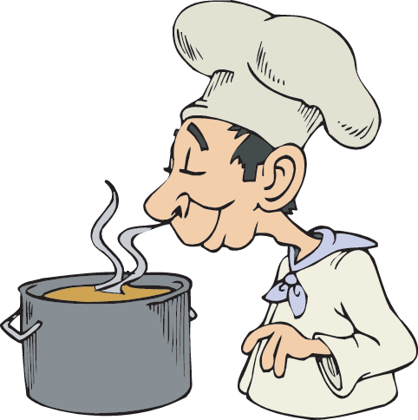 |  | 

- Orthography:
v – d – s – l – g

5
  - Fill in the missing letters:

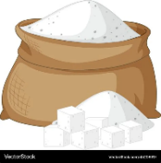 |  | 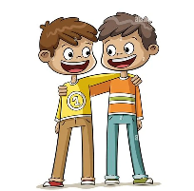 |  | 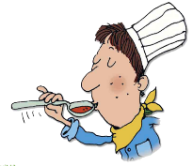
su__ar | she__f | frien__ly | dri__er | ta__te

المملكة العربية السعودية  وزارة التعليم  الإدارة العامة للتعليم بمنطقة  مدرسة |  |   Omar AlQurashi |  |  | المادة |  | لغة إنجليزية
 |  |  |  |  | الصف |  | الخامس / السادس
 |  |  |  |  | الزمن |  | ساعتان
أسئلة اختبار نهاية الفترة الدراسية الأولى (الدور الأول) للعام 1447هـ
اسم الطالب/ـة |  |  | اللجنة |  |  | رقم الجلوس

السؤال |  |  | السؤال الأول | السؤال الثاني | السؤال الثالث | السؤال الرابع | السؤال الخامس | المجموع | الدرجة الكلية
الدرجة | رقما
الدرجة | كتابة |  |  |  |  |  |  |  | 40
المصحح/ـة
المراجع/ـة
المدقق/ـة

14درجة
Q1)- A - Choose the correct answer ;
calling | call | .5- I will ___ him now | many | long | 1– How__ is the break ?
turning | turn | 6-We should _ the oven on. | much | many | 2-How _ boys are there ?
is he | isn't he | 7-He isn't a doctor ,__ ? | went | go | 3- He didn't ___ to Jeddah.
 |  |  | gone | going | 4- I am ___ to be a teacher.

B - Choose the correct answer:
1 – What are you going to be when you grow up ? A . an artist B . gallery
2 – Tidy means A . messy B . organized
3 – Who fixes cars ? A . mechanic B . pilot

4 – Which country will host the world cup 2034 ? A . Saudi Arabia B . Oman

5 – Someone is expert A. receptionist B. specialist
6 – Why is breakfast important ? A . gives you energy B. helps you sleep
7- What a balanced diet ? A . eat everything B. eat a bit of everything

Q2-) A- Fill in the missing letters :

12درجة
 |  |  |  | 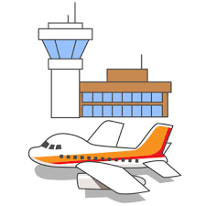
fa __ tory | sta __ e | act __ r | k __ y | air __ ort
c | g | o | e | p
k | j | u | i | b

_________________________________________________________________
B-) Read and say if the sentences are True ( ) or False ( X ) ;

X |  | . 5- A photographer takes pictures | X |  | 1– A waiter fix cars .
X |  | 6- You shouldn't use too much sugar. | X |  | 2- A pilot works at airport.
X |  | 7- Who takes a tour is an artist. | X |  | 3- Journalist reports news.
 |  |  | X |  | 4- Actors act on a factory.

14 درجة
Q3)-A- Choose the correct word :
 | 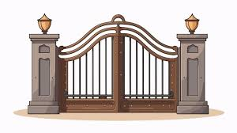 |  | 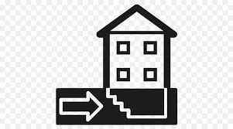 |  |  | 
factory  wi-fi | window  gate | doctor  pilot | basement  entrance | artist  waiter | screen  shelf | noisy  lucky

Use the following words to complete the paragraph about My house . B-)

very | Living room | big | garden | clean | like | kitchen

My house is …………………… and ……………..……… . It has a ………………………………… , 4 bedrooms , 5 bathrooms and a ……………………… . There is a …………………… in front of my house . I ………………… my house …………………much .
انتهت الأسئلة .. تمنياتي لكم بالتوفيق والنجاح
معلم المادة:
عمر القرشي

وزارة التعليم

الإدارة العامة للتعليم بمنطقة ......................
مدرسة .........................................
التاريخ: / / 1447هـ
الصف: ............... الابتدائي
الزمن: ساعة ونصف
المادة: اللغة الإنجليزية

أسئلة اختبار مادة اللغة الانجليزية للصف ال............. الابتدائي
للعام الدراسي 1447 هـ
الفصل الدراسي الأول
عدد الأوراق : 4

اسم الطالبة : ........................................................................
رقم الجلوس : .........................................................................
اليوم : ...............................................
التاريخ : .......... / ........... / 1447 هـ
الزمن : ...........................

 | Questions | Mark | Student's mark
Q1 | General Questions | 7
Q2 | Guided Composition | 7
Q3 | Reading Short Sentences | 7
Q4 | Grammar | 7
Q5 | Vocabulary | 7
Q6 | Orthography | 5
Total : |  | 40
المصححة : ...............................................................التوقيع :.....................................
المراجعة : ...............................................................التوقيع :.....................................

معلمة المادة :

......................................................

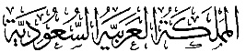
وزارة التعليم
الإدارة العامة للتعليم بمنطقة ......................
مدرسة .........................................
التاريخ: / / 1447هـ
الصف: ............... الابتدائي
الزمن: ساعة ونصف
المادة: اللغة الإنجليزية

الدرجة رقماً |  | الدرجة كتابة |  | اسم المصحح | توقيعه | اسم المراجع | توقيعه
الدرجة رقماً | 40 | الدرجة كتابة | درجة فقط
اختبار اللغة الإنجليزية نهائي – الدورالاول – للصف ال.......... – الفصل الدراسي الاول 1447هـ
اسم الطالب: ............................................ الفصل:
- General Questions:

7

- What is your favourite interest? |  | An architect.
- Who designs houses? |  | I need a key to get into a house.
- Who works in a hospital and helps sick people? |  | My favourite interest is drawing.
- What do you need to get into a house? |  | A doctor .
- What is your favourite dish? |  | We have 4 bedrooms .
- He is a flight attendant, isn’t he? |  | Yes, he is.
- How many bedrooms does your house have? |  | My favourite dish is pizza.
  - Match the questions with the correct answers:

- Controlled Writing:

7
        - Write a short paragraph about yourself.
Use the helping words to help you :
name – country – favourite food – hobby – future job
……………………………………..………………………………………………………………………………………………………………….
……………………………………..………………………………………………………………………………………………………………….
……………………………………..………………………………………………………………………………………………………………….
……………………………………..………………………………………………………………………………………………………………….
……………………………………..………………………………………………………………………………………………………………….
……………………………………..………………………………………………………………………………………………………………….
……………………………………..…………………………………………………………………………………………………………………
…………………………………………………………………………………………………………………………………………………………

B. Rearrange the words to form sentences:
    - shouldn’t – You – meals – skip
…………………………………………………………………………………………………………………………………………………….
    - going to – a book – I am – read
…………………………………………………………………………………………………………………………………………………….
C. Write the opposite :
1- Happy # ………………………….. | 2- Small #..............................

III. Reading Short Sentences:

7
  - Read the sentences then match them with the correct pictures:

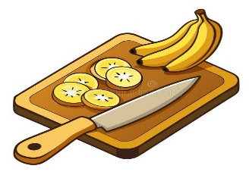 | 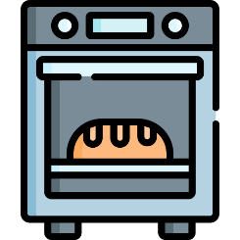 |  | 
a- Mix the ingredients.  b- Cut the bananas. | a-_It is an oven.  b-_It is a fridge. | a-He works in a factory.  b-He works in a hospital. | a-_He is a musician.  b-_He is a reporter.
  - Read and complete. Use the words in the box:

tidy – stage – honey - messy

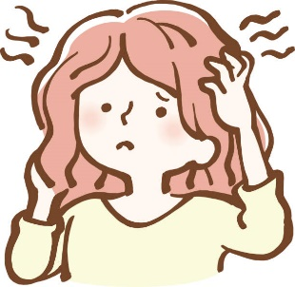  The woman has a  ……………………….. hair. |   Add ………………………  to make a sweet snack. |   Actors act on a ………………………..  .

- Grammar:
  - Choose the correct answer:

7
    - He (swim – swims – swam) in the ocean last summer.
    - You aren’t a doctor, (are you – aren’t you – you are)?
    - She (play – plays – played) board games on Thursdays.
    - This milk smells bad. You (had better – had better not) drink it.
    - It’s possible that we (may – might – are going to) study acting in the future.
    - He (is going to – will) play basketball tomorrow.
    - If you (eat – eats – eating) a good breakfast, you have lots of energy.

- Vocabulary:

7
  - Write the words under the correct pictures:
singer – cushion – fridge – untidy – Wi-Fi – screen – smell

 | 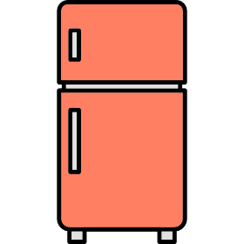 | 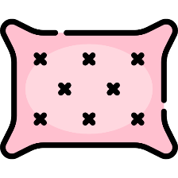 | 
 | 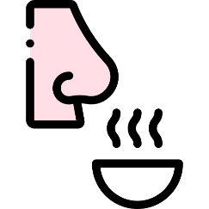 | 

5
- Orthography:
v – d – s – l – g
  - Fill in the missing letters:

 |  | 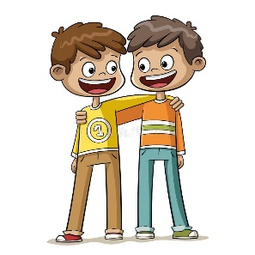 |  | 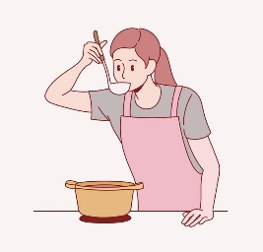
su__ar | she__f | frien__ly | dri__er | ta__te

