
Kingdom of Saudi Arabia
Ministry of Education
………………… School
English Language
Intermediate Grade 2nd
2nd period Exam
……….\20

Student's Name : class:

……\ 5 marks
1-Read the following passage and answer the questions below:
Omar loves ice hockey. Every weekend, he goes to the ice rink to practice with his friends. He enjoys skating fast and hitting the puck into the goal. His coach always reminds the team to wear helmets and follow safety rules. Ice hockey is Omar’s favorite hobby because it makes him strong, active, and happy.
c- swimming | b- tennis | a- ice hockey | 1- What is Omar’s hobby?
c-every day | b-every month | a-every weekend | 2- When does Omar practice?
Cin the park | b-At ice rink to | a-at school | 3-Where does Omar practice ice hockey?
c- helmets | b-caps | a- T-shirt | 4-The coach reminds the team to wear…
c-swimming | b- skating | a-running | 5- Omars enjoys …………. fast
A.Choose the correct answer.
……\ 4 marks
2-Choose the correct answer.
c-taking | b- takes | a- take | 1- Ali usually …………French classes .
c- working | b- worked | a- works | 2- Omar …….. at hospital.
c-flies | b- fly | a- flying | 3- He knows how to………a plane.
c- plays | b- playing | a- play | 4- They like …….videogames.
c-aren't | b-don't | a- doesn't | 5- They ……….read the story.
c-where | b-which | a-who | 6- My father buy a car ……. is BMW.
c- doing | b- does | a- do | 7- How often ……..you work out ?
c- drink | b- drinking | a- drinks | 8- I prefer to ………coffee .
3-Do as shown between brackets.
……\ 3 marks
(make Yes or No question)
1- Noura speaks English . ……………………………………………………………………………….……?
( reorder)
1- seldom \ watches TV \ Ahmad.
…………………………………………………………………..……………………
(Put the adverb of frequency in the correct place)
1-Jamal is late for school. ( always)
…………………………………………………………………………………………

……\ 4 marks
4- write the correct word under each picture (pilot – nurse – airplane – food court )





………………………
………………………
………………………
………………………

……\ 2 marks
5- Choose the correct answer.
1- He's a ( chef – teacher -architect. ) He knows how to cook.
2- Takes care of sick people ( policeman – director – doctor)

6.Choose the missing letter.
1- I want to be a newspaper ….ournalist ( d – j – z )
2- The ….hotographer knows how to take photos. ( p - s – z )

……\ 2 marks

7- write the missing letter




a…tist
de….tist



Your teacher:


Kingdom of Saudi Arabia
Ministry of Education
………… Education Directorate............
…………..……………….. Intermediate School

Total
المجموع | تحريري | شفهي
20 | 10 | 10

Second Period Exam
Second Intermediate Grade

Name ………………………………… Class ………………………………
__________________________________________________________________________________________
/ 2
Comprehension

Read the following then answer the questions:

Last winter my family and I went to France. At the beginning of our trip, we went on a cruise on the River Seine. It was a wonderful experience. There were so many interesting things to see there. We visited the Eiffel tower and took lots of pictures. They were amazing! My parents and I also tried horse riding. My brother didn’t want to go anywhere near the animal. You see, he was afraid. I really want to visit France again. It’s beautiful and there are many things to see there!
A- Put (√ ) for true or ( ᵡ ) for false :

( ) | 1. We went to France last summer .
( ) | 2. They went on a cruise on the River Seine .

B- Choose the right answer:

Eiffel tower | park | sea | pyramids | 1-They visited the ____ and took lots of pictures
Skiing | swimming | swing | horse riding | 2- My parents and I also tried ________.
_________________________________________________________________
/ 2.5
Grammar

Choose the right answer:

1- We would like ___________ Makkah .
A. visiting B. to visit C. visit D. visits
2 - There is _______ juice .
A. any B. most C. some D. many
3 - There aren't _____ fries.
A. most B. much C. some D. any
4 - He _______at home last night.
A. were B. was C. is D. are
5 - I didn’t hear __________. I was asleep.
A. anything B. nothing C. something D. thing

/ 2
Vocabulary

A- Choose the best answer to fill in the blank:
1. They eat in food courts or _________.
D. plains | C. restaurants | B. Schools | A. streets
.2. I'd like a piece of ___________
D. cup | C. cake | B. juice | A. water
3- We looked at the birds through _________.
D. glasses | C. sky | B. binocular | A. mirror
4- He was talking on his __________.
D. cell phone | C. window | B. car | A. lamp
B- Put the right word under its picture:
/ 2.5
 | 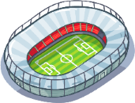 | 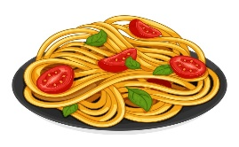 | 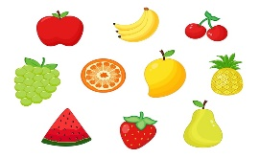 | 

Pasta - sleepy - stadium - aerobatic - fruit

_______________________________________________________________________________
/ 1
Orthography

Choose the correct letter:
k | b | g | 1. The word calli_raphy means “beautiful writing.”
d | p | r | 2. He didn’t see the sto_ sign .

Good luck T.


Kingdom of Saudi Arabia Name: ……………………………
Ministry of education Class: 2nd Intermediate Grade
10 /
…….. Intermediate School Second Exam - 1447 First Term
- Grammar:
- Choose:
- Amal can’t stand (wait – waits – waiting) in line.
- There isn’t (a – any – some) milk in the fridge.
- Remas (play – plays – played) tennis last week.
- I would like (to go – going – go) to Japan next week.

- Do as shown between brackets:
1- I don’t have …….. time to cook dinner. (Use ‘too’ or ‘enough’)
…………………………………………………………
2- (Rewrite the sentences with strong adjectives):
- Rana is very clever.
…………………………………………………………

- Vocabulary:
- Write the words under the pictures:
astronaut – lettuce – volcano – robot – food court
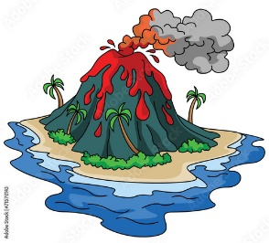
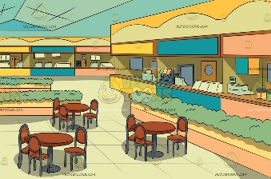
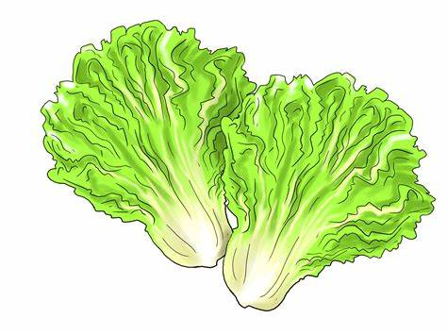


_____________ _______________ ________________ ______________

- Fill in the blank with the correct words in the box:
discovered – fish – awesome

- Salmon is a very popular type of …………….
- Columbus ……………… America in1492.

- Circle the odd word:
- reading – drawing – usually – cooking
- milk – juice – tea – cookie

- Orthography:
- Fill in the missing letters:
- The food was del__cious.
- Nada ba__ed a cake for her friend.
- They p__ay tennis twice a week.
- The waiter came to take their o__der.

Good Luck
Ms. Tahani Al-Ghamdi

