اختبارالنظري لمنتصف الفصل الدراسي الاول لمادة اللغة الانجليزية للصف الثالث الثانوي
المملكة العربية السعودية
وزارة التعليم
مكتب تعليم طويق
وثانوية حواء الانصاريه
10
Exam B : English Language for the 3ed Secondary grade
Name………………………………………………..(3\ )

1-Write the number under the picture ?

1-horror | 2- remote | 3-news paper | 4- detective | 5-animation | 6-solar system
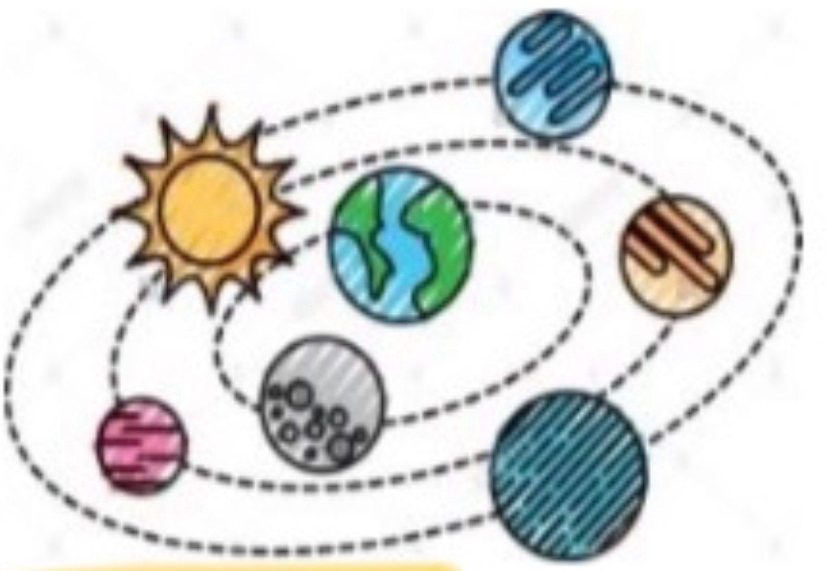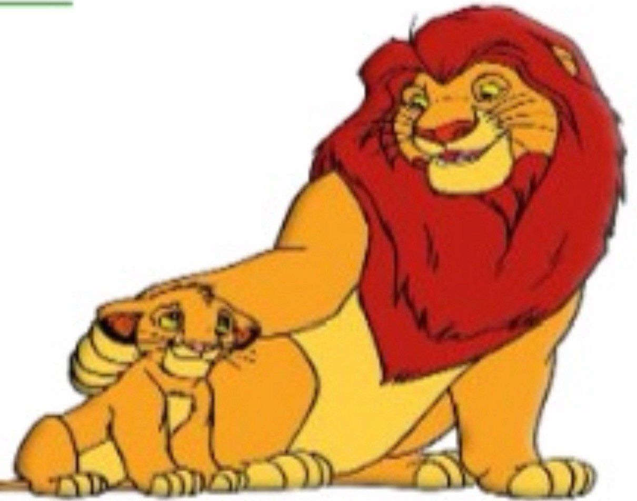

2-Choose the correct verbs?
1-The car company will have (introduced- introducing- introduce ) their new model.
2-By the year 2033, people will have been (fly- flying- flys )for130 years.
3-(Do-Does- Is) they use the internet?
4-where did you live? I (lives- living –lived) in Riyadh.
5- He is not only hardworking, (and- but also –or ) intelligent .
6- Both my father (and- but –nor ) his boss were present in the meeting.
7- Goldish are (small- smallest- smaller ) than clownfish.
8-Dora and is(as good as- good as- as better) Sonic the hedgehog .

5-Match

1- doze off | ( ) accept things
2-hard swallow | ( ) leave, get red of
3- just | ( ) carrying
4- lugging | ( ) really
5- ditsh | ( ) not easy to believe
6- go with flow | ( ) fall asleep

4-Name some geners of movies ? ……………………………………………………………………………………………………
…………………………………………………………………………………………………..

