
English Language
Intermediate Grade 1st
2nd period Exam
……….\20
Kingdom of Saudi Arabia
Ministry of Education
………………… School

Student's Name : class:

……\ 5 marks
1-Read the following passage and answer the questions below:
Last summer, Noura traveled with her family to a new city. They visited a museum to learn about history. The guide told them the rules: don’t touch anything and speak quietly. Noura saw old coins and a big dinosaur model. She enjoyed the visit and learned something new.
c- mall | b- park | a- museum | 1- Where did Noura go?
c- speak quietly | b-run fast | a- take pictures | 2-What was one museum rule?
c-type writer | b- cars | a- dinosaur | 3- What did Nora see?
c- family | b-friends | a-cousins | 4-She traveled with her………..
c-doctor | b- guide | a-manager | 5- The ……… told them the rules.
A.Choose the correct answer.

2-Choose the correct answer.
……\ 4 marks

c-closed | b-closing | a-close | 1-………….the book.
c-at | b-on | a-in | 2- Rome is ………….Italy.
c-Is | b-Am | a-Are | 3-………. you from England?
c-These | b- That | a- This | 4-……..are books.
c-are | b-am | a-is | 5- Where ……….. they from?
c-aren't | b-isn't | a-am not | 6- I …………from Saudi Arabia.
c- opening | b- opens | a- open | 7- Can you ………..the window?
c-the | b- X | a-a | 8- They visit ……….. Jeddah.

3-Do as shown between brackets.
……\ 3 marks
Answer the questions))
1-Is he from Brazil? - yes, …………..…………………………………....
(Reorder).
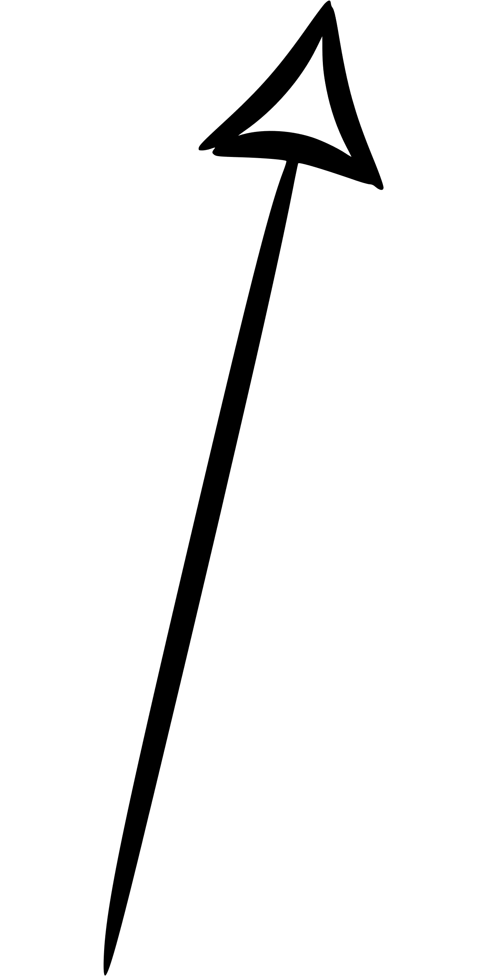
1-help \ Will \ me\ you \ ? …………………………………………………………..

(correct)
a-This is a pencil ………………….

……\ 4 marks
4- write the correct word under each picture ( headphones - cold – calculators – airport )

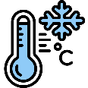
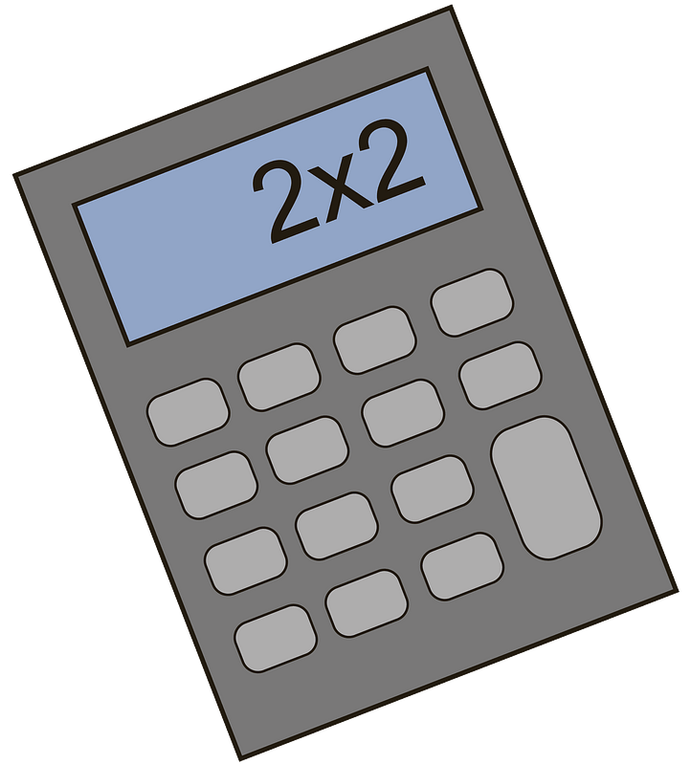



………………………
………………………
………………………
………………………

……\ 2 marks
5- Choose the correct answer.
1- Aisha is from Egypt. She is ( Egyptian – Venezuelan – Syrian )
2- (Sculptures - Tote bags - rocks) is a piece of art that is made from stone or wood.
.

6.Choose the missing letter.
1- My favorite to…. is a train. ( s – y – q )
2- Ottawa is the capital of Ca….da. ( n – s – q )

……\ 2 marks

7- write the missing letter


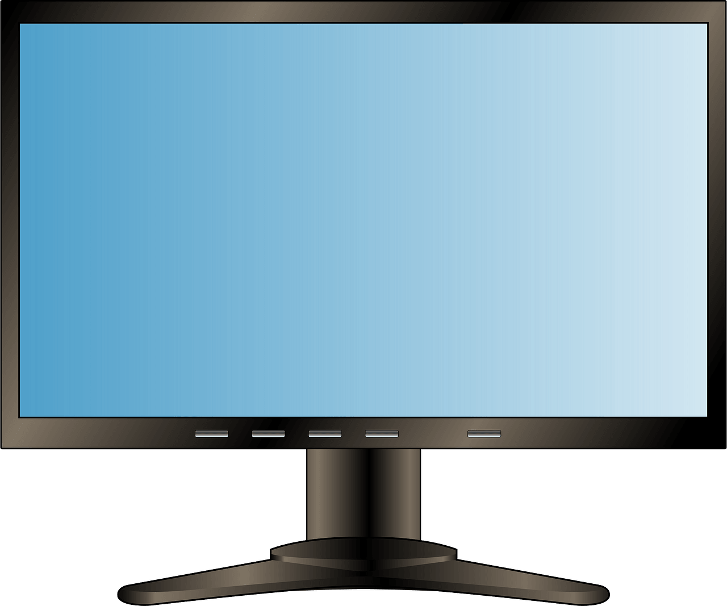

Tele….ision

Touri…t

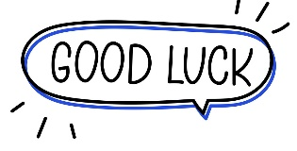

Your teacher:


Kingdom of Saudi Arabia
Ministry of Education
………… Education Directorate............
…………..……………….. Intermediate School

Total
المجموع | تحريري | شفهي
20 | 10 | 10

Second Period Exam
First Intermediate Grade

Name ………………………………… Class ………………………………
__________________________________________________________________________________________
/ 2
Comprehension

Read the following then answer the questions:

My house is where my family lives. It is white. It is big. There are four bedrooms. We have a kitchen and three bathrooms. Our family room is where we like to watch television together. When people come over, we eat in the dining room. We have a playroom in the basement. We have a swing in the backyard.
I love my house.
A- Put (√ ) for true or ( ᵡ ) for false :

( ) | 1. My house is big.
( ) | 2. There are two bathrooms.

B- Choose the right answer:

blue | green | white | red | 1-The house is ______.
swing | ball | garage | tree | 2- We have a ______ in the backyard.
_________________________________________________________________
/ 2.5
Grammar

Choose the right answer:

1- _______ you from Saudi Arabia ? Yes, I am .
A. Is B. Have C. Are D. Do
2 - She _______ a sister .
A. have B. has C. do D. does
3 - _____ ____ four people at the table .
A. There is B. There are C. There isn't D. Is there
4 - She lives ______ Riyadh .
A. in B. on C. at D. under
5 - They have three_____ .
A. child B. childs C. children D. boy

/ 2
Vocabulary

A- Choose the best answer to fill in the blank:
1. What is your ________ ? I am Chinese.
D. country | C. city | B. nationality | A. address
2. I come from a big ______ . I have three sisters and four brothers.
D. garden | C. house | B. car | A. family
3- The ______ is in the garage.
D. stove | C. motorcycle | B. shower | A. tree
4- ________ A place to take exercise.
D. Gym | C. Supermarket | B. Street | A. School
B- Put the right word under its picture:
 |  |  | 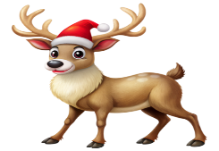 | 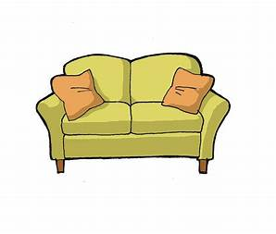
/ 2.5
reindeer - rug - child - sofa - turn right

_______________________________________________________________________________
/ 1
Orthography

Choose the correct letter:
r | c | n | 1. Mr. Ali works in a ba__k .
u | o | e | 2. She was looking at herself in the mirr__r.

Good luck T.


Kingdom of Saudi Arabia Name: ……………………………
Ministry of education Class: 1st Intermediate Grade
10 /
………. Intermediate School Second Exam - 1447 First Term
- Grammar:
- Choose:
- There (am – is – are) four chairs in the kitchen.
- Hanan (have – has – am) a big house.
- Lama is an Omani student. She is (from – in – on) Oman.
- This is (Amal – Amal’s – Amals’) book.

- Do as shown between brackets:
- Are you from India? (Answer the question)
…………………………………………………………
- That man (Write the plural)
…………………………………………………………

- Vocabulary:
- Write the words under the pictures:
world – tourist – grandparents – rug – sink



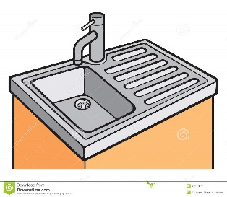

_____________ _______________ ________________ ______________

- Classify the words:
sister – shower – uncle – stove

Kitchen | Bathroom | Female members in the family | Male members in the family

- Orthography:
- Fill in the missing letters:
- These new shoes are not com__ortable to wear.
- Faten married her hus__and Hamed in 1998.
- The students go to their school by b__s.
- My e__ail address is on my business card.

Good Luck
Ms. Tahani Al-Ghamdi

