English Language
Mega Goal 1.3
1st Secondary Grade
Time: 0:45 minutes
Kingdom of Saudi Arabia
Ministry of Education
…………………………….. Education Directorate
……………………………………. Secondary School



English Language Midterm Exam Form of the Year 1444 AH – 3rd Semester/1st Session/Pathway System

Name: …………………………………………………………………………………………………..……… . Class: ……………………… .

10

Units 1-3

2

1. Guided Composition

Consider the following pictures. Then, speculate what happened using "can't/must/maybe".
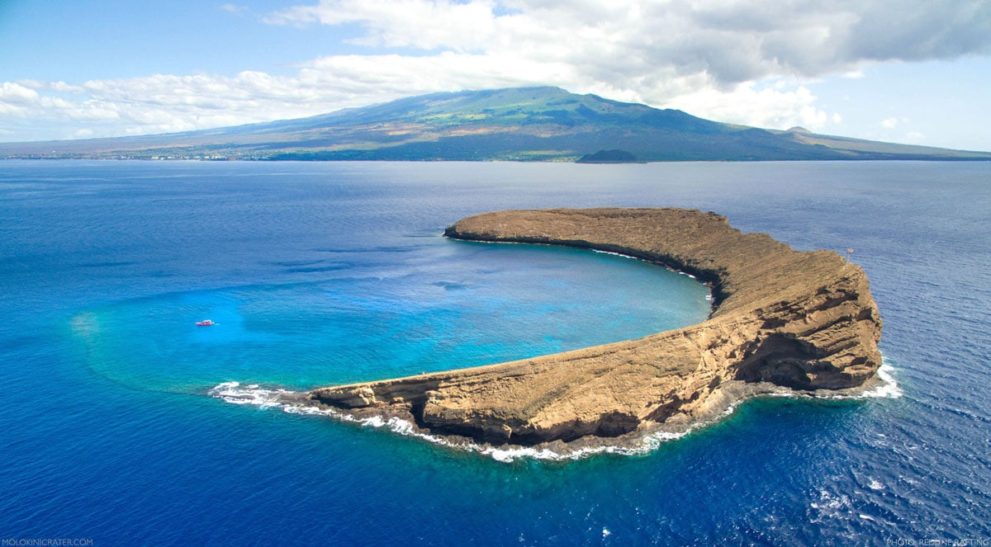
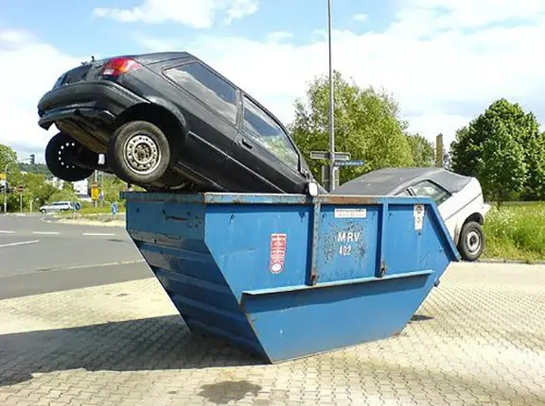

1
Please turn the page over

2
3. Reading Comprehension

Read the following passage. Then, answer the given questions:
Teenage is a very important stage in human life. It is full of stress. There are many things that make teenagers feel stressed and cause teenage stress.
What is stress?
Stress is the mental and physical strain or the nonspecific response of the body to any demand made upon it. Stress is a chemical reaction that takes place inside the body when there is a basic need to adapt to or resist changing internal or external influences. It is a response meant to return the body and mind to a state of equilibrium and balance.

1. This passage is about …
□ how to send email
□ teenage stress
□ new recipe

2. The main idea of the passage is …
□ working hard
□ calling for help
□ definition of stress

3. Stress is a chemical reaction that occurs inside the body, isn't it?
□ Yes, it is.
□ No, it isn't.

4. Stress results from adapting to or resisting changing internal influences, only.
□ True
□ False

5. On line (4), the adjective " mental " relates to ……………… .
□ body
□ mind
□ soul

6. The pronoun "It" on line (5) refers to …………………. .
□ stress
□ the body
□ teenage stage

2
Please turn the page over

3
3. Grammar
A). Tike the correct answer:
1. That period of history was ……………… fascinating!
□ bit
□ very
□ little
□ absolutely

2. Turn off your cell phone and enjoy ……………… on the beach.
□ sit
□ sits
□ sitting
□ doesn't sit

3. The whole city was destroyed by the hurricane, ……………… the citizens moved to another place.
□ or
□ so
□ and
□ but

4. Could you ……………… this form, please?
□ fill in
□ to fill in
□ filled in
□ filling in

B). Underline the correct verb:

 | Hind hasn't contacted her relatives ………….. Monday. She called them ………….. night.
 | A. [ in – since – for ] |  | B. [ on – ago – last ]

C). Highlight the correct answer:

1. | If Rana ………………… faster, she will finish sooner.
A. | write | B. | wrote | C. | written | D. | writes
2. | You needn't worry. The police have ………………… found the lost child. Listen to the live news!
A. | yet | B. | just | C. | already | D. | still

D). Choose the correct option:

1. | The button on the shirt is (A). It needs to (B). I want to (C) it (D).
A. | go  gone | B. | sewed  be sewn | C. | has  have | D. | repair  repaired
2. | I shouldn't (A) at the park longer. If I (B) earlier, I could (C) lunch before you (D) home.
A. | stayed  have stayed | B. | leaves  had left | C. | had prepared  have prepared | D. | arrived  arriving
3

Please turn the page over
1
1

3
4. Vocabulary

1. Fill in the blanks with the correct words:

urban –– states –– scratched DVD –– asset –– Excuse me
- The new invention will be a great …………………………………………………….…….. to our country.
- Telecommunications will be updated in …………………………………………………….…….. and rural areas.
- Murphy's Law …………………………………………………….…….. : If anything can go wrong, it might go wrong!".
- …………………………………………………….……. . What's going on?

2. Replace the underlined words with the correct synonym:

seems to be –– constantly checking –– lasting –– far away –– sleeves

Sentence | Synonym
a). My house is in a remote district.
b). You don't have a boss breathing down your neck.
c). We need a sustainable energy and a secure environment.
d). What a dress! It sounds like one of Donna Karan's creation.

3. Match each expression from column (A) with what fits (as a meaning) in column (B):

A |  | B
1 | That noise at the kitchen maybe from a dripping faucet or a leaky pipe! You never know. | ( ) | Plan activities.
1 |  | ( ) | Anything is possible.
1 |  | ( ) | What to be aware of.
1 |  | ( ) | Self-esteem is a real need.
2 | I want to go get a job and go out into the world. | ( ) | Having no idea.
2 | I want to go get a job and go out into the world. | ( ) | Share and share alike.
2 | I want to go get a job and go out into the world. | ( ) | 'd rather have a refund.
2 | I want to go get a job and go out into the world. | ( ) | Start to be on my own and independent.

Questions Over

With best wishes,
Nourah Abdul Aziz
4

Grade 10th
Mid-Term Exam / Third semester
Student's Name:…………………………………………………………………………….. Class: …………………… Subject: English

A) Fill in the gaps with the correct word / preposition:
0.5 each

us them me can’t must might

1. I’m going to be at home tonight. Please call _______________.
2. We want to come to your graduation. Don’t forget _______________.
3. I don’t want to ask my neighbors. I don’t know _______________.
4. You haven’t eaten all day. You ____________ be starving.
5. Pat’s joking. She ____________ be serious.
6. I’m not sure of the way there. Let’s ask my father. He _________ drive us there.

B) Rewrite the following sentences. Do as shown in parentheses.
0.5 each

1. It could be a helicopter. It could be a plane. ( Use: or )
_______________________________________________________________________________________

2. I don’t like guessing. I will wait for the facts. ( Use: so )
_______________________________________________________________________________________

3. she / clean / can’t stand / the house ( Use gerunds )
_______________________________________________________________________________________

4. my / to call / need / I / friends ( Unscramble the sentence )
_______________________________________________________________________________________

C) Choose the correct verb for each sentence.

1. I felt much better after I _________ the results of my test.
0.5 each
a. saw b. has seen c. had seen
2. It had been raining, but by the time we _________, the rain had stopped.
a. arrives b. arrived c. had arrived
3. I have never travelled outside my country until I ___________ to
Disney World last summer.
a. had gone b. gone c. went
4. When you heat water to 100 degrees Celsius, it___________.
a. boiled b. boiling c. boils
5. If you see a “falling star,” it ____________ a meteorite.
a. might b. will c. must

6. We’re ……………… the rooms decorated.
a. have b. get c. getting
7. The car seats need to be.
a. fixed b. fixes c. fix
8. ………………… he taken out the garbage?
a. Have b. Does c. Has
9. I don’t enjoy ………………… in the sun.
a. sit b. sitting c. to sit
10. I’ve ………………… done them.
a. yet b. ever c. already
Total Score _____/ 10

The End
By/ {Mr. Mohamed Salah}
Best wishes
Kingdom of Saudi Arabia
Ministry of Education
8th Secondary School in Qatif

Mega Goal 1.3 English Language
Units 1 + 2
_____________________________________________________________________________________
Name :………………………………………………. class: ………….
Read the following passage then answer the questions :
Ana was born in England . But when she was two years , her father traveled to Spain and she grew up in Madrid . Her grandfather had a big garden . He grew flowers , fruit and vegetables . He sold them in the market . He worked hard all his life and when he died , his son “ Ana’s father “ took his house and garden . Ana’s father did not have any more children , so Ana is the only child .
A-Questions:
1-Where did Ana grow up?
…………………………………………………………………………………………
2-Was Ana born in America?
…………………………………………………………………………………………
B- Put ( √ ) or ( × ):
1-Ana’s grandfather traveled to Spain( )
2-Ana’s father worked hard all his life( )
B-Choose the correct answer:
1-I haven’t eaten at that restaurant ( already _ just _ yet _ as soon as )
2-he fixed the ( crashes _ crash _ crashing _ crashed ) computer.
3-has he ( drives _ drive _ driven _ drove ) the car ?
4-the rooms ( need _ needs _ needed _ needing ) to be cleaned.
C-Do as shown between brackets:
1-she can be his mother. She is too young ……………………….. ( Correct )
2-if you freeze water, it turn into ice. ………………………. ( Correct )
3-He didn’t want to walk in the rain. He took a taxi.
( Combine into one )
………………………………………………………………………………………………….
D-Fill in the spaces with suitable word:
( serve _ debris _ dynamic )
1-the kingdom is honored to welcome and ………………….an increasing number of pilgrims and visitors.
2-he seemed a ……………………… and energetic leader.
E-Match the words with the meanings:
1-crashed ( ) shredded
2-flithy ( ) event
3-episode ( ) broken
4-torn ( ) very dirty

Good Luck
English Language  1st Secondary Grade, 1444  Quiz 3 , 3rd Term  Mega Goal 1.3 | الإجابة في ورقة التظليل الخارجية | Kingdom of Saudi Arabia  Ministry of Education  1st Secondary School  نموذج  Taif . (A)
Mark: | Class | Name
- Composition
“Stress is a chemical reaction that takes place inside the body when there is a basic need to adapt to or resist changing internal or external influences.” Write two or more important things that cause stress in your peers. Give some advice for handling these things in at least 50 words.
………………………………………………………………………………………………………………………………………………………………………………………………………………………………………………………………………………………………………………………………………………………………………………………………………………………………………………………………………………………………………………………………………………………………………………………………………………………………………………………………………………………………………………………………………………………………………………………………………………………………………………………………………………………………………………………………………………………………………………………………………………………………………………………………………………………………………………………………………………………………………………………
- Choose the correct form of the verb :
3. Grammar

- Do you want to order pizza , ………Should I make spaghetti?
- and | - but | - or | - so
- If they study hard, they ........... the exam.
- pass | - passed | - had passed | - will pass
- He might have …………. to the work.
- go | b. gone | c. goes | d. going
- I ……………. my breakfast before I went to school.
a. had eaten | b. eat | c. eats | d. eating

يتبع

4. Vocabulary
- Match the word in (A) with its meaning in (B) :

A |  | B
1. contribute |  | a. a space rock falls to Earth
2. rural |  | b. Play a significant part
3. meteorite |  | c. make it simpler
4. streamlined |  | d. in countryside
 |  | e. anything is possible

- Choose the correct word under each Picture:

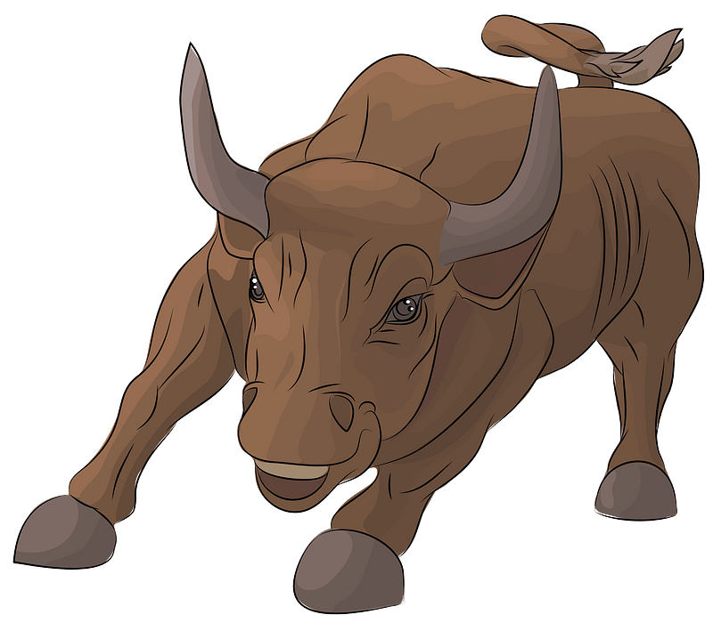  1. | 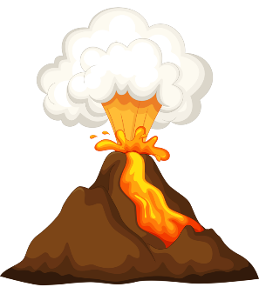  2.
a. bull | a. Gee!
b. train | b. journal
c. tornado | c. volcano
d. debris | d. sector

☺The End ☺

انتهت الأسئلة

