
Kingdom of Saudi Arabia 3rd Intermediate Grade
Ministry of Education Time: An hour and a half
Hefar Intermediate & Secondary School Number of papers: 3
Final Exam – Second Term - 1445 AH
- Guided Composition:

6
Use the following word bank to write a paragraph about Driving Safety Tips.
Word bank: (thousands – killed – injured – accidents – prevent – fast – follow)
________________________
___________________________________________________________________________________________________________________________________________________________________________________________________________________________________________________________________________________________________________________________________________________________________________________________________________________________________________________________________________________________________________________________________
- Reading Comprehension:
6
Read the passage and answer the questions below:
The little village in which I live is only about hundred meters away from the sea. About one thousand people live in my village. They are poor but they are very kind and honest. Most of the villagers are farmers. They grow fruit and vegetables. My school is near my house, and I can walk. There isn’t any supermarket, but there are many stores where we can buy anything we need. We have a stadium where my football club plays every Sunday. I go there to watch them with my dad. I love my village very much.
Hi my name is Adam. I live with my family in a
big house. I have two sisters and one brother.
We share many chores with our parents. My
brother and I take the garbage out.
We also wash our father’s car twice a week. Every Friday, I
weed the garden and my brother waters the plants. I also
make my bed in the morning. My sister, Emily, sweeps the
floor every evening and washes the dishes after dinner. She
also helps Mom with shopping every Thursday. My mother
cooks for us and washes our clothes. My father fixes
anything broken at home.
Hi my name is Adam. I live with my family in a
big house. I have two sisters and one brother.
We share many chores with our parents. My
brother and I take the garbage out.
We also wash our father’s car twice a week. Every Friday, I
weed the garden and my brother waters the plants. I also
make my bed in the morning. My sister, Emily, sweeps the
floor every evening and washes the dishes after dinner. She
also helps Mom with shopping every Thursday. My mother
cooks for us and washes our clothes. My father fixes
anything broken at home.
- Choose the correct answer:
- The village is ……….. meters away from the sea.
- 10 | - 100 | - 1000 | - 10000
- Poor in line 2 means someone who doesn’t have ………
- children | - parents | - money | - cars
- Most of the people there work as …………..
- teachers | - doctors | - players | - farmers
- The writer goes to school ………….
- by car | - by bike | - on foot | - by bus
- The football team play on ……………….
- Sunday | - Monday | - Tuesday | - Friday
- The writer goes to the stadium with his …………..
- brother | - friends | - father | - cousins

- Grammar:

7
- Choose the correct answer:
- Faten ………… English yesterday.
- study | - studies | - studied | - has studied
- Bayan has taught Chinese ……….. she was 22.
- for | - since | - yet | - ever
- Sara is ……….. than Hind.
- tall | - taller | - tallest | - more tall
- ……….. sun rises in the east and sets in the west.
- A | - An | - The | - Ø
- The Ferrari is the …………car.
- expensive | - expensiver | - expensivest | - most expensive
- Samar didn’t buy the toys, ………..?
- didn’t she | - do she | - did she | - does she
- Reema is a doctor, …………?
- is she | - does she | - isn’t she | - doesn’t she
- Ali …………. skate better when he was 12.
- be able to | - was able to | - were able to | - was to
- Let’s ………… a film.
- watch | - watches | - watching | - watched
- Faten is a good writer. She writes ………….
- good | - goodly | - well | - will

- Do as shown between brackets:
- When does the shop open? (Make indirect question)
……………………………………………………….
- (Complete the sentences with must or mustn’t)
- You ………………. cheat.
- You ………………. obey your parents.

- Vocabulary:

7
- Write the words under the pictures:
ignition – teapot – pliers – printer – bridge





_____________ ______________ _____________ ______________
- Choose the correct answer to fill in the blank in each question:
- He was arrested for driving without ……………..
- horn | - license | - windshield | - gas tank
- We need a ……….. to cut the grass.
- lawn mower | - spoon | - saw | - knife
- People can ………. things to make life easy.
- swim | - climb | - play | - invent

4
- Orthography:
- Choose the correct missing letters:
- I always carry a por__able computer with me.
- b | - d | - p | - t
- They live in a hu__e house.
- g | - j | - d | - k
- The room was warm and c__zy.
- r | - o | - u | - w
- The little village has very n__rrow streets.
- a | - e | - i | - o
- She is sweeping with a b__oom.
- l | - r | - u | - n
- We use a f__rk to eat food.
- a | - u | - o | - w
- I looked at myself in the rea__view mirror.
- l | - r | - v | - d
- The car needs a new headl__ght.
- a | - e | - y | - i
END OF QUESTIONS
BEST OF LUCK
Ms. Tahani AlGhamdi
المملكة العربية السعودية  وزارة التعليم  إدارة تعليم  مكتب تعليم  مدرسة |  | اختبار مادة اللغة الإنجليزية  الصف الثالث المتوسط  الفصل الدراسي الثاني  التاريخ  الزمن

المعلم/ة | التوقيع | المراجعـ/ة | التوقيع

السؤال الأول | السؤال الثاني | السؤال الثالث | السؤال الرابع | السؤال الخامس | المجموع كتابة | المجموع رقما
6 | 6 | 7 | 7 | 4

اسم الطالب : |  | الصف : |  | رقم الجلوس :
استعن بالله
Total : 6 /

1. Composition

Write about your city/town , and what you think the aims should be to improve it

…………………………………………………………………………………………………………………………………………………………………………………………………………………………………………………………………………………………………………………………………………………………………………………………………………………………………………………………………………………………………………………………………………………………………………………………………………………………………………………………………………………………………………………………………………………………………………

2. Comprehension

Read the text and answer the questions. Choose the best answer to each question.

The Ballpoint Pen
Ballpoint pens have not been around for very long. John Loud invented the first ballpoint pen in 1888. Before the invention of ballpoint pens, people had to dip their pens into ink when they were writing. This made writing slow. Also, sometimes too much ink made the writing messy. Ballpoint pens were the first pens that did not need to be dipped in ink. Laud’s invention was wonderful, but the design was still not perfect. Sometimes the pen did not get enough ink, and sometimes it got too much ink. Other inventors continued to work on the design of the ballpoint pen to improve it. For the next 30 years, inventors created over 350 kinds of ballpoint pens. But still the pens did not work very well, and people did not buy them. It wasn’t until 1935 that Ladislaw Biro and his brother developed an improved ballpoint pen in Hungary. Today, in the U.K. and Australia, some people call ballpoint pens biros after their inventor.
PTO
A. Choose the correct answer :

1. Ballpoint pens have been around since _____.
A. 1800 B. 1888 C. 1910 D. 1935
2. _______ invented the first ballpoint pen
A. John Loud B. John Lowie C. Luke James D. Dan Loud
3. Before ballpoint pens, writers had to _____.
A. use their fingers B. dip pens into water C. dip pens into ink D. use pencils
4. Ldislaw Biro and his brother developed an improved ballpoint pen in _____.
A. Hungary B. Spain C. Australia D. America
5. Some British people call ballpoint pens _____.
A. louds B. pencils C. inks D. biros
6. People have been using ballpoint pens for _____.
A. over 100 years B. less than 100 years C. 1888 D. 1935

B. What were the problems with Loud’s invention ?
- ……………………………………………………………………………………………
- ……………………………………………………………………………………………
C. How many kinds of ballpoint pens were invented ?
………………………………………………………………………
D. When did Ldislaw Biro and his brother developed an improved ballpoint pen ?
………………………………………………………………………
Total : 6 /

3. Grammar
A. Choose the best answer to fill in the blank.

1. The newest laptops are _____.
A. clumsy B. light C. huge D. conventional
2. The first computer was _____.
A. light B. fast C. conventional D. huge
3. We _____ friends since first grade.
A. has been B. have been C. been D. being
4. They _____ on the phone for two weeks.
A. not has talked B. not have talked C. hasn’t talked D. haven’t talked

B. Write for or since to fill in the blank.

1. I have had my new car …………… September.
2. He has been studying Arabic …………… six months.
3. They have played tennis together …………… five years.
4. We haven’t gone to the beach …………… last summer.
PTO
C. Write the correct form of the adjective in parentheses to fill in the blank.

1. Our town has the …………… water of all the towns in this area. (clean)
2. Traffic in big cities is …………… than it is in smaller towns. (bad)

D. Complete the tag question.

1. He bought a hammer, …………………. ?
6. She didn’t go to school, …………………. ?

E. Write the adverb of manner to fill in the blank.

1. Stan is a slow runner. He runs ……………
2. Ali is a good writer. He writes ……………

4. Vocabulary
A. Match a term in Column 1 with a description in Column 2.

Column 1 |  | Column 2
1. digital |  | A. phone .
2. cellular . |  | B. camera
3. laptop . |  | C. printer .
4. high-tech . |  | D. computer .

B. Choose the best answer to fill in the blank.

1. _____ are green areas.
A. Buildings B. Roads C. Parking lots D. Parks
2. An apartment is a type of _____.
A. recreation B. transportation C. housing D. hospital
3. dash _____
A. shield B. sign C. wheel D. board
4. road _____
A. belt B. sign C. wheel D. mirror
5. What do you use to climb a wall?
A. a ladder B. a bike C. a hammer D. a stove
6. What do you use to water the garden?
A. a garage B. a plate C. a hose D. a spoon
7. What do you use to clean the living room?
A. a ladder B. a sofa C. a vacuum cleaner D. a hose
8. What do you use to sweep the backyard?
A. a spoon B. a broom C. a bike D. a fork
PTO
C. Match :
Stove – teapot – danger – camera

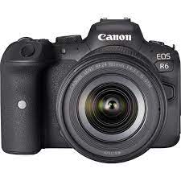 | 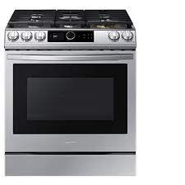 | 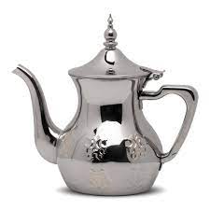 | 

Total : 7 /

5. Orthography

Complete the missing letters :
Total : 4 /

c__mp__ters T__levi__ions

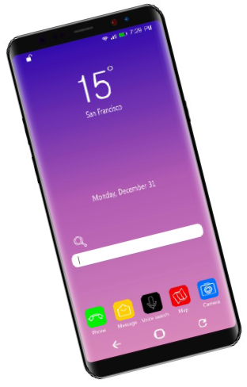 ce__l p__ones 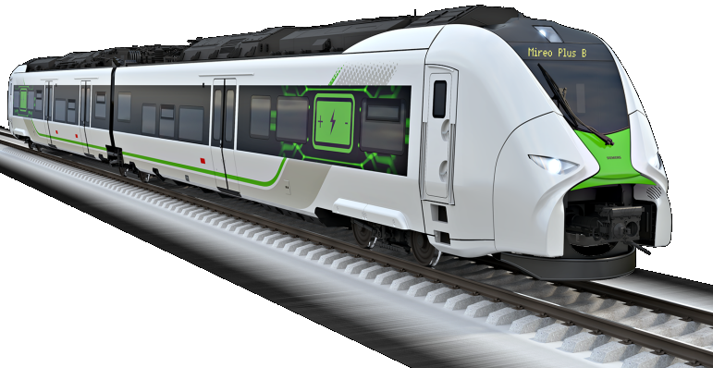 Tr__in

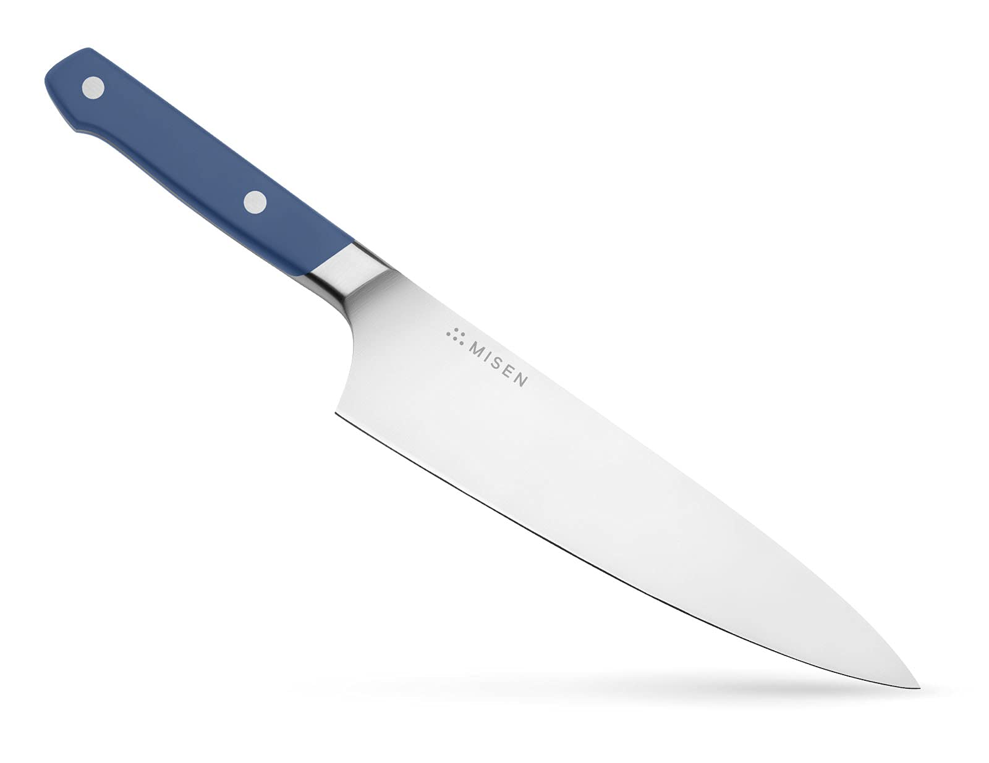 __nife  Fo__k
Sp__ed L__mit N__ pas__ing

Best of luck

Kingdom of Saudi Arabia Ministry of Education
English Language Third Intermediate Grade

Bisha Education Directorate
Khaibaral Al-janob Intermediate School
2nd
Term Exam 1443 -1444
Time: 2 hours


اختبار مادة اللغة الإنجليزية الصف ثالث متوسط الفصل الدراسي الثاني 1444هـ

Name/ ……………………………………… | Class / …………… A- B- C | Seat No./ ……………………………

Number | Question |  | Student’s Mark Number
Number | Question | Mark | Student’s Mark Number
Q1 | Composition | 6
Q2 | Reading Comprehension | 6
Q3 | Grammar | 7
Q4 | Vocabulary | 7
Q5 | Orthography | 4
Total Written Tasks |  | 30

Corrected by | Name
Revised by | Name

1 / Q Composition
6
A)-. Read the following paragraph below, then choose correct
Completion:
English - Style – language- Expand –class- making
English is an international (1)……….. To improve your English, you need to find out you learning (2)………….... Speak a little (3)………….. every day. Attend an English (4) ……..…..or discussion group. (5)…….…your vocabulary. (6)…………new friends.

6
Q2 - Reading Comprehension
\
Read the following passage and choose the correct answer below:
Daniel is a very social person. He is intelligent, but sometimes he has too many things to do at one time. For example, next week he has extra football practice, he has to volunteer at the youth Center, and he wants to hang out with his friends and go skiing. He also has a history Test on Monday. He needs to get a good grade on test .He likes to fit in tennis with his friends .Playing sports Is important, too. Also, he needs to focus on studying more.
- Which kind of person is Daniel? He is a very………………… person
a – social b- bad c- angry

- He is …
a – sad b- intelligent c- crazy

- He has a history test on .......................
a- Saturday b- Monday c- Friday

- He likes to fit in with his ………………….
a- football b- tennis c- basketball

- He needs to get a good grade on ………………..
a- game b- test c- exercise

- he needs to focus on more
a- English b- studying c- exercis
7
1- You were born in Abha, …………….
[ a – were not you b- are you c- is he ]

2- I was not able …………to the park
[ a – comes b- come c- coming ]

3- Why do not we ……….. a pizza
[ a – order b- orders c- ordering ]

4- You should ……….under the speed limit

[ a – drive b- drives c- driving]

5- Hameed has had tv. ……. 16 years

[ a – yet b- since c- for ]

6- In Japan, trains are as …….. as plans
[ a- expensive b- more expensive c- older ]
7- She walked ………

[ a – quickly b- near c- next ]

Q3 – Grammar

Choose the correct answer

7
Q4- Vocabulary
- Match the following words in a correct way:
Genes from generation to another |  | 1- Triplet
Child who has lost his parent . |  | 2- coincidence
3 baby born at the same time |  | 3- Orphan
By chance |  | 4-heredity

- Put the correct word under its picture:
Camera – Television – Spoon – Lap top

 | 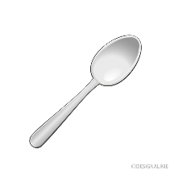 | 

1-…………. 2-……………. 3-…………

4
Q5- Orthography “Spelling”
Choose the missing letters:

4
1-This is a new pri…er | a-( ut ) | b-( nt ) | c-( tm )
2-I bought a l…pto… | a-( e - o) | b-( a-p ) | c-( u)
3-Use a gar…ge can, please | a-( eb ) | b-( ba) | c-( si )
4-I like this te….y bear. | a-( dd ) | b-( da ) | c-( k )

GOODLUCK
T.Asma Alshehri

