
English Language
elementary Grade …..
period Exam
…………….\20
Kingdom of Saudi Arabia
Ministry of Education
……..Education Directorate
………………… School
Student's Name : class:


……\ 4 marks

General questions

A. Answer the questions
I play hide and seek. |  | What do you like to do for fun? | 1
No, she didn't. |  | Can you run quickly? | 2
Yes, I can. |  | Did she finish the story? | 3
I like to read a storybook. |  | What after-school activities do you do? | 4

Controlled Writing
……\ 1 marks
A-reorder.
1-your / Did / call /you / ? / friends
………………………………………………………………………………………………..

……\ 4 marks

Reading short sentence
 | 1- She watered the flowers every day ( )
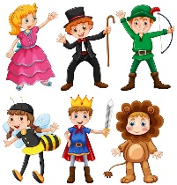 | 2- Nasser loves dressing up ( )
A-Put ( ✔ ) or ( X )
B. Choose the correct answer
c-swim | b-drive | a-score | 1- Soccer players ……………..goals.
c-plant | b- blindfolded | a-inside | 2- When you aren’t outside, you are …………

……\ 4 marks

Grammar
A-Choose the correct answer.
1- What( did – does – doing ) you do yesterday?
2- I didn't ( watered – watering – water ) the plants
3- My dad (fix – fixed – fixes ) my computer last week.
4- We ( plant – planted- plants ) flowers last weekend.

Vocabulary
……\ 5 marks
A.write the correct word under each picture
( mouse - loudly - cry - texting – hose )
)

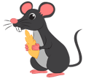 | 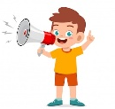 |  |  | 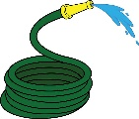
Orthography
……\ 2 marks

A. Fill in the missing letters.

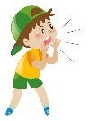

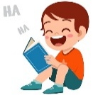


1- ….ream
( d – i – s )
4-s…out
( h – c - j )
3-hap…ily
( z – w - p )
2- fun…y
( x – p - n )

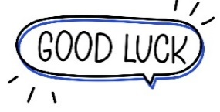

Your teacher …..:…………………………….


Kingdom of Saudi Arabia 4th, 5th & 6th Elementary Grade
Ministry of Education Second Term

20
………….. Elementary School . . Mid-Term Exam 1446 AH
Name: ………………………………………………………….………………. Class: …………..
- General Questions:
- Choose the correct answer:
1- What do you like to do for fun?
a- I like to climb the tress. |  |  |  |  | b- Snow White story
2- Did he go to school yesterday?
a- Yes, I did. |  |  |  |  | b- Yes, he did.
- Controlled Writing:
- Rearrange the words to form a sentence:
is |  | A girl |  |  | TV |  |  |  |  | watching
- Reading short sentence:
- Read the sentences then match them with the correct pictures:
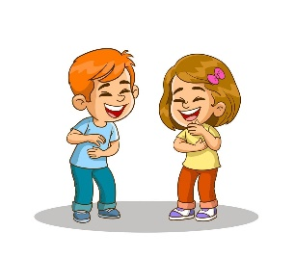 | a-_They laugh.  b-_They cry.
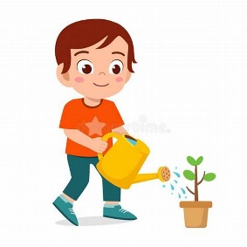 | a-_He e-mailed his friend.  b-_He watered the plants.
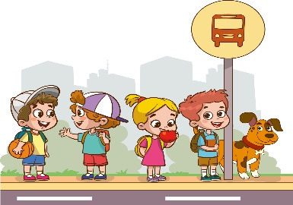 | a-_They wait for the bus.  b-_They play soccer.

- Grammar:
- Choose the correct answer:
- She ………… a goal in the game yesterday.
- score |  |  |  | - scores |  |  |  | - scored
- He didn’t ………… his bike.
- fix |  |  |  | - fixes |  |  |  | - fixed
- ………… she invite her friend last Monday?
- Do |  |  |  | - Does |  |  |  | - Did
- The past form of the verb: study
- studyed |  |  |  | - studyied |  |  |  | - studied
- Vocabulary:
- Choose the correct answer:
 |  | 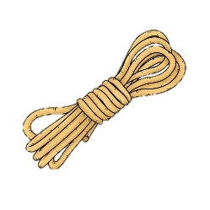 |  |  | 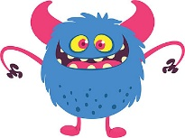 |  |  |  |  | 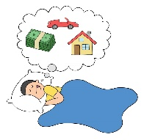
- prefer  - clap |  | - story  - rope |  |  | - monster  - poem |  | - writer  - tree |  |  | - dream  - carry
- Orthography:
- Choose the correct missing letters:
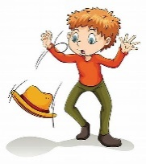  d__op |  |   r__b |  |  | 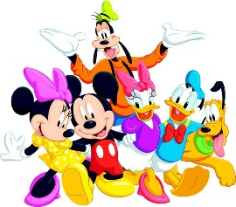  charac__er |  | 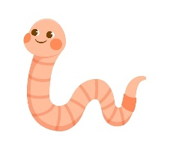  wo__m |  |  | 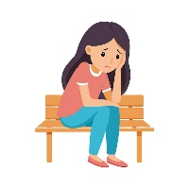  al__ne
e | r | o | u |  | k | t | r |  | a | o | u

BEST OF LUCK
Ms. Tahani Al-Ghamdi


Midterm Exam– Top Goal1

مدرسة:

الاسم ثلاثي: |  | الفصل | / | الدرجة | 20 /
__________________________________________________________________________________________
Choose the correct answer:
1– What do you like to do for fun?

A. I like to climb trees B. I like English..
2 – What after-school activity do you do ?

A. I play computer games. B. No, I am not .

____________________________________________________________________________________________________
Choose or :
I watch TV . | They go shopping | He planted flowers.
 |  | 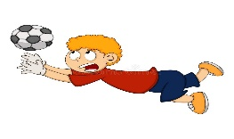

___________________________________________________________________________________________
1- your / Did / call / you / ? / friends ( Rearrange) ………………………………………………………………………………………
bag | bike | ball | 2 - He is riding his________ to school. (choose )
Do as shown between brackets :
Choose the correct word:
played | plays | play | 1- I ____ a soccer yesterday .
going | went | go | 2- I didn't _____ shopping.
Did | Does | Do | 1- ____ play a soccer yesterday?

Choose the correct word:

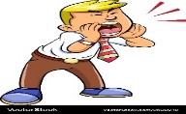 |  | 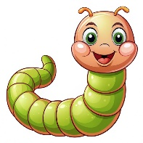 | 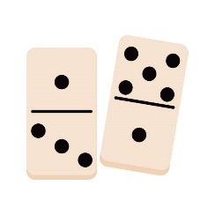 | 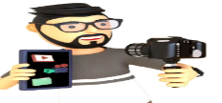 |   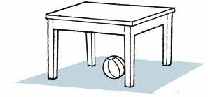
shout | sleep | rope | Dominos | vlogging | walking
jump | laugh | worm | Piano | running | reading
Choose the correct letter to fill in the blank:
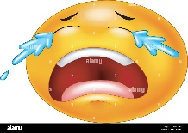 | 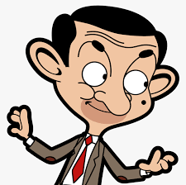 | 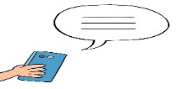 | 
_ry | funn_ | te_ting | Vi_eo games
b | e | x | d
c | y | c | n

Good luck T.
Controlled writing

4



