المملكة العربية السعودية |  | المادة: | اللغة الانجليزية (استماع)
وزارة التعليم |  | الصف | الرابع
الادارة العامة للتعليم بـــ |  | التاريخ: | / /1446 هـــ
مدرسة الابتدائية |  | الزمن: | نصـف ساعة
اختبار نهاية الفصل الدراسي الاول – الدور الأول للعام الدراسي 1446 هـ
5
اسم الطالب ___________________________________ الصف_______ رقم الجلوس_________

Listen and circle the correct answer:

- What does the girl do after school? |  |   1
 | She reads a book .
 | She plays with her brother.
 | She goes to the park with her sister.

- Norma loves to go to the beach with her_____ |  | 
 | granddaughter and grandsons
 | aunt and uncle
 | dad and mom
3
- Her brother is kind and ______ |  | 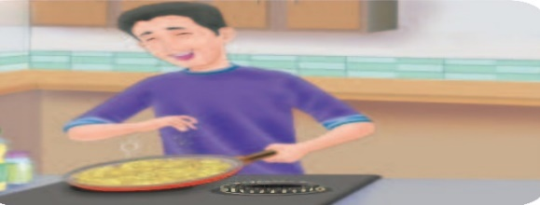
 | helpful
 | busy
 | naughty
4
- The man has big arms. He's _____ |  | 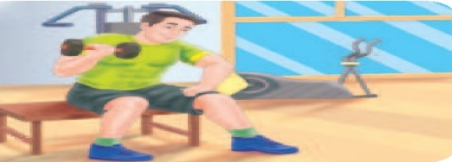  5
 | lazy
 | weak
 | strong

- The boy gets up every morning at : |  | 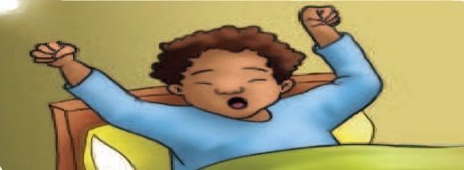
 | 6:30
 | 6:45
 | 6:00



رابط الاستماع

Audio Script:

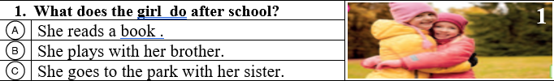
1



Boy: What do you do when you finish it?
Girl : It depends. I often play computer games or go to the park with my sister.

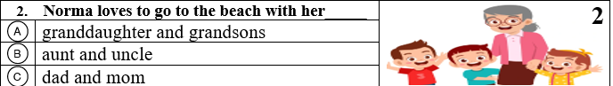
2

Interviewer: What about you, Norma? What do you like to do with your family?
Norma: I love to go to the beach with my granddaughter and grandsons

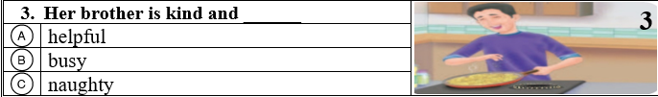
3

Boy: Do you have any brothers or sisters?
Girl : Yes, just one brother. He’s nice because he’s kind and helpful.
Boy : That’s nice!

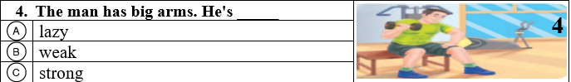
Boy: That man in the gym has big arms. He’s strong
4

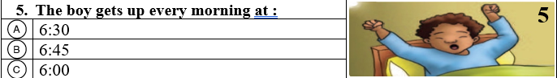
5

Boy1: Do you have a morning routine on school days?
Boy 2 : Yes, I do. I get up every morning at six o’clock

