English Language
Intermediate Grade 2nd
period Exam
Kingdom of Saudi Arabia
Ministry of Education
………..Education Directorate
………………… Intermediate School

Student's Name : class:

Reading comprehension ✦
……\ 5 marks
1-Read the following passage and answer the questions below:
Autumn is our favorite season. We enjoy the color of the leaves. It ranges from yellow to dark brown. The grey sky makes it all look like a beautiful painting. Today is Wednesday .It is hot and sunny in Saudi Arabia in June .I am sitting in the garden .My mother is in the kitchen .My brother is in the living –room .He is reading a book.

1-Autumn is a …………………………..
c- month | b- year | a- season
2-The leaves range from yellow to dark ……………
c- brown | b- blue | a- pink
3-Today is …………..
c- Wednesday | b-Sunday | a-Monday
4- It is hot and ………….. in Saudi Arabia
c-snowy | b- sunny | a- rainy
5- Mother is in the ……………………….
c- living room | b- park | a- kitchen
Grammar ✦
……\ 4 marks
A-Choose the correct answer:
1- They are going to ( play – played – plays ) bowling.
2- If it’s hot and humid, I don’t ( feel – feels – felt ) very active.
3-I will ( travel – traveling _ travels ) to Jeddah.
4- Imad is ( go – goes – going ) to climb a mountain.
5-If you heat the water to 100ْC , it( boil – boils – boiling ).
6- Omar drives ( slow – slows – slowly ).
7- How will he ( gets – getting -get) to work?
8- (what – where – who ) are they going to write to ?

B-Do as shown between brackets.
1-(correct)
a- Ali is goes to hang out with his friend. …………
b-if I am sick , I may stayed at home. …………….

2-(Give the negative)
a- It’ll be cold and snowy.
……………………………………………………………………………….

3-( use adverb of manner)
a- Asma is a good writer
…………………………………………………………………………………
4- (answer)
a-is he going to play tennis?
Yes,……..…………………………………………………………………….

……\ 4 marks

✦ Vocabulary
……\ 5 marks
A-Choose the correct answer.
1- Where are my sunglasses? It’s really(cloudy -snowy-sunny) today.
2-Jazan, in southwestern Saudi Arabia, is a (coastal - exciting -ancient ) city on the Red Sea.

B- Choose the correct word for each picture

oasis - cloudy - thunderstorm - noisy

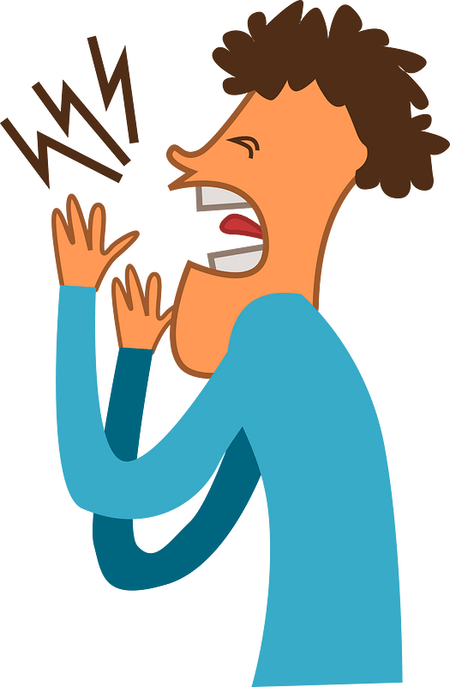
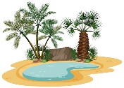
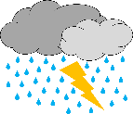

……………………
……………………
……………………
……………………
✦ Orthography
Choose the corre

……\ 2 marks
A-Choose the missing letter.
1- I’m aller….ic to shrimp. ( g – u – f )
2-It's ten degrees belo…. zero (-10). ( d – w – p )
3- What’s your favorite seaso… of the year? ( b – v – n )
4- The gui..e is going to show us around the site.( d -j – s)

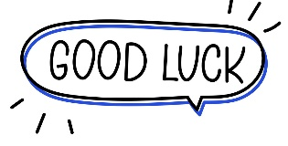
The end of the questions
Good luck
Your teacher ………………………
Your teacher:

Kingdom of Saudi Arabia
Ministry of Education
………… Education Directorate............
…………..……………….. Intermediate School

20
Total

Midterm Test units 12 & 13
Second Intermediate Grade

Name ………………………………… Class ………………………………
__________________________________________________________________________________________
/ 4
Comprehension

Read the following then answer the questions:

The winter months are December, January and, February. It's cold and rains in winter. We wear
heavy clothes in winter. The summer months are June, July and August. It's hot in summer. People wear light clothes. They go to the to the park or to the sea, some children like to play football and fly their kites.

A- Put (√ ) for true or ( ᵡ ) for false :

( ) | 1. The winter months are June , July and August .
( ) | 2. They go to the to the park or to the sea in summer.

B- Choose the right answer:

spring | autumn | winter | summer | 1- It is hot in _______.
jacket | clothes | glasses | shoes | 2- We wear light ____in summer.
_________________________________________________________________
/ 5
Grammar

Choose the right answer:

1- _____ old is Ali ?
D. Where | C. How | B. Who | A. When
2 - I am _________ travel to Jeddah next month .
D. going | C. going to | B. will | A. go
3 - Riyadh is _____ _____.
D. beautiful a city | C. a beautiful | B. a city beautiful | A. a beautiful city
4 - Maybe I_________ drive.
D. am going to | C. go | B. will | A. am going
5 . Jane: Will it be sunny tomorrow? Amira: No, ___ ____ .
D. it will | C. won't it | B. will it | A. it won't.

Vocabulary
/ 4

A- Choose the best answer to fill in the blank:
1. This place is ____. You can learn about traditions from around the world here.
D. unique | C. peaceful | B. exotic | A. cultural
2. This place is ____. It was built thousands of years ago .
D. modern | C. historical | B. adventurous | A. noisy
3- It’s __________ today. Hold on to your hat!
D. hot | C. cold | B. windy | A. funny
4- ______ is usually sunny, really hot, and very dry
D. cloud | C. summer | B. rain | A. winter
B- Put the right word under its picture:
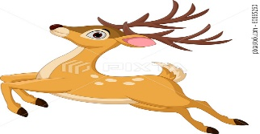 | 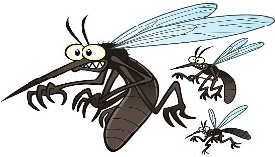 | 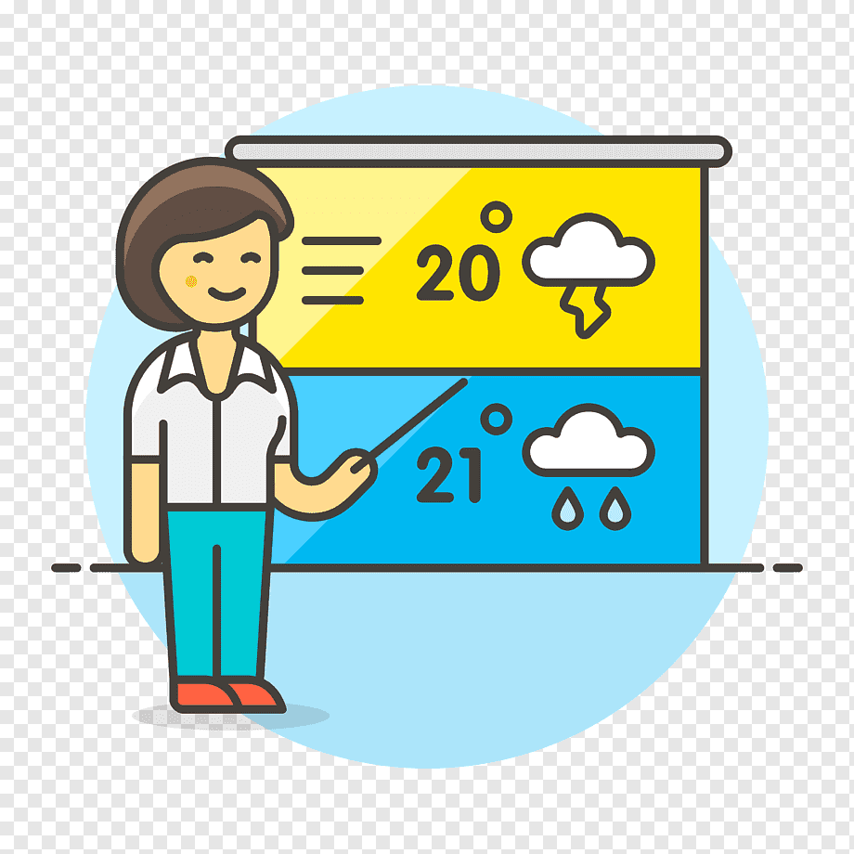 | 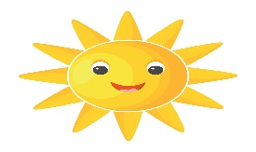
sunny , forecast , buck , mosquitoes
/ 4

_______________________________________________________________________________
/ 3
Orthography

Choose the correct letter:
g | s | v | 1. I live on an i__land .
r | t | d | 2. We’re staying in a comfortable ho__el .
n | h | m | 3. The cli__ate in the city of Jazan is very hot .

Good luck T.

Kingdom of Saudi Arabia
Ministry of Education
………… Education Directorate
……………….. Intermediate School

Super Goal 2 - Test unit 12 & 13
By Rashed Alsulami | Telegram: https://t.me/iRashed

Name :………………………………………………………………………… Class:…….……….

Comprehension
2 Marks
- Read the text and answer the questions. Write T or F at the end of each question/statement.
The best place to shop for a bargain is a yard sale. Many people in the U.S. have yard sales. They gather things from their home that they don’t use anymore and put them out in the front yard for other people to buy. You can buy almost anything at a yard sale, but there are usually clothes, appliances, toys, furniture, and DVDs. Usually these things are in good condition and the owner just doesn’t need them anymore. Items at a yard sale are usually very cheap, so you can get good bargains. Some people go to yard sales every week. They drive around neighborhoods every weekend looking for bargains. Sometimes they look for items that they can sell to someone for a higher price at their own yard sale!
- You can buy almost anything at a yard sale. ( )
- People sell things they don’t use anymore. ( )
- Yard sale items are usually expensive. ( )
- Yard sales are held in stores. ( )
Grammar

- Choose the best answer to fill in the blank in each question.
5 Marks
- Jeddah is__________________.
a. a beautiful city b. a city beautiful c. a beautiful d. beautiful a city
- They _________ going to go by plane.
a. isn’t b. are c. is d. am
- _______ is he going to leave ?
a. What b. Which c. When d. Who
- Jane: Will it be sunny tomorrow? Amira: No, ______________.____________________.
a. it won’t b. it will c. won’t it d. will it
- If the hurricane hits Florida, it _________ a lot of damage.
a. may causing b. causes c. might cause d. will causes
اقلب الصفحة

- Write the correct adverb to fill in the blank.
1.5 Marks
- My grandmother is a good cook. She cooks ____________________.
- Majid is a fast learner. He learns ______________.
- They have a peaceful life in the village. The people in the village live ____________.

- Use Information Questions ( How – Where – What ).

1.5 Marks
- _______________will you do in the summer? I’ll probably trave.
- ______________ will you go? I’ll go to Jordan.
- ______________will you go? Maybe I’ll drive.

Vocabulary
- Choose the best answer to fill in the blank in each question.
5 Marks
- This quiet beach is __________.
a. noisy b. relaxing c. adventurous d. expensive
- I go to this place to relax because it is ___________.
a. noisy b. cultural c. historical d. peaceful
- This place is ________. It was built thousands of years ago.
a. adventurous b. historical c. relaxing d. noisy
- It’s _______________ today. Hold on to your hat.
a. windy b. sunny c. cloudy d. snows
- It will be _______________ this afternoon. You should bring your umbrella.
a. windy b. cloudy c. rainy d. sunny

- Write the correct word under the picture.
3 Marks
Partly cloudy – Desert – Rainforest

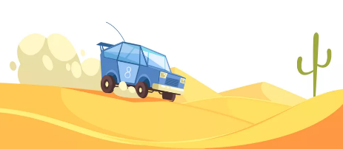
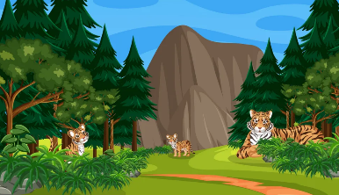
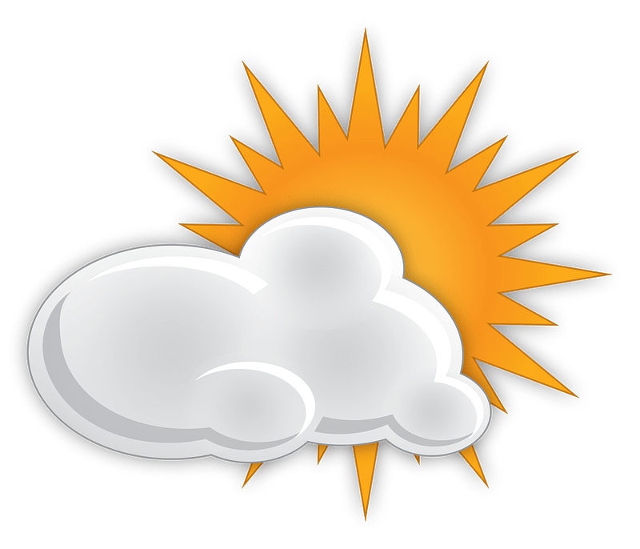

………………………………………….

………………………………………….

………………………………………….

Orthography
- Choose the correct letter.
2 Marks
- Are you going on va…..ation ? ( c – o – r )
- Spring is usually c….ol ( v – o – r )

انتهت الأسئلة....
التوفيق والنجاح دوماً في طريقكم أبنائي.. تذكروا دائماً بأنني فخور بكم فأنتم مستقبل هذا الوطن الغالي إن شاء الله ونجاحكم هو نجاحي..
الأستاذ / راشد السلمي

