- Name:…………………… Class:…….. Test: 1

General Questions
1. Match "A" with "B":
"A" |  | "B"
1. would you like to come in? |  |  | f-u-n
2. Where's Hashim? |  |  | Sure, here you go.
3. how do you spell fun? |  |  | He's in the living room.
4 Can I have some candy? |  |  | Yes, please.

Reading short sentences

. Read and put ( ) or ( X )2
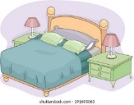
1. It's a wallet. [ ]
2. This is my bedroom. [ ]

3. Circle the odd word.
1. fox – cut - box – hot
2. sun - fun – run – ox
3. pen – cat – pencil - paper
4. cow - wallet – watch

Controlled writing
4. Do as shown between brackets.
________________________ |  |  | 1. my – is – This – house. (Rearrange )
snake | fox | ox | 2-This is an __________ ( choose )

Grammar
5. Choose the correct answer.
1. what is [ this – these – those ]?
2. They [ is - are – am] watches.
3. It's [ a - an – it ] wallet.
4. The mouse is [ on – in – under ] the chair.

Vocabulary
6. Choose the correct answer.
 | 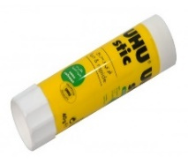 |  | 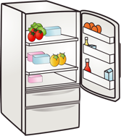
pen | glue | pen | fridge | bedroom
pencil | eraser | scissors | table | kitchen

Orthography (spelling)
7. Fill in the missing letters with: [ sp – fr – sm – ou ]
 |  | 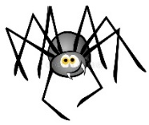
_ _ ies | cl_ _ d | _ _ ider | _ _ ile
Good Luck
Tr. Dalal Alotaibi

