اسم الطالب/ة : ................................................ الفصل: .......................
نموذج اجابه
6
I- General Questions:
A- Match the questions in column (A) with the correct answers in column (B):
B | A
( 4 ) He is a doctor.  ( 1 ) I cooked breakfast.  ( 3 ) I made a rocket  ( 2 ) 2 cups of flour  ( 6 )I want to be a teacher  ( 5 ) I usually go to bed at 9:00 | 1- What did you do over the weekend?  2- How much flour do we need ?  3-What good things happened to you last year ?  4- What does your dad do ?  5- What time do you go to bed ?  6- What do you want to be when you grow up ?

II- Controlled Writing:
5
A- Complete the sentences with the correct word:
Sick(3)
Fires(1)
Thirty(2)
1- Firefighter put out fires
2- Ten , twenty , thirty , forty.
3- Doctors help sick people.

B- Rearrange the words to form a sentence:
1- game / We / a football / won
……We wo a football game…….
2- scary / How
………How scary……….
III- Grammar:
5
A) Choose the correct word:
1- I usually ( take – took ) a bath in the morning.
2- Yesterday , I ( play – played ) computer games.
3- We don't have ( some – any ) oil.
B) Fill in the spaces with much or many :
1- How _much_ oil do you need ?
2- How __many_ apples do you eat ?

IV- Reading Short Sentence:
نموذج اجابه
A- Read the sentences and match them with the correct pictures:
4

1- It's 10:30 2- a half past three 3- He is a baker
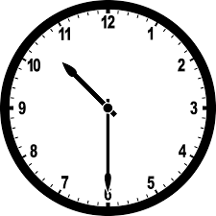

3
2
1

B- Read the question and choose the correct answer:
1- I broke my leg.
a) congratulations b) How nice c) sorry about that

6
V- Vocabulary:
A) Write the correct number under each picture:
1- pizza 2- teacher 3- boot 4- diver 5- bed 6- reporter

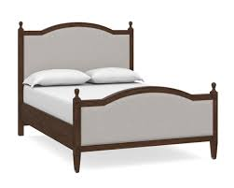
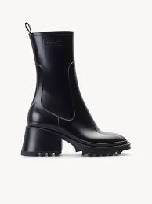

( 6 ) ( 3 ) ( 5 ) ( 1 ) ( 2 ) ( 4 )
VI- Orthography:
4
A) Choose the correct letter:
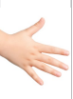
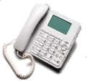
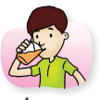

1- dri_ _ 2- _ _one 3- ha_ _ 4- lau_ _
( nk – sh – ch ) ( f – ph – kn ) ( gh – sh – nd ) ( gh – nt – nk )
T.Fatma ALmahdi

