المملكة العربية السعودية
وزارة التعليم
ادارة التعليم
مدرسة

عددالأوراق:4
الزمن: ساعتان ونصف
الصف: ثاني ثانوي مسارات عام

الاختبار النهائي لمادة اللغة الإنجليزية المرحلة الثانوية الفصل الدراسي الثاني الدور الأول للعام الدراسي 1444ه‍
اسـم الطالبة: ................................................................................................... رقم الجلوس : ................................................................

Question | 1  Guided composition | 2  Free Composition | 3  Comprehension | 4 Grammar | 5  Vocabulary | Total written
Mark given
Mark | 6 | 6 | 6 | 6 | 6 | 30
Corrector |  |  |  |  | Reviser

I-Composition:
A) Guided Composition:
-Write an assay about ( Sport ) using the notes below Guided words:
(important - physical - strength – hearts- reduce -stress - diseases – managing – enjoying- significant.)
_____________________________________________________________________
_____________________________________________________________________
_____________________________________________________________________
_____________________________________________________________________
_____________________________________________________________________
_____________________________________________________________________
_____________________________________________________________________

B ) Free Composition

- Choose one topic from the following to write about:
1- ( Your dream Job )
2- ( The internet in our life )
_____________________________________________________________________
_____________________________________________________________________
_____________________________________________________________________
_____________________________________________________________________
1 ) )

II-Reading Comprehension:

A-Read the following text, and then answer the questions below:

French fries are one of the most common food around the world . French fries are long, thin pieces of potato fried in oil or fat . Vegetables oil is the best fat to make amazing fries . French fries are served hot, either soft or crispy, and are generally eaten as part of lunch or dinner or by themselves as a snack, and they commonly appear on the menus of diners and fast food restaurants. French Fries are usually salted and, depending on the country, may be served with ketchup, mayonnaise or tomato sauce. To achieve golden-brown perfection, you have to fry them twice: first at a low temperature, to poach them; then at a high heat, to crisp them up. Actually , French fries are better when cooked at restaurants .Some people got addicted to French Fries because they don't need a fork or spoon to eat them . They can eat French fries with their fingers . Many restaurants selling French fires frequently combine servings of fries with another food, for example, fried fish or beef burgers. In fact , French fries go with hot dogs, hamburgers, fish and all sorts of sandwiches. Many countries in every corner of the globe have their own way of eating this beloved dish.
A-Answer the following questions :
1- What are French fries ? …………………………………………………………………………………………………… 2- Why did some people get addicted to French Fries ? ……………………………………………………………………………………………………3- Do French fries go with all sorts of sandwiches ? ……………………………………………………………………………………………………B-Choose the correct answer:
1- The best fat to make amazing French fries is ( vegetables – corn – olive - palm ) oil.
2- To achieve golden-brown perfection, you have to (grill - roast – boil - fry) them twice
3- crispy in line (3) means (crunchy – flexible – organic - neutral)
4- The opposite of beloved is (admired – popular – favorite - unloved )
( 2 )

C- Write ( True ) or ( False ) :
1- French Fries are usually salted. ( )
2-French fries may be served without ketchup, mayonnaise or tomato sauce.( )
III-Grammar

A-Circle the correct answers:
1) | The manager insisted that he …………………..late.
a- | works | b- | Work | c- | Worked | d- | working
2) | You ………….. stop at " STOP " sing.
a- | must | b- | Had to | c- | Need to | d- | Have to
3) | Our class enjoys………………………about ways to help the environment .
a- | learn | b- | Learns | c- | Learning | d- | learned
4) | The Saudi Riyal …………..the official currency of the kingdom of Saudi Arabia.
a- | Am | b- | is | c- | Was | d- | Were
5) | She can't reach the shelf. She is ……...short.
a- | enough | b- | For | c- | How | d- | too
6) | …………………………. uses more muscles of the body.
a- | swimming | b- | Swim | c- | Swam | d- | swum
7) | It was the night shift you wanted,………………..?
a- | Was you | b- | Wasn't it | c- | Is it | d- | Weren't it
8) | She has …………………three lessons.
a- | explain | b- | explains | c- | explained | d- | explaining

B- Do as shown between brackets:

1- Could \ me \ you \ help \ ? ( reorder)

………………………………………………………………

2- Skiing is dangerous. Snowboarding is dangerous. (Join using as ……… as) …………………………………………………………………………………
( 3 )

IV –Vocabulary:

- Fill the blanks with the correct words:

cooperate - loyalty - economy - furnish - marathon

- Thousands of runners participate in the ……………. every year..
- They had no money to ……………… their house.
- The people showed ……………… for the king by putting his face on the coins.
- I ……………. well with others when I’m in a group.
- Match each phrase/expression with its meaning :
Phrase / Expression |  | Meaning
- Take off |  | - Make a mistake
- A piece of cake |  | - Great!
- Cool! |  | - very easy
- mess up |  | - leave
 |  | - Really?

- Write the correct word and its picture:
skiing - No parking - zoologist - medal - Recycling

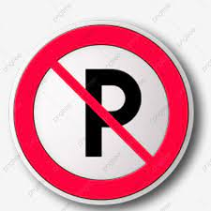 | 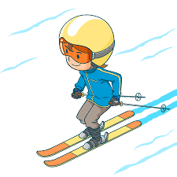 | 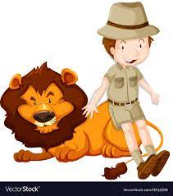 | 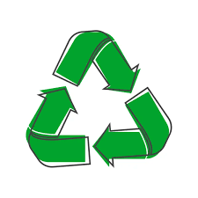
____________ | ____________ | ____________ | ____________
Finished & Good Luck
Done by:

( 4 )

