__________________________________________________________________________________
General Questions

/ 3

Choose the correct answer:

1 – What does your dad do ?
A . I am playing. B . He is a doctor.
2 – What does the firefighter do?
A. He puts out fires . B. He flies plane .
3 – What is the time? 10:30
A . It is ten o'clock. B. It is ten thirty.

________________________________________________________________________________________________________________________________________________________________________________________________________
/ 3
Reading short sentences
Read the sentence then choose or :

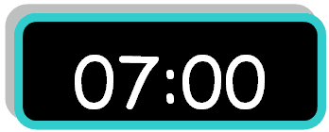
1. It is seven o'clock.

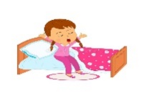
2. I eat my lunch.

3. He is a pilot.

______________________________________________________________________________________________________________________________________________________________________________________________________
/ 3
Grammar
C. got | B. get | A. go | 1 – I usually ____ up at 5:00 .
C. go | B. came | A. come | 2- yesterday, I ____ home at 1:00 .
C. where | B. what | A. who | 3- ____ does she do ? She is a nurse .

Choose the correct answer:

Do as shown between brackets:
/ 2
Controlled writing

Thirty | Thousand | hundred | 2- One _______. ( choose )
..................................................... |  |  | 3– she - a – teacher – is. ( rearrange )

/ 5
Vocabulary

Put the right word under its picture:
clock – doctor – firefighter – baker - get up

 |  | 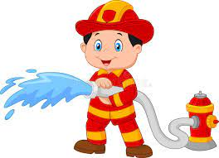 | 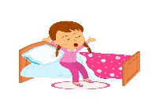 | 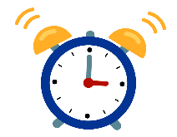

Orthography
/ 4

Fill in the missing letters:
ng – kn – gh -nk

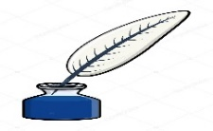 |  | 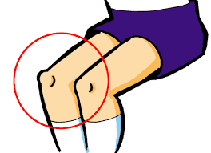
i_ _ | ri_ _ t | _ _ ee | ri_ _

Good luck T.

