

Kingdom of Saudi Arabia

Ministry of Education

……..Education Directorate

………………… School

English Language

elementary Grade …..

period Exam

…………….\20

Student's Name : class:

……\ 4 marks

General questions

**A.Answer the questions**

[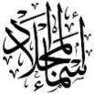](https://t.me/Asmaworld)**1-What does he do?**

a-Good afternoon b- He's a lawyer c- No. he isn't.

**2-What time did you get up yesterday?**

a-Yesterday, I got up at 5:30 b- I usually get up at 5:30 c- Yes, I did.

**3-What time do you take a bath?**

a- She plays basketball at 3:00 b-I usually take bath at 10:00 c- No , I can't.

**4-Where do they work?**

a-They work in airport. b-She works in hospital. c-I am work in school.

Controlled Writing

……\ 1 marks

**A-reorder.**

**grow up, - a firefighter – I want – When I – to be**

……………………………………………………………………………………

……\ 4 marks

Reading short sentence

|  |  |  |
| --- | --- | --- |
| Child brushes his teeth clipart | 1- I usually finish the school at 1:30 ( ) | |
| The clock in room in its mirror image showed as if the time is quarter past  seven . What is actual time - Brainly.in | 2- It's a quarter past seven ( ) |

**A-Put (** ✔ **) or (**  X  **)**

**B.Match**

|  |  |  |
| --- | --- | --- |
|  |  | 1-It's 5 o'clock. |
| Clock 5:00 | ClipArt ETC |  | 2-A doctor helps sick people and works in a hospital. |

[](https://t.me/Asmaworld)**A-Choose the correct answer.**

Grammar

……\ 4 marks

1- What does she ( do – does – doing ) ?

2- I usually ( eat – ate – eats ) lunch at 1:00.

3-Yesterday, I ( do – does – did ) my homework at ten o'clock.

4-Where do you ( work – works – working)?

……\ 5 marks

Vocabulary

**A.write the correct word under each picture**

**( cheese – ink - clock - baker - astronaut )**

**)**

|  |  |  |  |  |
| --- | --- | --- | --- | --- |
| Cheese png graphic clipart design 19614416 PNG | Ink clip art cartoon Royalty Free Vector Image |  | Bakers Clipart PNG, Vector, PSD, and Clipart With Transparent Background  for Free Download | Pngtree | Vintage alarm clock clipart |
|  |  |  |  |  |

Orthography

……\ 2 marks

**A. Fill in the missing letters**

Sh Kn ph gh

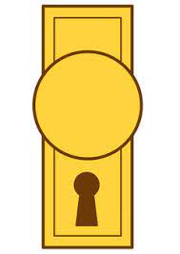

…..ob

….ip

Ni…..t

…..one

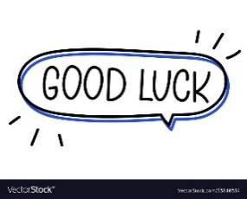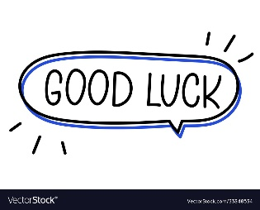

Your teacher …..:…………………………….

Your teacher: