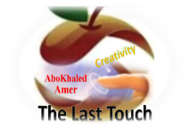

##### 

##### وزارة التعليم

**الإدارة العامة للتعليم بمنطقة -------**

**مجمع مدارس --------------------- ( بنين )**

**اختبارات نهاية الفصل الدراسي الأول 1445هـ**

|  |  |  |
| --- | --- | --- |
| **المادة:**  **لغة انجليزية** | **الصف: الأول المتوسط رقم الجلوس : ( )** | **الزمن:**  **ساعتان** |
| **اسم الطالب: ................................................................................................................................................** |

|  |  |  |  |  |  |  |  |
| --- | --- | --- | --- | --- | --- | --- | --- |
| **Total**  **written** | **5 spelling** | **4 Vocabulary** | **3 Grammar** | **2 Comprehension** | | **1 Composition** | **Q. NO.** |
|  |  |  |  |  | |  | **Mark Given** |
| **30** | **4** | **7** | **7** | **6** | | **6** | **Mark** |
|  | | | **Reviser** | |  | | **Corrector** |
|  | |

[**https://t.me/abokhaledamer**](https://t.me/abokhaledamer)

**0557325813**

**Composition**

**6**

**1- Write a paragraph about “Yourself"**

**\* Who are you? * How old are you? * Where are you from? * What's your nationality?**

**\* What subjects do you like? * What sports do you play? * What do you want to be?**

…………………………………………

………………………………………………………………………………………………………………………………………………………………………………………………………………………………………………………………………………………………………………………………………………………………………………………………………………………………………………………………………………………………………………………………………………………………………………………………………………………………………………………………………………………………………………………………

**2) Comprehension**

**6**

**2- Read the following passage then answer the questions:**

**Nada is a student. She is 13 years old. She is from Najran. She is very active girl. She loves museums. Last Monday, she visited Al OKHDOOD MUSEUM. She saw old things.**

**A- Put ( ) or ( x ):**

**1. Nada is a teacher. ( )**

**2. She is from Najran. ( )**

**B- Choose the correct answer:**

**1. She visited the museum on (**Saturday – Monday – Friday**).**

**2. She saw (**new – old – bad**) things old.**

**C- Answer the following questions:**

**1. Is she active girl?**

.....................................................................

**2. What did she visit?**

...................................................................

**3) Grammar**

**A: Choose the correct answer:**

**7**

**1. I (**am – is – are**) very happy.**

**2. This is my brother. (**Her – His – My**) name is Ali.**

**3. English classes are (**in – on – at**) Mondays and Wednesdays.**

**4. (**Who – How – What**) old are you?**

**5. This (**am – is – are**) my pencil.**

**6. (**Isn’t – Doesn’t – Don’t**) buy that painting.**

**7. Mr. Omar is here (**in – on – at**) business.**

**8. (**When – What – Where**) are you from?**

**9. I (**have – has – is**) a sister.**

**10. Do you have (**a – any – some**) brothers and sisters?**

**B: Do as shown between brackets:**

**1. She is Nora. (**Make Negative**)**

……………………………………………………………………………………………………………………………………

**2. What day is today? (**Answer the question**)**

……………………………………………………………………………………………………………………………………

**3. That is --------- calculator. (**Put indefinite article a / an**)**

……………………………………………………………………………………………………………………………………

**4. She is from Saudi Arabia. (**Make Yes/No Question**)**

……………………………………………………………………………………………………………………………………

**4) vocabulary:**

**7**

**A- Write the correct number under its picture:**

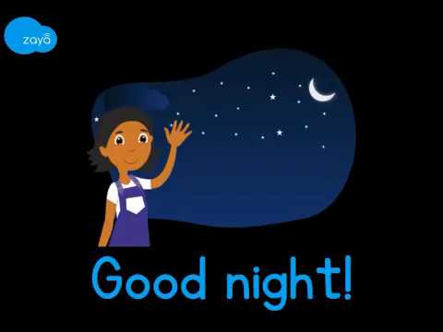**1. camera 2. parrot 3. family 4. scissors 5. reindeer 6. headphones 7. night**

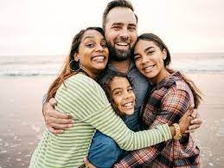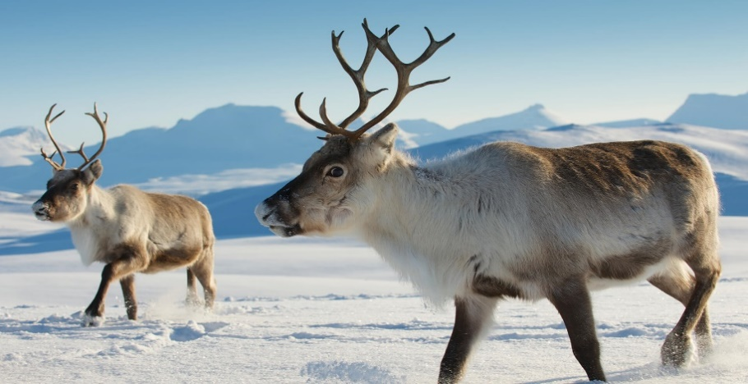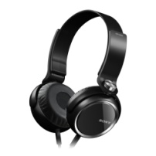

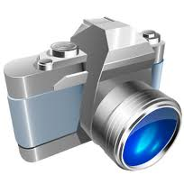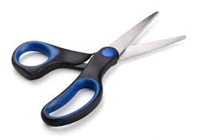

**( ) ( ) ( ) ( ) ( ) ( ) ( )**

**B- Match the Real Talk:**

**1. I’ve got a. Not very much**

**2. Not really b. I have**

**3. Guess what? c. A reply to “Thank you.”**

**4. You’re welcome d. tell a surprise**

**C- Circle the correct spelling:**

**1. skelton - skeltan – skeleton**

**2. family – familiy - famliy**

**3. vacotion – vacation – vecation**

**5) Orthography**:

**4**

**A- Fill in the missing letters:**

**1. m__rning**

**b – r – o – u**

**2. num__ers**

**3. muse__m**

**4. wo__ld**

**B- Circle the odd one out:**

**1. morning afternoon evening school**

**2. father mother Jeddah sister**

**3. doctor Brazil Egypt Canada**

**4. Sunday Mom Monday Tuesday**



**End of Questions**

[**https://t.me/abokhaledamer**](https://t.me/abokhaledamer)

**0557325813**

**Best of Luck**