|  |  |  |  |  |
| --- | --- | --- | --- | --- |
| **المملكة العربية السعودية**  **وزارة التعليم**  **الإدارة العامة للتعليم ...... .......** | **http://tabuk2day.com/wp-content/uploads/IMG_3362.jpg** **اختبار الفصل الدراسي الأول**  **للعام الدراسي 1444 هـ** | **المادة** | لغة انجليزية | |
| **الصف** | الثاني المتوسط | |
| **الزمن** | ساعة ونصف | |
| **الدور** | الأول | |
| **الاسم: .............................................................................................................** | | | | |

**30**

1. **Composition**

***Write a paragraph about (* yourself *) not less than 6 sentences using the following words .***

**6**

***( name – age – favorite sport – live –like )***

…………………………………………………………………………………………………………………………………………………………………………………………………………………………………………………………………………………………………………………………………………………………………………………………………………………………………………………………………………………………………………………………………………………………………………………………………………………………………………………………………………………………………………………………………….

**6**

**2. Reading Comprehension**

**Read the passage and answer the questions below :**

**Every Thursday, Mr. Saleh goes shopping. He likes to buy things from the supermarket near his house. It is a big supermarket. He buys meat, fruit, milk and vegetables for the week. Today, two of his children are going with him, Maram and Basil. Maram wants to buy biscuits for her sister Hanan. Basil wants to buy ice-cream. Basil does not have much money. He asks his father to give him some money.**

**Answer :**

**1- What does Mr. Saleh like to buy ? .....................................................................**

**2- Where is the supermarket ? ...............................................................**

**Choose :**

**3- Mr. Saleh likes to…………… things from a supermarket. ( buy - drink - eat )**

**4- Basil asks his father to give him some ( money - milk - ice-cream )**

**5- Today, two of his ……… are going with him. (children - friends teachers)**

**6- It is a ……………… supermarket. ( good - big - small )**

**7**

**3. GRAMMAR**

**Choose the correct words :**

**1- ( who - when - why ) is the tall man?**

**2- he is ( playing - plays - play ) football now .**

**3-she doesn't ( work - works - worked ) in hosbital.**

**4- I am good in math ( and - but - because ) English .**

**5- The book ( which - who ) I read is good .**

**6- sorry we don’t have ( any - some ) juice.**

**7- I know how to ( reads - read - reading ) stories.**

**7**

**4. Vocabulary**

**A-Match the meaning and the responses to the situations :**

|  |  |  |  |
| --- | --- | --- | --- |
| **1** | **How are you?** |  | **I am from Saudi Arabia** |
| **2** | **what are you doing?** |  | **3 books** |
| **3** | **How many books?** |  | **I am playing football** |
| **4** | **Where are you from?** |  | **I fine** |

**B-Match the picture with words:**

**( coffee - shrimp - elevator )**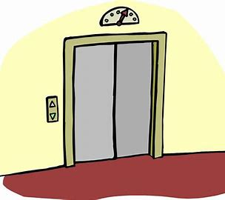

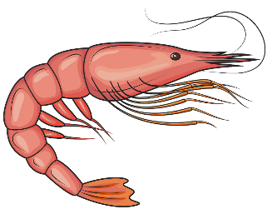

………………………………. ………………………… ....................................

**5. orthography**

**Write the missing letters :**

**4**

**1-comp_ny ( o – a ) 2- j_b ( o - m )**

**3- spo_t ( r- m) 4- vis_on ( i - f)**

**انتهت الاسئله**