Kingdom of Saudi Arabia  Ministry of Education  …Tabuk Education Directorate  21ST Intermediate School | اختبار مادة اللغة الإنجليزية الصف الثالث متوسط الفصل الدراسي الأول (الدور الأول) 1443-1444 | English Language  Third Intermediate Grade  1st Term Exam 1443 -1444  Time: one hour and half
Name/ ………………………………… | Class / …………… | Seat No./ ……………………………
Student’s Mark Written | Student’s Mark Number | Question |  | Number
 |  | Mark | Question
 |  | 6 | Composition | Q1
 |  | 6 | Reading Comprehension | Q2
 |  | 7 | Grammar | Q3
 |  | 7 | Vocabulary | Q4
 |  | 4 | Orthography | Q5
 |  | 30 | Total Written Tasks

Sign | Name | Corrected by
Sign | Name | Revised by
Sign | Name | Checked by

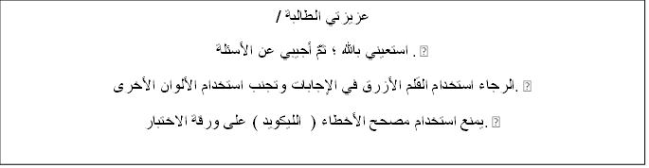
Page 1
اختبار الصف الثالث متوسط الفصل الدراسي الأول ( الدور الأول) 1443-1444

Q1 / Composition

6
1.Tea is a popular drink. Write a paragraph with 5 sentences about how to make
a cup of tea. Use the following sequence words (First -Next -After that -Finally –)
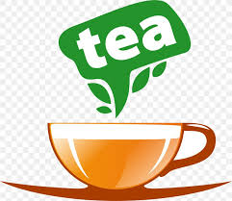

6
1-put a teabag into a cup.
2-pour very hot water into the cup.
3-leave it for three minutes.
4-take the teabag out.
5-pour some milk into the tea, but not too much.
Reading Comprehension
Read the following passage and choose the correct answer below:
Sara is interested in Geography books. She has already read many books about India
Indonesia, Bangladesh, and Japan. She learned a lot about these countries. Sara visits the school library almost every day where she can read a lot of Geography books. The librarian is always ready to help her choose any book which she likes to read about it. Last week, Sara wrote a very good note in the school Magazine and the headmaster was happy to read that note. She gave her some books as a gift..
1- What does Sara visit ? Sara visits the school ………….
[ a – library b- class c- office]
2- Sara wrote a very good ……………………
[ a - homework b- note c- exam ]
3- Is Sara interested in English books?.......................
[ a- No, she is not b- Yes, they do c- Yes, iam ]
4- The headmaster was .....................to read Sara's note
[ a- angry b- sad c- happy]
5- The headmaster gave Sara some ……… as a gift
[ a – books b- pencils c- flowers ]
6- the pronoun (she) in line 4 refers to ………………..
[ a- Sara b- Maha c- Huda ]

7
Q3 – Grammar
Choose the correct answer
8- I go to school ……..7 a.m.  - in  - on  - at | 7- I eat a ………..carrots  a- little  b- few  c- any
10- I used to …………. With toys. .  - play  - plays  - playing | 9 – I rarely ……..coffee  a- drink  b-drinks  c-drinking
12- I do not have ……..for lunch.  a- something  b - some  c- anything | 11- - …………..milk do you drink?  a-How much  b-How  c-How many
13- He likes to look at ……in the mirror.
a – herself
- him self
- mine

Q4- Vocabulary; Choose [ true] for true statement and [ false] for false one
false | true | 1- Someone who exercise a lot is exercise freak
false | true | 2- Prince Sultan flew abroad the space shuttle Discovery
false | true | 3- The opposite of the word [ poor] is busy.

7
-Match each word with word that has same correct meaning
a- appointment | 1- give to charity ……….
b- donated | 2- an arrangement to meet..
c- infant | 3- supported someone to succeed
d - encourage  e _ gathered | 4- a baby

4
Q5- Orthography “Spelling”
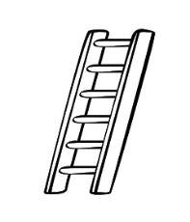
Choose the correct spelling
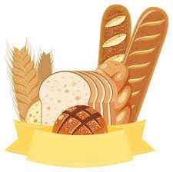 | 14- I enjoy eating ……….  a – bread b- readb c- bird
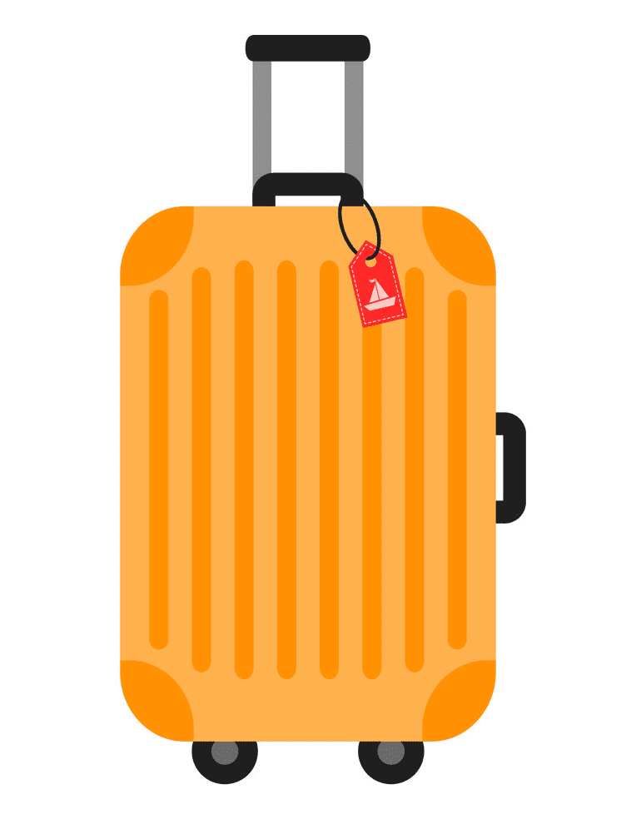 | 15- I buy a new ……………case  a – sikcs b- suit c- tsicsk

Choose the missing letters:
16-My mother finished her an av…..ado juice. [ a- oc b- oo c- dd]
17-He got his flight ti……et [ a- h b- ck c- ph ]

انتهت الأسئلة
T.AFAF Salem

