التاريخ: / / 1445هـ
الصف: السادس الابتدائي
الزمن: ساعة ونصف
المادة: اللغة الإنجليزية

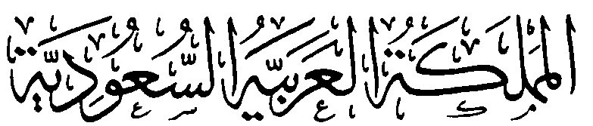
وزارة التعليم
الإدارة العامة للتعليم بمنطقة ................

مدرسة .....................................

اختبار اللغة الإنجليزية نهائي – الدورالاول – للصف السادس – الفصل الدراسي الاول 1445هـ
6
اسم الطالب: ............................................ الفصل: /6
I- General Questions:
A- Match the questions in column (A) with the correct answers in column (B):
B | A
( ) I set the table.  ( ) I like tennis.  ( ) I live in Madina.  ( ) I think they're scary.  ( ) Yes, she does sometime.  ( ) I'm 12 years old. | 1- Where do you live?  2- Does she vacuum the floor?  3- How old are you?  4- What sport do you like?  5- What chores do you do?  6- What do you think about sharks?

II- Controlled Writing:
golf
fast
feed
plane
5
A- Complete the sentences with the correct word:
1 – I think dolphins are ……………..
2 – I'd like to try sky diving but I have no ……………
3 – I sometimes ………….. the fish.
4 – Does your brother play ……………

B – Rearrange:
a seahorse / think / I / is / slow
…………………………………………………………………….

III- Reading Short Sentence:
4
A- Read the sentences and match them with the correct pictures:

1- I'm washing the dishes 2- I like playing football
3- I think whales are the biggest sea animals 4- scuba diving is dangerous sport
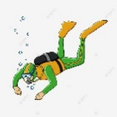
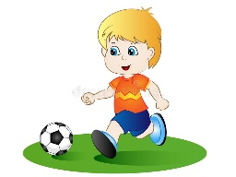
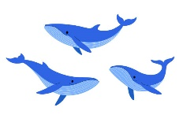

IV- Grammar:
5
A) Choose the correct word:
1 – Seals are ( cute – cuter – cutest ) than octopus.
2 – ( Who – What – How ) do you go to school?
3 – Dolphins ( is – are – am ) fast.
4 – My mother is a doctor. ( Her – His – My ) name is Mona.
5 – I ( have – has – is ) a bicycle.
6 – I think the whale is the ( big – biggest – bigger) sea animal.
7 – She ( have – has – am) a doll.
8 – They are my sisters. ( My - Their – its ) names are Nora and Alia.
9 – Whose cap is this ? It is ( Ahmed – Ahmed's ).
10 – A whale ( is – are - am ) big.

V- Vocabulary:
6
A) Write the correct number under each picture:
1- horse riding 2- jellyfish 3-jog 4- seagull 5- rock climbing 6- walrus

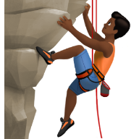
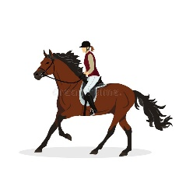
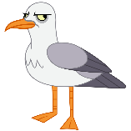
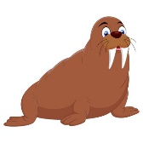
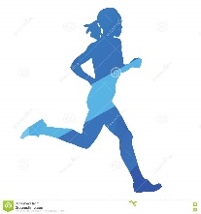

( ) ( ) ( ) ( ) ( ) ( )
VI- Orthography:
4
A) Choose the correct letter:
oy ea air ow

4 - ch_ _ _ 1 - m_ _ t 2 - sn_ _ 3 - t_ _

End of the Questions

