التاريخ: / / 1444هـ
الصف: الرابع الابتدائي
المادة: اللغة الإنجليزية

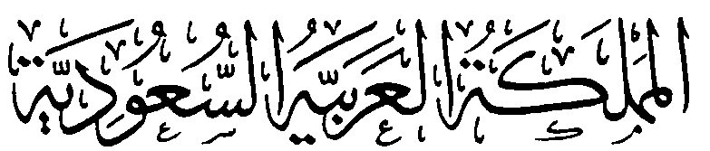
وزارة التعليم
الإدارة العامة للتعليم بمنطقة ................
مكتب ...............
مدرسة ....................................

اختبار اللغة الإنجليزية نهائي – الدور الأول – للصف الرابع – الفصل الدراسي الثالث 1444هـ
اسم الطالب:........................................................ الفصل:.............
I- General Questions:
A- Answer the following questions correctly:
6
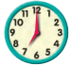
1- What time is it?
A – It's seven o'clock. B – It's fife o'clock.
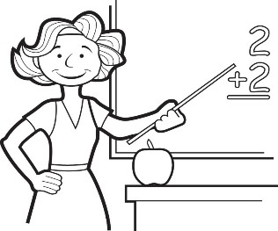
2- Is she a doctor?
A – Yes, she is. B – No, she isn't.

B- Match the questions in column (A) with the correct answers in column (B):
B | A
( ) I get up at 6 o'clock.  ( ) He's a teacher.  ( ) They are 7 days.  ( ) Sure. Here you go. | 1- How many days in the week?  2- Can I use your pen?  3- What does he work?  4- What time do you get up?
II- Controlled Writing:
summer
sunny
fly

5
A- Complete the sentences with the correct word:
1- Ostriches can run but they can't ………………
2- It's ………………………… and very hot in ……………………
B- Rearrange the words to form a sentence:

1- is / a / . / He / pilot
………………………………………………………………………………………………………………………….
2- is / a / This / . / watch
………………………………………………………………………………………………………………………….

III- Reading Short Sentence:
4
A- Read the sentences and match them with the correct pictures:

1- They are wallets. 2- It's a sheep. 3- It's snowy and cold. 4- They're cooks.

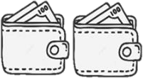
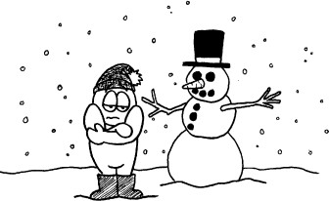
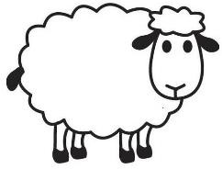

IV- Grammar:
5
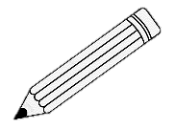
A) Choose the correct word:
1- They ( is – are ) pencils.
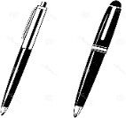
2- What ( do – does ) she do?
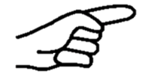
3- ( That – These ) is my eraser.
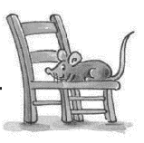
4- What are ( this – these )?
5- The mouse is ( under – on ) the chair.
V- Vocabulary:
6
A) Write the correct number under each picture:
1- candy 2- watch 3- MP3 player 4- kangaroo 5- scissors 6- firefighter

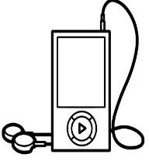
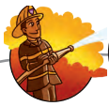
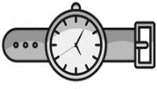
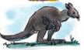

( ) ( ) ( ) ( ) ( ) ( )
VI- Orthography:
4
ea - sp - sm - sw

A) Choose the correct letter:
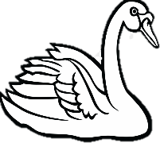
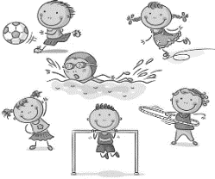

1- _ _ an 2- h _ _ d 3- _ _ ort 4-_ _ ile

