******المملكة العربية السعودية**

**Kingdom of Saudi Arabia**

**Ministry of Education**

**------- Educational Directorate**

**------- Future Educational Schools**

**2nd Grade High School 2022**

**3rd Term – Final Exam**

**وزارة التعليم**

**الإدارة العامة للتعليم بن**

**مدارس م ن التعليمية**

**الصف الثاني الثانوي**

**الاختبار النهائي للفصل الدراسي الثالث1443**

|  |  |  |  |  |  |  |  |
| --- | --- | --- | --- | --- | --- | --- | --- |
| **Total**  **written** | **5**  **Vocabulary** | **4**  **Grammar** | **3**  **Free Composition** | **2**  **Guided Composition** | | **1 Comprehension** | **Q. NO.** |
|  |  |  |  |  | |  | **Mark Given** |
| **30** | **6** | **6** | **6** | **6** | | **6** | **Mark** |
| **6** | | | **Reviser** | |  | | **Corrector** |
|  | |

**زمن الاختبار: 3 ساعات**

**اسم الطالب: ------------------------------------ رقم الجلوس: ------------- الصف الثاني الثانوي**

**1)** **Comprehension**

**Read the following passage then answer the questions**

**One night, Pilar was in a deep sleep when she was woken by her cat Inti. Inti was meowing wildly outside Pilar's bedroom and throwing himself against the closed bedroom door. When Pilar opened her eyes, she saw that her bedroom was filling with smoke. As she escaped her house with Inti in her arms, she saw that a fire was blazing in her kitchen. Pilar could easily have lost consciousness from breathing in the smoke, but Inti wouldn't let that happen. Even though Inti could have escaped the house through a cat door, he wouldn't leave Pilar. A fireman at the scene said, " Without question, that cat is responsible for saving his owner's life.  He should be honored as a hero."**

***A)* Answer the following questions*:*  
1. How could Pilar have lost consciousness?-----------------------------------------------------.**

**2. When was he in a deep sleep? ----------------------------------------------------------.**

**3. Where was Pilar sleeping? ----------------------------------------------------------.**

**4. Who put out the fire?  -----------------------------------------------------------.**

***B)* Put ( √ ) or ( X ):  
5. Inti was meowing wildly outside Pilar's bedroom.  ( )**

**6. Even though Inti could have escaped the house, he wouldn't leave Pilar. ( )**

**7. Pilar left Inti inside the house and escaped. ( )**

**8. The cat is responsible for saving his owner's life. ( )  
*C)* Complete*:*  
9. Pilar saw that her bedroom was filling with --------------------------------.  
10. The cat should be honored as a -----------------------------------.**

**D) Choose the correct answer:**

**11. The best title for the paragraph is: (**Animal Hero – Firemen – The Kitchen**)**

**12. The cat could have escaped the house through a (**window – balcony – cat door**).**

**2) Guided Composition**

**6**

**Studying online and studying face to face are two ways of learning**

**Write an essay about the two kinds, using the following guide words:**

**Guiding words:**

**inside class – contact – expression – active – go anywhere – computer – internet – limit – time – age (**Write not less than 150 word **(**

-------------------------------------------------------

--------------------------------------------------------------------------------------------------------------------------------------------------------------------------------------------------------------------------------------------------------------------------------------------------------------------------------------------------------------------------------------------------------------------------------------------------------------------------------------------------------------------------------------------------------------------------------------------------------------------------------------------------------------------------------------------------------------------------------------------------------------------------------------------------------------------------------------------------------------------------------------------------------------------------------------------------------------------------------------------------------------------------------------------------------------------------------------------------------------------------------------------------------------------------------------------------------------------------------------------------------------------------------------------------------------------------------------

**3) Free Composition**

**6**

**Choose one topic from the following to write about.**

**1. Imagine that you are invited to a famous restaurant in your city.**

**Writ a paragraph about "Your Favorite Dish".**

**2. Write a paragraph about "Your Dream House" in which you describe which kind of you want to live in, where, who live with, …**

**(**Write not less than 100 word**).**

-------------------------------------------------------

--------------------------------------------------------------------------------------------------------------------------------------------------------------------------------------------------------------------------------------------------------------------------------------------------------------------------------------------------------------------------------------------------------------------------------------------------------------------------------------------------------------------------------------------------------------------------------------------------------------------------------------------------------------------------------------------------------------------------------------------------------------------------------------------------------------------------------------------------------------------------------------------------------------------------------------------------------------------------------------------------------------------------------------------------------------------------------------------------------------------------------------------------------------------------------------------------------------------------------------------------------------------------------------------------------------------------------------

**4) Grammar**

**6**

**A: Choose the correct answer:**

**1. If we (played – had played – play – playing) well, we would have won.**

**2. My car (has – is – will – does) be repaired tomorrow.**

**3. I turn off the TV. I (turn off it – turn it off – it turn off – off it turn).**

**4. Nora is (interest – interesting – interests – interested) in watching TV.**

**5. (Not Warming – Not warm – Not warms – Not warmed) up is bad.**

**6. She is not (enough tall – tall enough – tall too – tall so) to reach the shelf.**

**Do as shown between brackets:**

**1. I bought (yellow – big – Japanese – expensive) car. (**Reorder the adjectives)

-------------------------------------------------------------------------------------------------.

**2. Ali is the tallest boy I (see). (Correct the adjective)**

-------------------------------------------------------------------------------------------------.

**3. The book was very (bore). I didn’t enjoy it. (**Correct**)**

-------------------------------------------------------------------------------------------------.

**4. The chef cut the steak up into small pieces. (Decide if it is** Separable or Nonseparable**)**

-------------------------------------------------------------------------------------------------.

**5. Ali can help the boys. (**Make Passive**)**

-------------------------------------------------------------------------------------------------.

**6. If she had had time, she (visit) her friends. (**Correct**)**

-------------------------------------------------------------------------------------------------.

**5) vocabulary:**

**6**

**A- Match the words with the pictures:**

**medal – popscile – gorilla – dilemma – centipede – canyon**

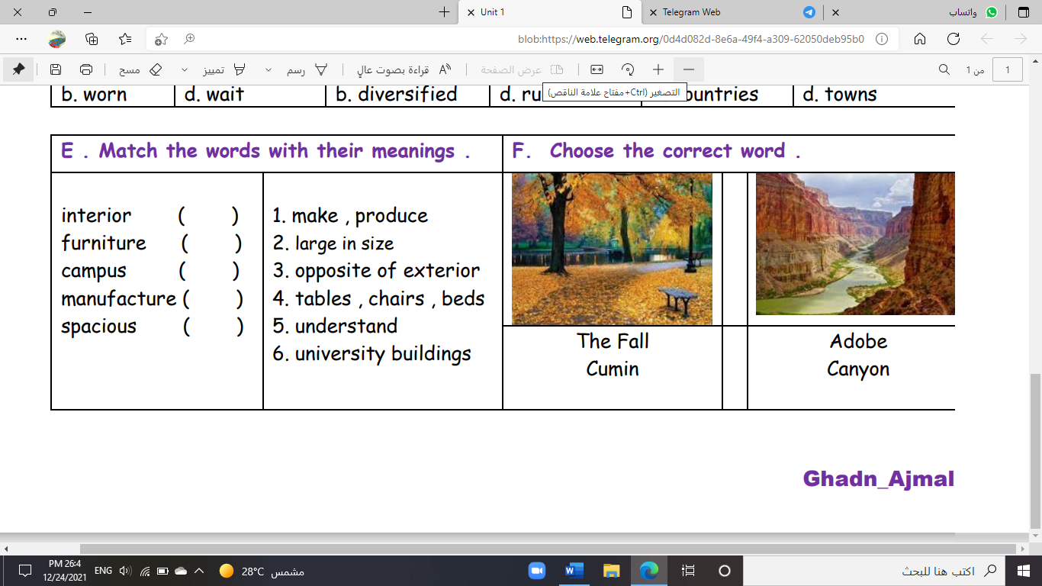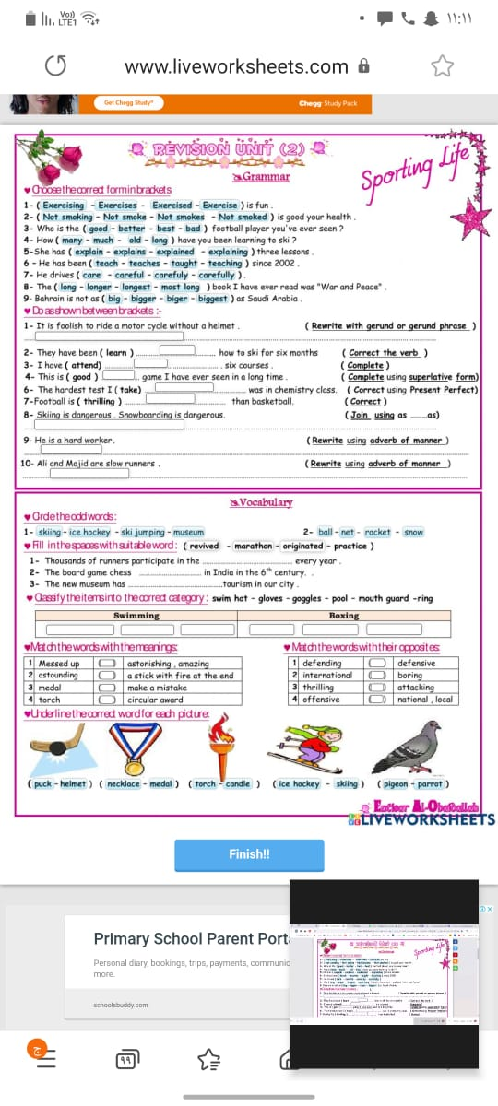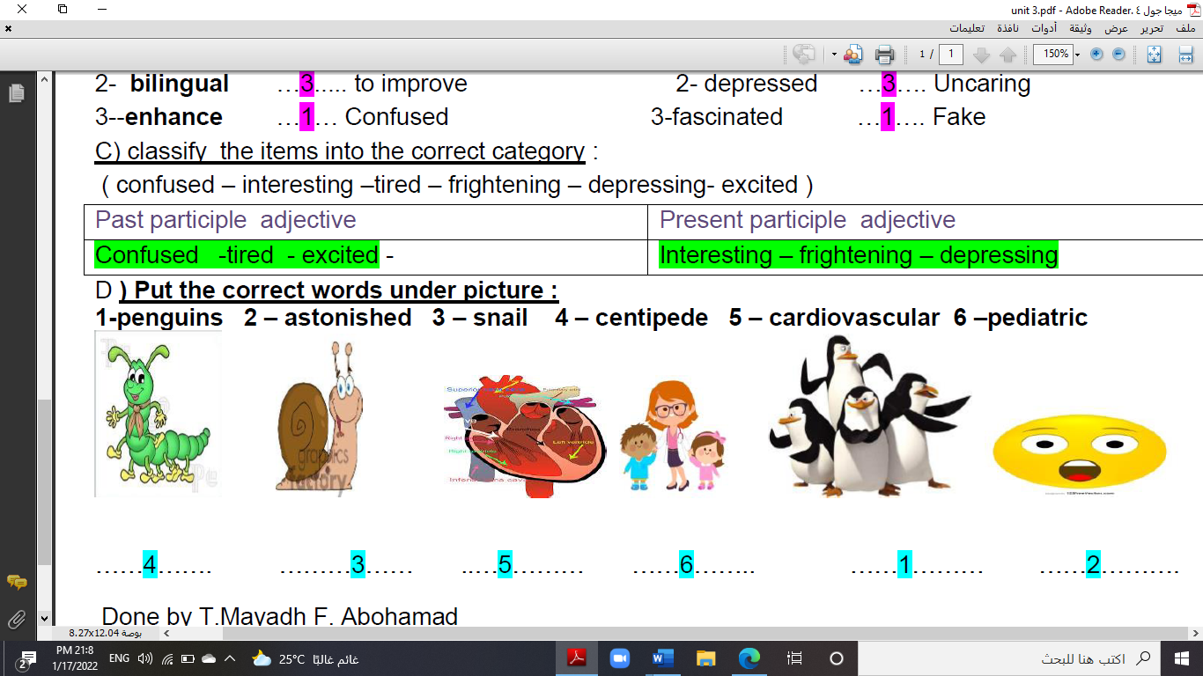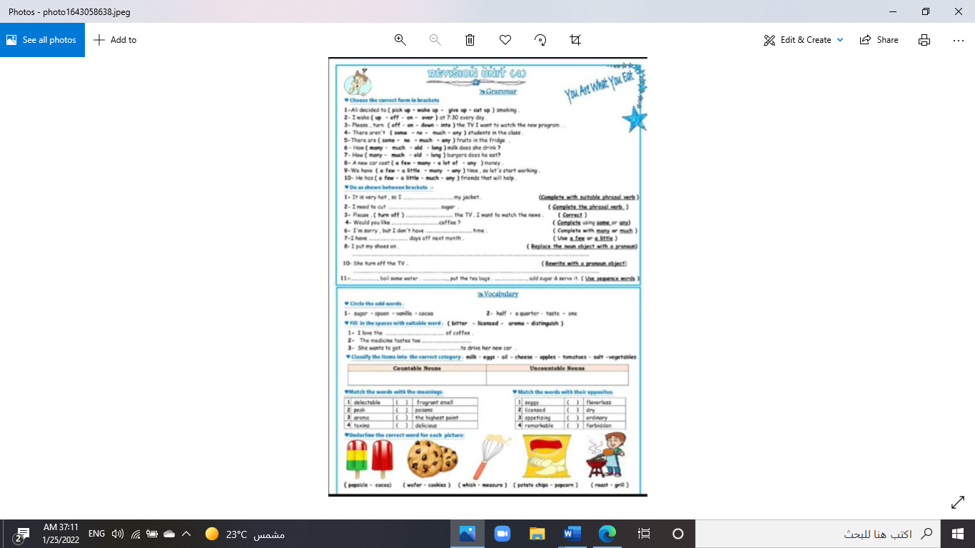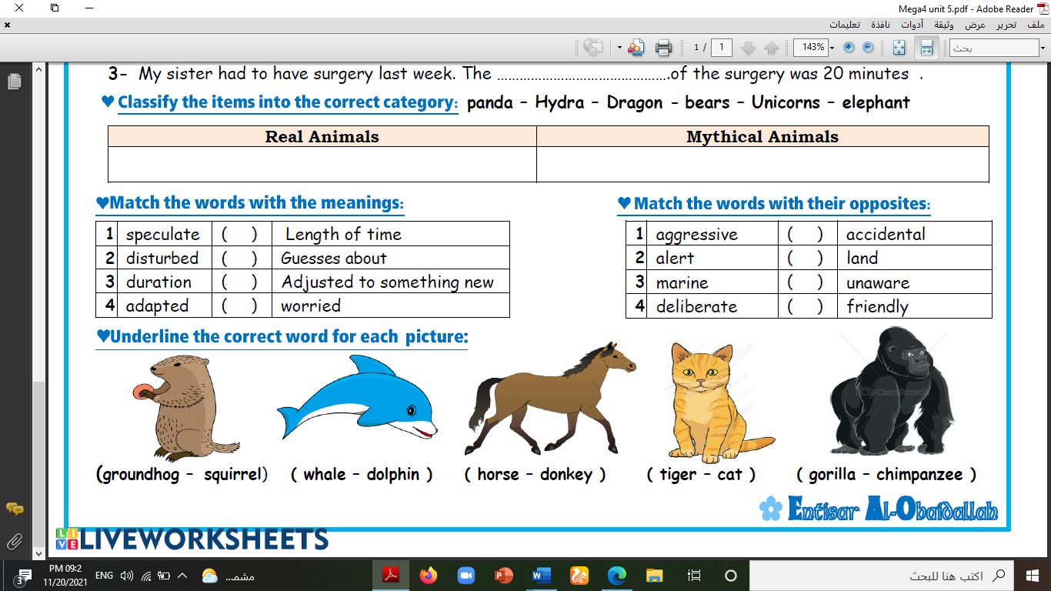

**--------- ------- -------- --------- -------- -----------**

**A) Match to form new words or expressions:**

**1. rotten ---- a. very good**

**2. pampered ---- b. bad**

**3. Hang in there ---- c. indulged**

**4. quite the ---- d. someone who sells something**

**5. vendor ---- e. annoying or bothering**

**6. getting to ---- f. Don't give up**

**End of Questions**

**Best of Luck** [**https://t.me/abokhaledamer**](https://t.me/abokhaledamer)