|  |  |  |  |
| --- | --- | --- | --- |
| **المملكة العربية السعودية**  **وزارة التعليم**  **الإدارة العامة للتعليم بـن مدرسة مستقبل ن الابتدائية** | **بسم الله الرحمن الرحيم** **اختبار الفصل الدراسي الثالث**  **للعام الدراسي 1443 هـ** | **المادة** | **لغة انجليزية** |
| **الصف** | **الخامس** |
| **الزمن** | **ساعة ونصف** |
| **الفصل** | **----- /5** |
| **اسم الطالب رباعيا: .............................................................................................................**   |  |  |  |  |  |  |  |  | | --- | --- | --- | --- | --- | --- | --- | --- | | **السؤال** | **1** | **2** | **3** | **4** | **5** | **6** | **المجموع** | | **الدرجة** |  |  |  |  |  |  |  | | **الدرجة** | 6 | 5 | 4 | 5 | 6 | 4 | 30 | | **المصحح** |  |  |  |  |  |  |  | | | | |

**I- General Questions:**

**https://t.me/abokhaledamer**

**6**

**Q1: Answer the following questions correctly:**

**1. Where's Hashim? -------------------------------.**

**2. Can I have some candy?**  **-------------------------.**

**3. What time do you eat lunch? ---------------------- .**

**5**

**II- Controlled Writing:**

**Q2: Do as shown between brackets:**

**1. many - are – How – there?(Rearrange)>____ _____ ___ ____?**

**2. How do you spell "box"? (Answer) >. ______.**

**III- Reading Short Sentence:**

**4**

**Q3: Match the sentence with the pictures:**

**1. Can I use your scissors?**

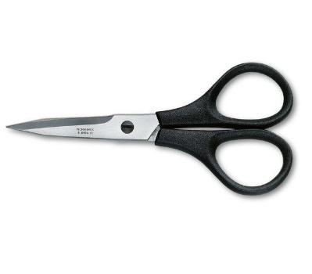

**2. The mouse is on the chair.**

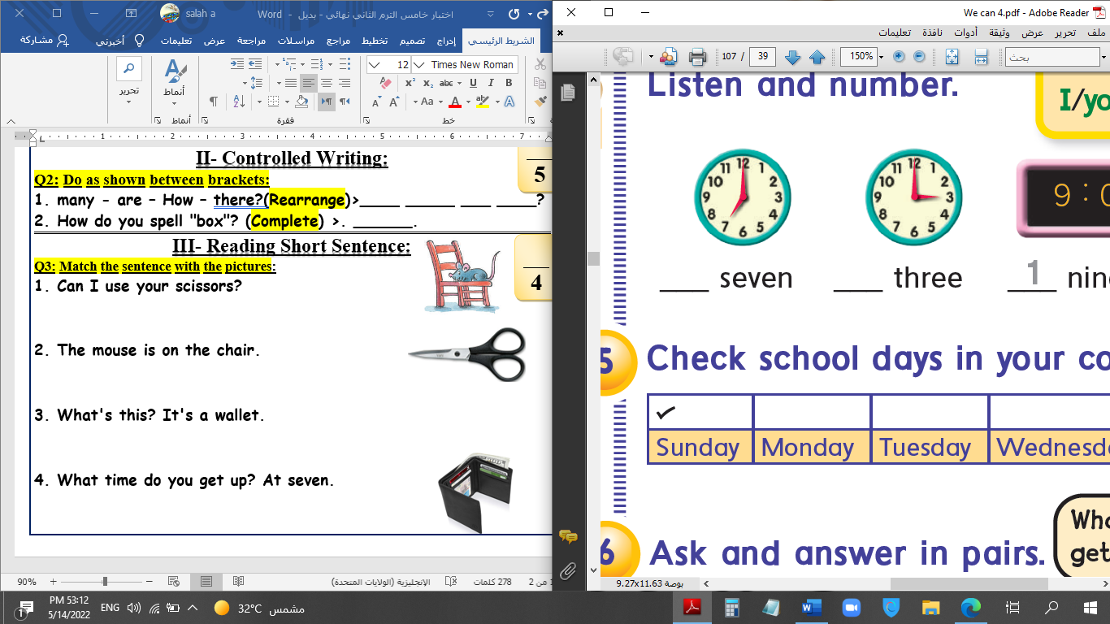

**3. What's this? It's a wallet.**

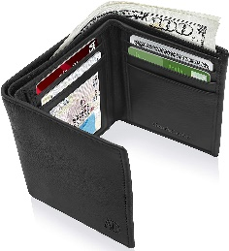

**4. What time do you get up? At seven.**

**IV- Grammar:**

**5**

**Q4: Choose the correct answer:**

**1- This (am – is – are) the living room.**

**2- Nora is (in – on – under) the kitchen.**

**3- (When – Where – What) is the boy?**

**4- Let's (counts – counting – count) them.**

**5- What are (this – that – these)?**

**V- Vocabulary:**

**6**

**Q5: Write the number under picture:**

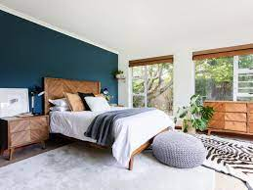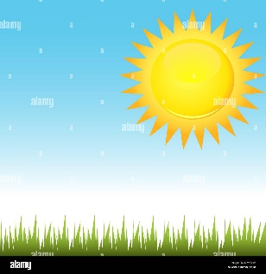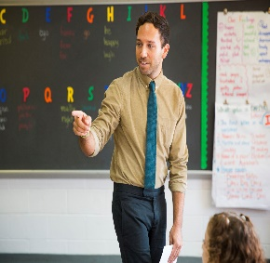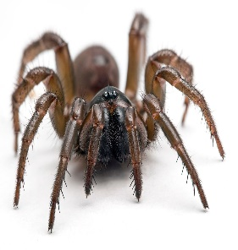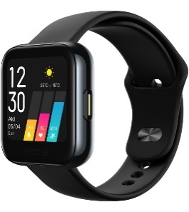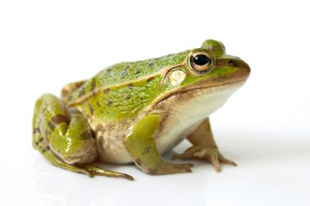**1. spider 2. sunny 3. frog 4. teacher 5. watch 6. bedroom**

**( ) ( ) ( ) ( ) ( ) ( )**

**VI- Orthography:**

**4**

**Q6: Fill in the missing letters:**

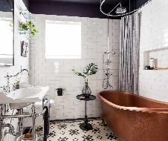**sp / oo / ou / sw / fr / sm / pr / ow**

****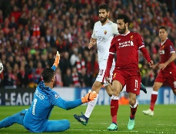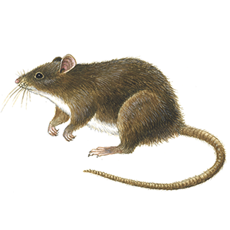

**bathr_ _m _ _ize m_ _se _ _ile _ _ing _ _ies _ _ort sn_ _y**

**End of Questions**