**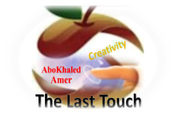****المملكة العربية السعودية**

**Kingdom of Saudi Arabia**

**Ministry of Education**

**------- Educational Directorate**

**------- Future Educational Schools**

**2nd Grade High School 2022**

**3rd Term – Final Exam**

**وزارة التعليم**

**الإدارة العامة للتعليم بن**

**مدارس م ن التعليمية**

**الصف الثاني الثانوي**

**الاختبار النهائي للفصل الدراسي الثالث1443**

|  |  |  |  |  |  |  |  |
| --- | --- | --- | --- | --- | --- | --- | --- |
| **Total**  **written** | **5**  **Vocabulary** | **4**  **Grammar** | **3**  **Free Composition** | **2**  **Guided Composition** | | **1 Comprehension** | **Q. NO.** |
|  |  |  |  |  | |  | **Mark Given** |
| **30** | **6** | **6** | **6** | **6** | | **6** | **Mark** |
| **6** | | | **Reviser** | |  | | **Corrector** |
|  | |

**زمن الاختبار: 3 ساعات**

**اسم الطالب: ------------------------------------ رقم الجلوس: ------------- الصف الثاني الثانوي**

**1)** **Comprehension**

**Read the following passage then answer the questions**

**Water**

**Water is life and the lack of water means death. Any living thing cannot go on living without water. Plants need water to grow. Animals need water to drink. People need water to drink and to use in cleaning, cooking, farming and irrigating their lands. We can get water from rivers and lakes. But the main source of water is the rain.  In the desert, people dig deep wells to get water. For keeping water from being wasted, people build dams for storing water in reservoirs that form behind the dams. Water is stored in water towers that supply all the houses with pure water. Our government has set up desalination plants for treating seawater and removing the salt. Thanks be to God, the Merciful, who has created water for us. We don't need to pay for it as it is neither sold nor bought.**

***A)* Answer the following questions*:*  
1. What does the lack of water mean?-------------------------------------------------------.**

**2. Why do people need water? -----------------------------------------------------------.**

**3. What is the main source of water? ----------------------------------------------------------.**

**4. Who has created water for us?  --------------------------------------------------------------.**

***B)* Put ( √ ) or ( X ):  
5. Any living thing can go on living without water. ( )**

**6 Plants and animals need water to grow and drink. ( )**

**7. In the mountains, people dig deep wells to get water. ( )**

**8. We don't need to pay for water. ( )  
*C)* Complete*:*  
9. Our government has set up desalination plants for --------------------------------.  
10. We can get water from -----------------------------------.**

**D) Choose the correct answer:**

**11. Farmers need water for farming and irrigating their (**houses – lands – rooms**)**

**12. To restore water, people build (**dams – schools – farms**)**

**2) Guided Composition**

**6**

**You read a book about some life threating situations that man can hardly survive. Write about a situation you passed or heard about.**

**(**Write not less than 150 word **(**

**Guiding words:**

(fire – smoke – burning – collapsed – call fire department – fire engines – rescue …)

-------------------------------------------------------

--------------------------------------------------------------------------------------------------------------------------------------------------------------------------------------------------------------------------------------------------------------------------------------------------------------------------------------------------------------------------------------------------------------------------------------------------------------------------------------------------------------------------------------------------------------------------------------------------------------------------------------------------------------------------------------------------------------------------------------------------------------------------------------------------------------------------------------------------------------------------------------------------------------------------------------------------------------------------------------------------------------------------------------------------------------------------------------------------------------------------------------------------------------------------------------------------------------------------------------------------------------------------------------------------------------------------------------

**3) Free Composition**

**6**

**Choose one topic from the following to write about.**

**1. Imagine that you are going to buy a new house for your new family. Write a short paragraph describing your new home.**

**2. Sports are spread around the world. All nations have their favorite sport. Write about your favorite sport.**

**(**Write not less than 100 word**).**

-------------------------------------------------------

--------------------------------------------------------------------------------------------------------------------------------------------------------------------------------------------------------------------------------------------------------------------------------------------------------------------------------------------------------------------------------------------------------------------------------------------------------------------------------------------------------------------------------------------------------------------------------------------------------------------------------------------------------------------------------------------------------------------------------------------------------------------------------------------------------------------------------------------------------------------------------------------------------------------------------------------------------------------------------------------------------------------------------------------------------------------------------------------------------------------------------------------------------------------------------------------------------------------------------------------------------------------------------------------------------------------------------------

**4) Grammar**

**6**

**A: Choose the correct answer:**

**1. You are not well (too – so – enough – just) to work today.**

**2. (Watching – Watched – Watches – Watch) sports is my favorite hobby.**

**3. My grandfather's stories about his childhood are (amuse – amusing – amused).**

**4. I take off my shoes. I (take them off – take off them – take it off – take off it).**

**5. The tiger will be (releasing – releases – release – released) into the wild.**

**6. If they had slept early, they would have (be – been – bees – are) on time.**

**Do as shown between brackets:**

**1. If Hassan (visit) me, I would have told him the whole story. (**Correct**)**

-------------------------------------------------------------------------------------------------.

**2. You should clean the bird's cage weekly. (**Make Passive**)**

-------------------------------------------------------------------------------------------------.

**3. I never tire of chocolate. (**Decide if it is Separable or Nonseparable**)**

-------------------------------------------------------------------------------------------------.

**4. Hassan was (disgust) by the news report. (**Correct**)**

-------------------------------------------------------------------------------------------------.

**5. Nora is the (beautiful) girl I have ever seen. (**Correct the adjective**)**

-------------------------------------------------------------------------------------------------.

**6. Ali is wearing a ( white , beautiful , linen , small ) jacket. (**Reorder the adj.)

-------------------------------------------------------------------------------------------------.

**5) vocabulary:**

**6**

**A- Match the words with the pictures:**

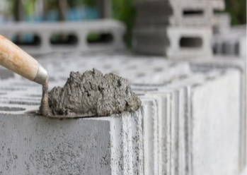**parrot – groundhog – mortar - chocolate – torch – lifeboat**

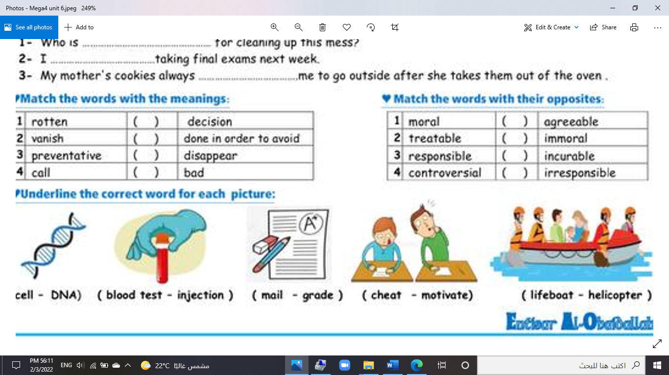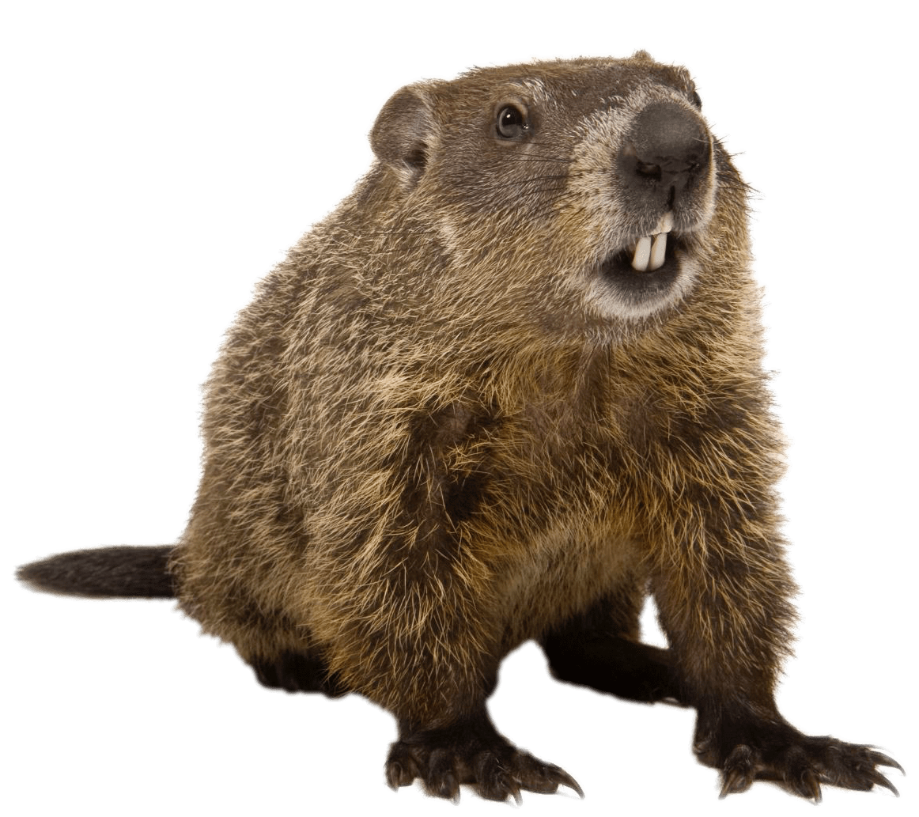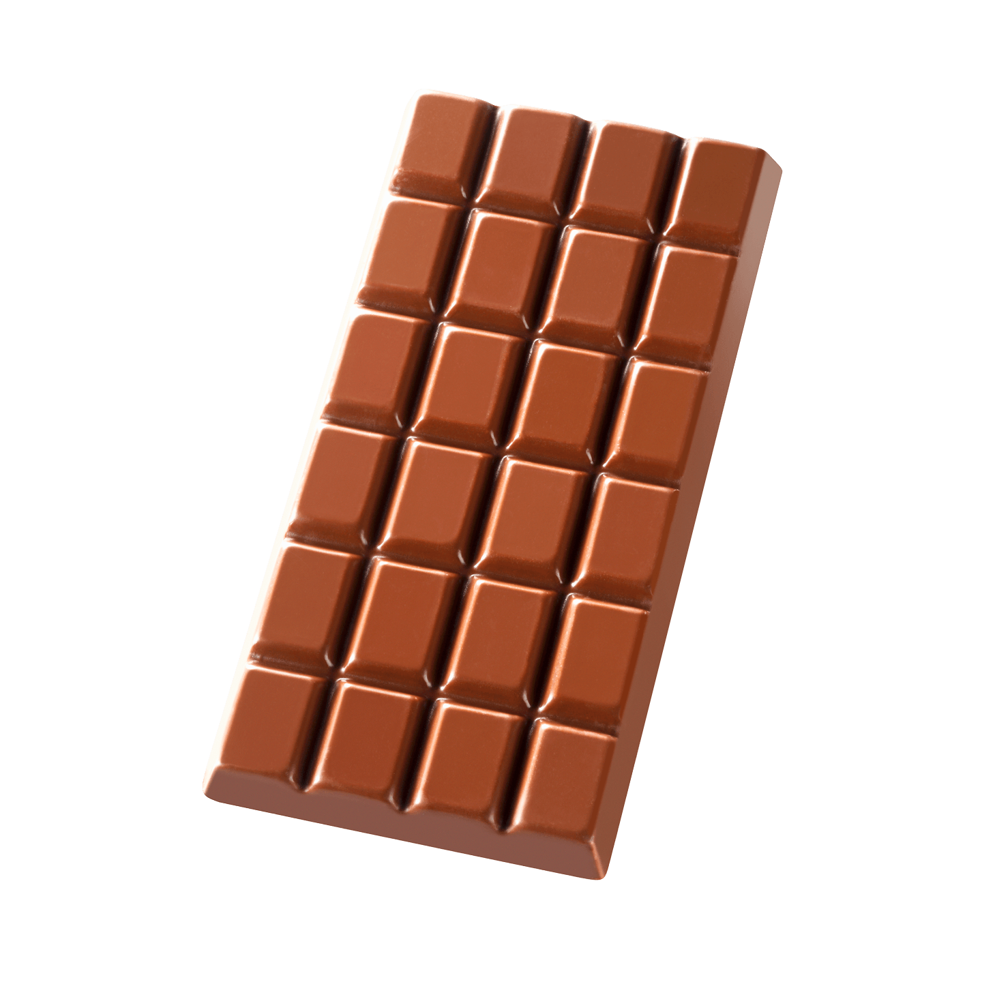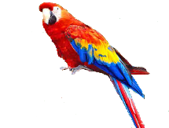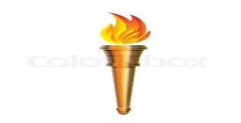

**--------- ------- -------- --------- -------- -----------**

**A) Match to form new words or expressions:**

**1. killer ---- a. very quickly**

**2. genuine ---- b. great**

**3. alert ---- c. real**

**4. bond ---- d. aware**

**5. call ---- e. connection**

**6. in no time ---- f. decision**

**End of Questions**

**Best of Luck** [**https://t.me/abokhaledamer**](https://t.me/abokhaledamer)