**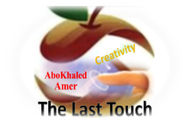****المملكة العربية السعودية**

**Kingdom of Saudi Arabia**

**Ministry of Education**

**------- Educational Directorate**

**------- Future Educational Schools**

**1st Grade High School 2022**

**3rd Term – Final Exam**

**وزارة التعليم**

**الإدارة العامة للتعليم بن**

**مدارس م ن التعليمية**

**الصف الأول الثانوي**

**الاختبار النهائي للفصل الدراسي الثالث1443**

|  |  |  |  |  |  |  |  |
| --- | --- | --- | --- | --- | --- | --- | --- |
| **Total**  **written** | **5**  **Vocabulary** | **4**  **Grammar** | **3**  **Free Composition** | **2**  **Guided Composition** | | **1 Comprehension** | **Q. NO.** |
|  |  |  |  |  | |  | **Mark Given** |
| **30** | **6** | **6** | **6** | **6** | | **6** | **Mark** |
| **6** | | | **Reviser** | |  | | **Corrector** |
|  | |

**زمن الاختبار: 3 ساعات**

**اسم الطالب: ------------------------------------ رقم الجلوس: ------------- الصف الأول الثانوي**

**1)** **Comprehension**

**Read the following passage then answer the questions**

David Copperfield is a beautiful story. It is about a boy whose father died before he was born. The boy lived his early years happily with his mother, Carla. Few years his mother got married to Edward Murdstone who was very cruel. David's stepfather used to beat him then he sent David to boarding school. David 's mother died and the boy was sent to work in London. After finishing school, he trained to become a lawyer while he married to beautiful woman, Dora, but few years she died. David left to Switzerland to find comfort on Alps. While living there he worked on his book that his friend published it. Later, he became a famous novelist.

***A)* Answer the following questions*:*  
1. What is this story about?**

**---------------------------------------------------------------.**

**2. Did David's mother get married after her husband's death?**

**----------------------------------------------------------------.**

**3. Where did David go after his mother's death?**

**----------------------------------------------------------------.**

**4. Was David's book published?**

**----------------------------------------------------------------.**

***B)* Put ( √ ) or ( X ):  
5. While David was in London he worked on his book. ( )  
6. David became a famous novelist.( )**

**7. David's friend helped him to publish his book. ( )**

**8. David never got married. ( )**

***C)* Complete*:*  
9. David's mother name was --------------------------------.  
10. David's wife name was -----------------------------------.**

***D)* Choose the correct answer*:***

**11. Line 7: the underlined word (there) refers to: (**London – Home – Switzerland**)**

**12. Line 7: the underlined word (he) refers to: (**stepfather – David – friend**)**

**2) Guided Composition**

**6**

**There are some important inventions that have changed our life. Write a short paragraph about one of the inventions that affects your life.**

**(**Write not less than 150 word **(**

**Guiding words:**

(computer – useful – assignment – search – watch – play …)

-------------------------------------------------------

--------------------------------------------------------------------------------------------------------------------------------------------------------------------------------------------------------------------------------------------------------------------------------------------------------------------------------------------------------------------------------------------------------------------------------------------------------------------------------------------------------------------------------------------------------------------------------------------------------------------------------------------------------------------------------------------------------------------------------------------------------------------------------------------------------------------------------------------------------------------------------------------------------------------------------------------------------------------------------------------------------------------------------------------------------------------------------------------------------------------------------------------------------------------------------------------------------------------------------------------------------------------------------------------------------------------------------------

**3) Free Composition**

**6**

**Choose one topic from the following to write about.**

**1. Imagine that a friend has written to you for advice about a problem that he has at school or work. Write a reply to your friend.**

**2. You moved to a new apartment but unfortunately it is unsuitable.**

**(**Write not less than 100 word**).**

-------------------------------------------------------

--------------------------------------------------------------------------------------------------------------------------------------------------------------------------------------------------------------------------------------------------------------------------------------------------------------------------------------------------------------------------------------------------------------------------------------------------------------------------------------------------------------------------------------------------------------------------------------------------------------------------------------------------------------------------------------------------------------------------------------------------------------------------------------------------------------------------------------------------------------------------------------------------------------------------------------------------------------------------------------------------------------------------------------------------------------------------------------------------------------------------------------------------------------------------------------------------------------------------------------------------------------------------------------------------------------------------------------------------------------------------------------------------------------------------------------------------------------------------------------

**4) Grammar**

**6**

**A: Choose the correct answer:**

**1. The car seats need to be (**fix – fixes – fixed – fixing**)**

**2. The shirt is not OK. The tailor sewed the (tear – torn – tears – tearing) shirt.**

**3. After she (**cooks – cooked – cooking – had cooked**) lunch, she watched TV.**

**4. You haven't eaten all day. You (can't – must – may – might) be starving.**

**5. If you had played well, you (will – can – would – may) have won the game.**

**6. Ali said that he (was – is – has – can) at home waiting for me.**

**Do as shown between brackets:**

**1. Ali asked, "Where do they play tennis?" (Reported speech)**

-------------------------------------------------------------------------------------------------.

**2. He should have (call) me before coming to visit me. (Correct the verb)**

-------------------------------------------------------------------------------------------------.

**3. He is sick at home. He (must) be at school. (Correct)**

-------------------------------------------------------------------------------------------------.

**4. By the time he arrived home, his dad had (drive) his car. (Correct)**

-------------------------------------------------------------------------------------------------.

**5. My car is broken. I'll take it to the mechanic to ---------------------------- (repair)**

**6. If he had had enough time, he would have -------------------------- (Complete)**

**5) vocabulary:**

**6**

**A- Match the words with the pictures:**

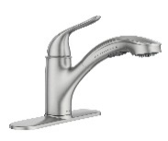**Meteorite – wheel – iron – faucet – pomegranate – volcano**

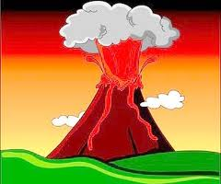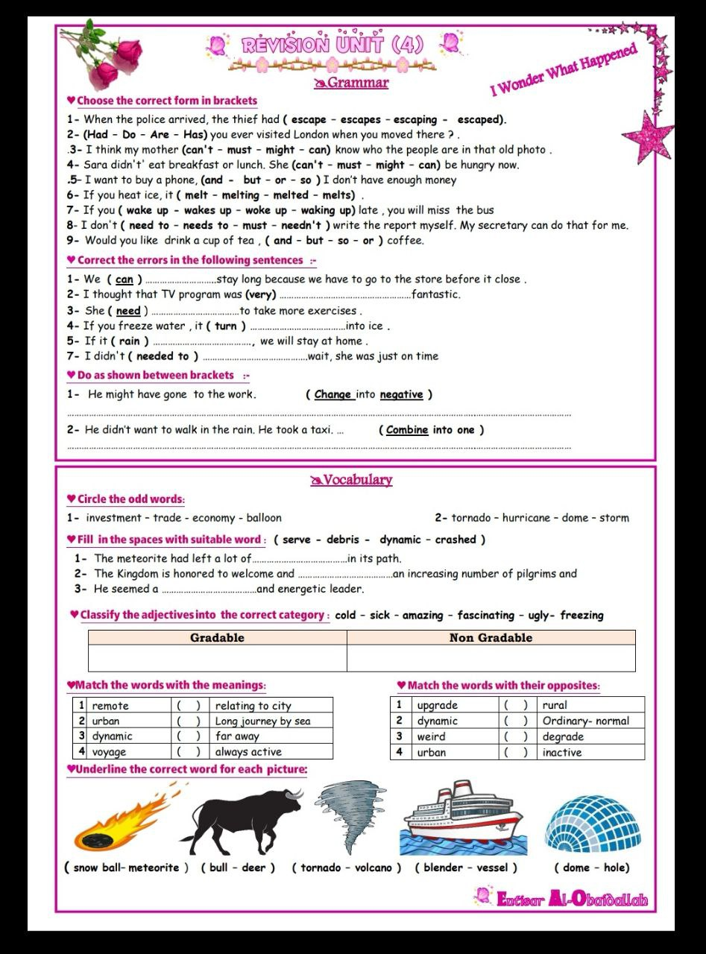****

**------ --------- ----------- ---------- --------- --------**

**A) Match to form new words or expressions:**

**1. oil ---- a. guard**

**2. scan ---- b. well**

**3. hair ---- c. get an image**

**4. devasted ---- d. style**

**5. meat ---- e. destroyed**

**6. security ---- f. grinder**

**End of Questions**

**Best of Luck** [**https://t.me/abokhaledamer**](https://t.me/abokhaledamer)