|  |  |  |  |
| --- | --- | --- | --- |
| **المملكة العربية السعودية**  **وزارة التعليم**  **الإدارة العامة للتعليم بـن مدرسة مستقبل ن الابتدائية** | **بسم الله الرحمن الرحيم** **اختبار الفصل الدراسي الثالث**  **للعام الدراسي 1443 هـ**  **https://t.me/abokhaledamer** | **المادة** | **لغة انجليزية** |
| **الصف** | **الرابع** |
| **الزمن** | **ساعة ونصف** |
| **الفصل** | **----- /4** |
| **اسم الطالب رباعيا: .............................................................................................................**   |  |  |  |  |  |  |  |  | | --- | --- | --- | --- | --- | --- | --- | --- | | **السؤال** | **1** | **2** | **3** | **4** | **5** | **6** | **المجموع** | | **الدرجة** |  |  |  |  |  |  |  | | **الدرجة** | 6 | 6 | 4 | 5 | 4 | 5 | 30 | | **المصحح** |  |  |  |  |  |  |  | | | | |

**I- General Questions:**

**6**

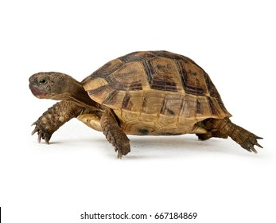**Q1: A- Choose the correct answer:**

**1. Do you have a pet?**

( Yes, I am 9 years old – Yes, I have a turtle - Yes, I am fine )

**2. What day do you like?**

**I like** ( Ali – windy - Friday ).



**3. What's the weather like today?**

It's ( sunny - Monday - cow ).

**B- Match the questions in column (A) with the correct answers in column (B):**

**6**

**6**

|  |  |
| --- | --- |
| **B** | **A** |
| **( ) I'm thirsty.**  **( ) Yes, I am.**  **( ) These are shirts.** | **1. Are you happy? 2. What's the matter? 3. What are these?** |

**Q2: A Write the correct number under each picture:**

****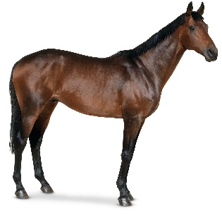**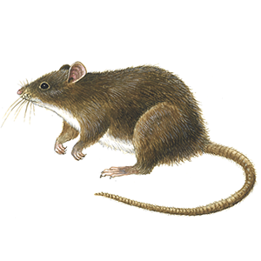1.zebra 2.mouse 3.umbrella 4.horse 5.rainy 6.hungry**

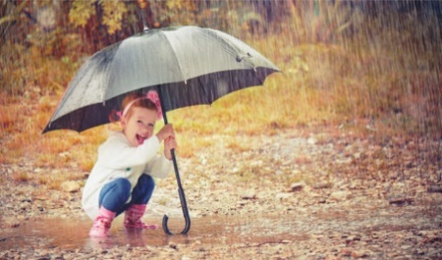****



**( ) ( ) ( ) ( ) ( ) ( )**

**صورة تحتوي على قصاصة فنية

تم إنشاء الوصف تلقائياًQ3: Put ( 🗸 ) or ( X ):**

**4**

**1. I have a fish. ( )**



**2. It is a tiger. ( )**

**3.There was a farmer who had a horse. ( )**



**4. It is windy today. ( )**

**Q4: A. Choose the correct answer:**

**5**

1. **( Do – Is – Are ) you have a pet?**
2. **I ( likes – like - liking ) Sunday.**
3. **( He – She - We ) is scared.**
4. 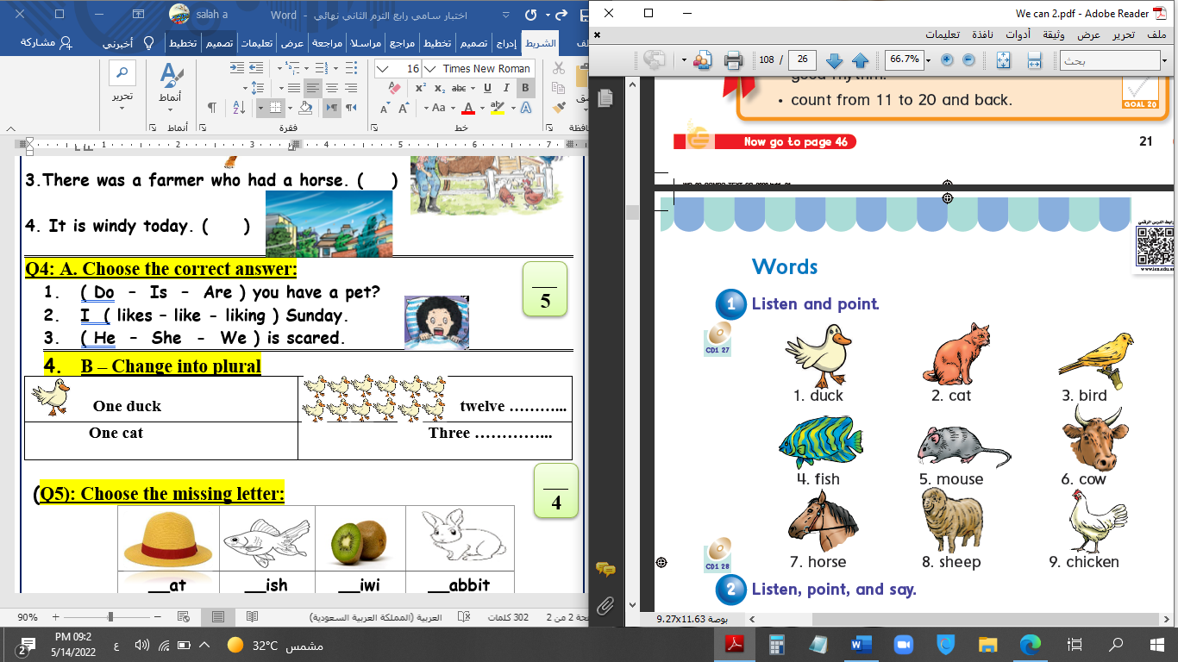******B – Change into plural**

|  |  |
| --- | --- |
| **One duck** | **twelve ----------** |
| **One cat** | **ten ----------** |

**4**

**Q5: Choose the missing letter:**

|  |  |  |  |
| --- | --- | --- | --- |
|  |  |  |  |
| __ase | **__olf** | **__loudy** | **__aptop** |
| F – V | **W - F** | **C - K** | **L - C** |

**Q6: Copy:**

**5**

**I have a new cap.**

|  |
| --- |
|  |
|  |
|  |

**End of Questions**