**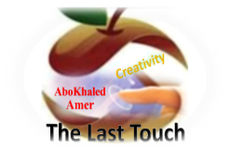****المملكة العربية السعودية**

**Kingdom of Saudi Arabia**

**Ministry of Education**

**------- Educational Directorate**

**------- Future Educational Schools**

**2nd grade intermediate 2022**

**3rd Term – Final Exam**

**وزارة التعليم**

**الإدارة العامة للتعليم بن**

**مدارس م ن التعليمية**

**الصف الثاني المتوسط**

**الاختبار النهائي للفصل الدراسي الثالث1443**

|  |  |  |  |  |  |  |  |
| --- | --- | --- | --- | --- | --- | --- | --- |
| **Total**  **written** | **5 spelling** | **4 Vocabulary** | **3 Grammar** | **2 Comprehension** | | **1 Composition** | **Q. NO.** |
|  |  |  |  |  | |  | **Mark Given** |
| **30** | **4** | **7** | **7** | **6** | | **6** | **Mark** |
|  | | | **Reviser** | |  | | **Corrector** |
|  | |

**زمن الاختبار: ساعتان**

**اسم الطالب: ------------------------------------ رقم الجلوس: ------------- الصف الثاني المتوسط**

**6**

1) **Composition**

**1- Write a paragraph about “Your Best Friend "**

**You may talk about the following words: His name – His age – His favorite color – His father job – His favorite subject – His favorite sport – His future job**

…………………………………………

………………………………………………………………………………………………………………………………………………………………………………………………………………………………………………………………………………………………………………………………………………………………………………………………………………………………………………………………………………………………………………………………………………………………………………………………………………………………….

**2) Comprehension**

**6**

**2- Read the following passage then answer the questions:**

**Bill's Family**

**My name’s Bill. I’m 12 years old. I have two brothers and one sister. My father is a doctor, and my mother is an English teacher. I live in a flat with my family. Our flat is on the second floor and there are three bedrooms and one kitchen. We also have a beautiful balcony. Our favorite day of the week is Saturday. We all get up at about 10 o’clock and have breakfast. Then I play computer games with my sister. After lunch, I go to the park to play football with my brothers. In the evening, I often play basketball with my friends. I like it but my brothers love football.**

**A- Put ( ) or ( x ):**

**1.In this passage, the boy's name is Billa. ( )**

**2.His father is a doctor. ( )**

**3.His flat is on the fourth floor. ( )**

**4.On Sunday, they have breakfast at 10 o'clock. ( )**

**5. He plays computer games with his brothers. ( )**

**B- Choose the correct answer:**

**1. Bill's mother is an (**science – math - English**) teacher.**

**2. In his flat, they have a beautiful (**horse – yard – balcony**).**

**3. He plays (**tennis – football – computer games**) with his brothers.**

**4. Bill's family are (**six – seven – eight**) members.**

**C- Answer the following questions:**

**1. How old is Bill?.............................**

**2. How many brothers does Bill have?...........................**

**3. Where does he go after lunch? ..............................**

**3) Grammar**

**A: Choose the correct answer:**

**7**

**1. They (am – is – are) going to visit their uncle.**

**2. (What – Where – Who) is he going to spend the weekend?**

**3. I (will – am going to – have) probably travel to Abha next summer.**

**4. (Why – When – What) is the weather like today?**

**5. (Could – Have – Are) you help me with this bag?**

**6. Let me (carry – carrying – carries) this box for you.**

**7. Hans (walk – was walking – walking) to college when he saw Samir.**

**8. She has (cleans – cleaning – cleaned) her own room.**

**B: Chang into Negative:**

**1. He is going to wash the car.**

…………………………………………………………………………………………………………………………………………………………………………………………………………………

**2. They were cooking lunch at home.**

……………………………………………………………………………………………………………………………………

3. **They have watched TV with their kids.**

……………………………………………………………………………………………………………………………………

**C: Make Yes/No question:**

**1. He will do his homework.**

……………………………………………………………………..……………………………………………………………

**2. Ali was helping his mom in the kitchen.**

……………………………………………………………………………………………………………………………………

**3. We have brushed our teeth.**

……………………………………………………………………………………………………………………………………

**4) vocabulary:**

**7**

**A- Match the words with the pictures:**

****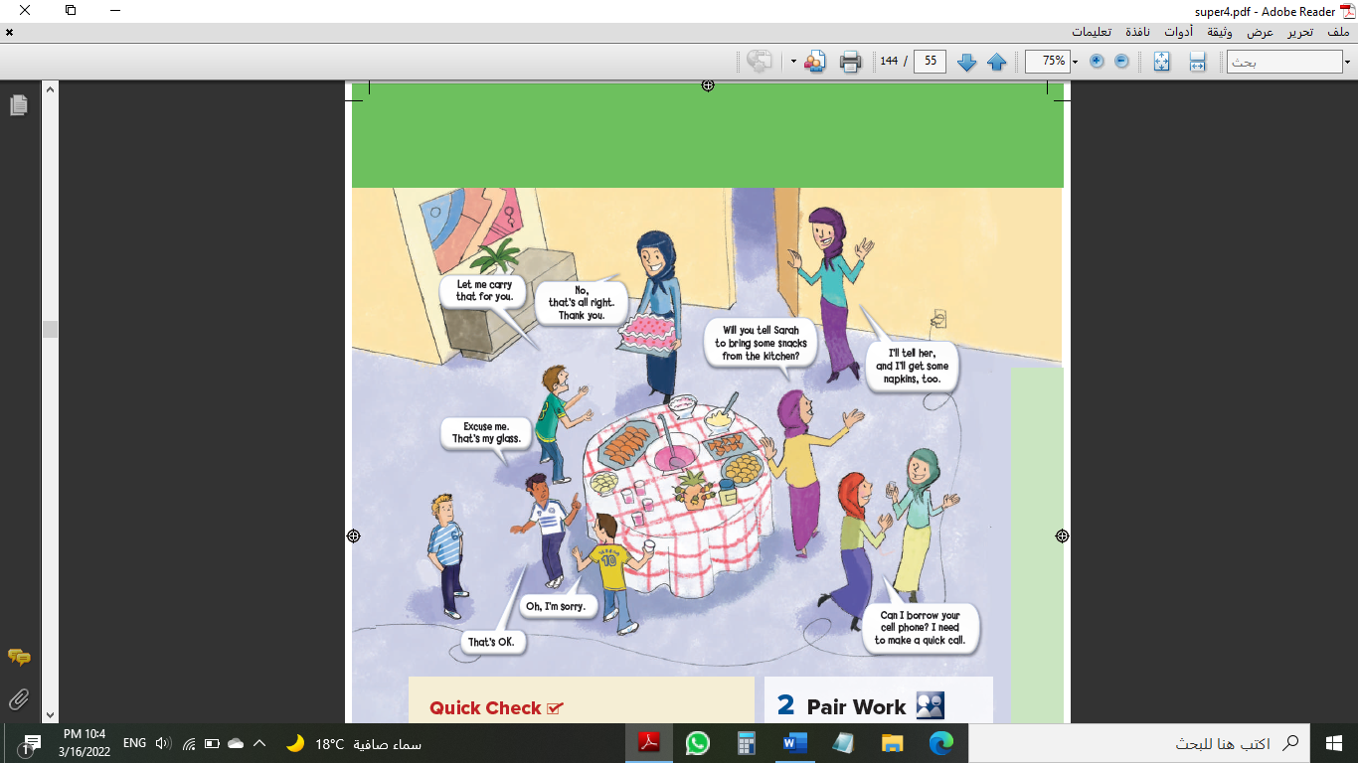**cake – parrot – pyramids – cliff hanging – graduation – rainy**



**……………. ……………. ……..……. ………..…… …………… …………..**

**B- Match the answers:**

|  |  |
| --- | --- |
| a. not certain | **1. We go the sea for ------** |
| b. No problem | **2. We say: "It depends" when we are ------** |
| c. scuba diving | **3. How many seasons are there in a year? ------** |
| d. Lost his job | **4. Can you open the door for me, Please? ------** |
| e. Four seasons | **5. He was "fired" means that he -------** |

**C- Circle the correct spelling:**

**1. awesome - awosome – owesome**

**2. snaek – snake - sanke**

**3. emergancy – emargency – emergency**

**5) Orthography**:

**4**

**A- Fill in the missing letters:**

**1- saf__ri**

**l – a – c – o – n**

**2- wor__d**

**3- fav__r**

**4- atta__k**

**B- Choose the odd one out:**

**1. written taken seen eat**

**2. going reading sing working**

**3. sunny cloudy year snowy**

**4. zebra doctor turtle zorse**

**End of Questions**

**Best of Luck https://t.me/abokhaledamer**