|  |  |  |  |  |  |  |  |  |  |
| --- | --- | --- | --- | --- | --- | --- | --- | --- | --- |
| **المملكة العربية السعودية** | |  | | | | **المادة:** | | **اللغة الانجليزية (شفوي)** | |
| **وزارة التعليم** | | **الصف** | | **الأول متوسط** | |
| **الادارة العامة للتعليم ب______** | | **التاريخ:** | | **/11/1444 هـــ** | |
| **مدرسة________المتوسطة** | | **الزمن:** | | **نصـف ساعة** | |
| **اختبار نهاية الفصل الدراسي الثالث – الدور الأول للعام الدراسي 1444 هـــــ** | | | | | | | | | |
| **الاستماع 5** |  | **التحدث 5** |  | **المجموع 10** |  | | | | |
| **الاسم ثلاثي** |  | | | **الفصل** | **أول /** | | **رقم الكشف** | |  |

**Listen and circle the right answer:**

|  |  |  |
| --- | --- | --- |
| 1. What did you do yesterday afternoon? | |  |
| 🔿 | I went to the zoo. |
| 🔿 | I went to the park. |
| 🔿 | I went to the museum. |

|  |  |  |
| --- | --- | --- |
| 1. Where were you? | |  |
| 🔿 | Sorry I was busy. |
| 🔿 | Sorry I was late. |
| 🔿 | Sorry I was sick |

|  |  |  |
| --- | --- | --- |
| 1. When is the national holiday   in your country? | |  |
| 🔿 | It is on the February 25th. |
| 🔿 | It is on the December 2nd. |
| 🔿 | It is on the September 23rd. |

|  |  |  |
| --- | --- | --- |
| 1. I don’t know what to wear   I’m going to go shopping for………… | |  |
| 🔿 | a formal blouse. |
| 🔿 | a formal dress. |
| 🔿 | a formal shoe. |

|  |  |  |
| --- | --- | --- |
| 1. Do you like to draw?   I like to_______ | |  |
| 🔿 | make design. |
| 🔿 | make models. |
| 🔿 | make things. |

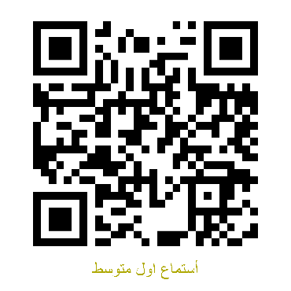 Audio: <https://youtu.be/DF9771ehDeA>