English Language Final Exam
Term: 1 – 1444 Session: 1
Time: 2:30 hrs
Grade: 1 - Mega Goal 1.1

Kingdom of Saudi Arabia
Ministry of Education
__________ Gen. Dept. of Education
__________ Secondary School

Graded by: | ________________________________________  ________________________________________ |  | Mark out of  30
Revised by:

اختبار مادة (اللغة الإنجليزية 1.1- الفصل الدراسي الأول - الدور الأول) للصف الأول ثانوي - للعام الدراسي 1444هـ - نظام المسارات
اسـم الطالب : ___________________________________________________________ رقم الجلوس : ________ اللجنة : ________

اللَّهمَّ لا سَهلَ إلَّا ما جَعَلتَه سَهلًا، وأنتَ تَجعَلُ الحَزْنَ إذا شِئتَ سَهلًا
- Reading Comprehension (1 mark each)
6

Read the following text, and then answer the questions below:

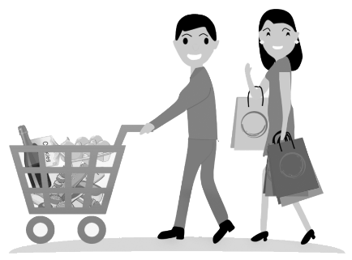
Today, hypermarkets are found in almost every city in the world. Panda, AlOthaim, Carrefour and LuLu are one of the famous hyper markets in Saudi Arabia. Euromarche was the first hypermarket opened in Saudi Arabia in 1981. A hypermarket is different from mini markets or other shops.
People prefer shopping in hypermarket because it is convenient, international and one-stop-shopping. Besides, there are special offers that most customers like. In hypermarkets, goods are placed on open shelves. The customers help themselves to choose what they want and put them in the shopping basket, then take them to the check–out counter. There are usually special shelves in hyper markets for inexpensive items just in front of the check – out counter: such as chocolate, sweets, gum and so on.
When customers reach the check – out counter, they can pay cash or with a bank card. Customers feel glad because their shopping is finished. To give comfort to customers, hypermarkets provide parking areas and stay open until very late at night. Nowadays, many of the hypermarkets become huge shopping centers and malls.

- (choose) The best title for this article is …..
a) History of Panda c) AlOthaim Mall b) Hypermarkets d) Mini Markets

- When was the first hypermarket opened in KSA? _________________________

- Why do people prefer shopping in hyper markets? (Write only 1 reason)
__________________________________________________________________________

- Choose the correct answer

- The _________ help themselves to choose their goods.
a) customers b) malls c) shelves d) check-out counters

- Put ( T ) for true or ( F ) for false sentences :

- Hypermarkets stay open until very late at night. [______]
- Nowadays, many of the hyper markets become mini shops. [______]
Page: 1 out of 4
P.T.O
- Vocabulary (½ mark each)
6

- Fill the blanks with the correct words

quality(iess) - treasure – plastic – motivation – disease

- I read a story of the discovery of hidden___________________ in the ocean.
- Please don’t throw away ___________________ bottles. Recycle them.
- He has a real ___________________ to work. He wants to buy a car.
- Khaled has different ___________________ . He is organized and reliable.

- Match word with its meaning

Word |  | Meaning
- to cash in |  | - to come together
- to witness |  | - to be strong
- to establish |  | - to set up; to start
- to gather |  | - to make money from
 |  | - to see an event

- Write the correct word and its picture
submarine - robot – bike - economy - cell phone

 |  | 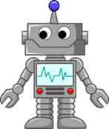 | 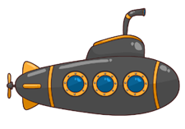
____________ | ____________ | ____________ | ____________
Page: 2 out of 4
P.T.O
- Grammar (½ mark each)
6

- Circle the correct answers

1) | Hey Jinan. _____________ lessons has she explained? Sara: I guess 6.
a- | How long | b- | How much | c- | How many | d- | How often
2) | This is the shirt _____________ I bought yesterday.
a- | who | b- | which | c- | where | d- | when
3) | When _____________ they watch the movie?
a- | do | b- | does | c- | is | d- | are
4) | The food will _____________ by my mother soon.
a- | cook | b- | cooked | c- | be cooked | d- | been cooking
5) | The store won't close soon, _____________ .
a- | will it? | b- | it won't? | c- | it will? | d- | won't it?
6) | Bader: _____________ bag did you buy? Ali : the black one
a- | who | b- | whose | c- | which | d- | who's
7) | He is interested _____________ reading novels.
a- | at | b- | in | c- | on | d- | of
8) | This coffee is hot _____________ . I can drink it
a- | very | b- | too | c- | enough | d- | many

- Unscramble the sentence
- new car / expensive / is not as / as the / the used car
________________________________________________________________

- Make it Negative
- My grandparents visited us last night.
My grandparents _____________________________ last night.

- Put the word in a correct Comparative form
- Water is ______________________ (healthy) than soda. Everybody knows that.

- Make a Question about the underlined
- They will go (to Dubai) tomorrow morning
______________________ will they go tomorrow morning?

Page: 3 out of 4
P.T.O
- Composition
- GUIDED COMPOSITION (6 Marks)
6
- Of no less than (70) words, write about: Teaching the Great Career.
- The followings words may help you.

dream – job – students - pass – knowledge – moral – values – educate – study

_____________________________________________________________________
_____________________________________________________________________
_____________________________________________________________________
_____________________________________________________________________
_____________________________________________________________________
_____________________________________________________________________
_____________________________________________________________________
_____________________________________________________________________
_____________________________________________________________________

- FREE COMPOSITION (6 Marks)
6
- Choose ONE topic and write a paragraph about it of no less than (50) words.

- Saudi Vision 2030
- My Favorite Gadget

_____________________________________________________________________
_____________________________________________________________________
_____________________________________________________________________
_____________________________________________________________________
_____________________________________________________________________
_____________________________________________________________________
_____________________________________________________________________
_____________________________________________________________________

Finished & Good Luck
Regards - ___________________

Page: 4 out of 4
Done by: Essa Al Hussaini

