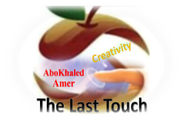

**Kingdom of Saudi Arabia**

**Ministry of Education**

**------- Educational Directorate**

**------- Educational Schools**

**1st Grade High School 2022**

**1st Term – Final Exam**

**المملكة العربية السعودية**

**وزارة التعليم**

**الإدارة العامة للتعليم بن**

**مدارس م ن التعليمية**

**الصف الأول الثانوي**

**الاختبار النهائي للفصل الدراسي الأول 1444هـ**

|  |  |  |  |  |  |  |  |
| --- | --- | --- | --- | --- | --- | --- | --- |
| **Total**  **Written** | **5**  **Vocabulary** | **4**  **Grammar** | **3**  **Free Composition** | **2**  **Guided Composition** | | **1 Comprehension** | **Q. NO.** |
|  |  |  |  |  | |  | **Mark Given** |
| **30**  **ABOKHALEDAMER**  **0557325813** | **6** | **6** | **6** | **6** | | **6** | **Mark** |
| **6** | | | **Reviser** | |  | | **Corrector** |
|  | |

**زمن الاختبار: 3 ساعات**

**اسم الطالب: ------------------------------------ رقم الجلوس: ------------- الصف الأول الثانوي**

**1)** **Comprehension**

**Read the following passage then answer the questions**

**A VISION OF THE FUTURE**

**The French writer Jules Verne wrote several books in the late 1800s. In *them*, he wrote about the future. He asked, “What will life be like at the end of the 20th century-one hundred years from now?” In one of his adventure novels (From the Earth to the Moon), his characters traveled to the moon in a rocket. In another novel (20,000 Leagues Under the Sea), his characters dove through the depths of the ocean in a submarine in the shape of a whale. In a novel titled Paris in the Twentieth Century, Verne described a city with skyscrapers of glass and steel, high-speed trains, gas-powered automobiles, and a global communications network. Space rockets and submarines and other things in his novels didn’t exist in Verne’s time, but many of the inventions that Verne imagined became reality by the end of the 1900s.**

***A)* Answer the following questions*:*  
1. Who is the passage talking about? ---------------------------------------------------------.**

**2. What was the nationality of Jules Verne? ---------------------------------------------------.**

**3. When did he write his books? ----------------------------------------------------------------.**

**4. What did he write about? ----------------------------------------------------------------.**

***B)* Put ( √ ) or ( X ):  
5. Jules Verne wrote about the past. ( )  
6. All Jules Verne’s imaginations were wrong. ( )**

**7.**  **In one of his novels, his characters traveled to the moon. ( )**

**8. The submarine was in the shape of a whale. ( )  
*C)* Complete*:*  
9. The title of his novel about a submarine was “-------------------------------------------".  
10. Jules Verne described a city with skyscrapers of --------------- and ---------------.**

***D)* Choose the correct answer*:***

**11. Jules Verne was [** a teacher – a writer – an engineer**].**

**12. Line 1: the underlined word (them) refers to his: (**books – rockets – submarines)

**2) Guided Composition**

**6**

**You want to buy a new story. There are many advertisements about stories.**

**Write a paragraph about: “Your Favorite story”**

**You may use the Guiding words:**

(story – characters – actions – places – price …)

-------------------------------------------------------

---------------------------------------------------------------------------------------------------------------------------------------------------------------------------------------------------------------------------------------------------------------------------------------------------------------------------------------------------------------------------------------------------------------------------------------------------------------------------------------------------------------------------------------------------------------------------------------------------------------------------------------------------------------------------------------------------------------------------------------------------------------------------------------------------------------------------------------------------------------------------------------------------------------------------------------------------------------------------------------------------------------------------------------------------------------------------------------------------------------------------------------------------------------------------------------------------------------------------------------------------------------------------------------------------------------------------------------------------------------------------------------------------------------------------------------------------------------------------------------------------------

**3) Free Composition**

**6**

**Choose one topic from the following to write about.**

**1. Write an email to STC asking for a job. Present your Education, Experience, Skills…**

**2. Write a paragraph about: “Your Dream Intelligent Home”.**

-------------------------------------------------------

------------------------------------------------------------------------------------------------------------------------------------------------------------------------------------------------------------------------------------------------------------------------------------------------------------------------------------------------------------------------------------------------------------------------------------------------------------------------------------------------------------------------------------------------------------------------------------------------------------------------------------------------------------------------------------------------------------------------------------------------------------------------------------------------------------------------------------------------------------------------------------------------------------------------------------------------------------------------------------------------------------------------------------------------------------------------------------------------------------------------------------------------------------------------------------------------------------------------------------------------------------------------------------------------------------------------------------------------------

**4) Grammar**

**6**

**A: Choose the correct answer:**

**1. He (is living – live – lives) with his uncle until he can find his own place.**

**2. The scientists (isn't understanding – don’t understand – understands) the problem.**

**3. I’m interested in (worked – works – working) outdoors.**

**4. Hanan has been (reading – read – reads) a book for two hours.**

**5. Maybe I (am going to – will – was) go to Abha.**

**6. Our products have been (use – uses – used) by travelers all over the world.**

**Do as shown between brackets:**

**1. Currently, the number of immigrants in our country (increase).** (Correct the verb)

-------------------------------------------------------------------------------------------------.

**2. I’m not very good** ------- **speaking in public. (Insert a preposition)**

-------------------------------------------------------------------------------------------------.

**3. Adnan has been (write) books for years (Correct the verb)**

-------------------------------------------------------------------------------------------------.

**4. I’m going to spend a month in Abha. (Make Negative)**

-------------------------------------------------------------------------------------------------.

**5. Saleh is tall. Ahmed is tall. (use: as…as)**

-------------------------------------------------------------------------------------------------.

**6. Karl Benz made the first car in 1886. (Make Passive)**

-------------------------------------------------------------------------------------------------.

**6**

**5) vocabulary:**

**A-Write the number under its pictures:**

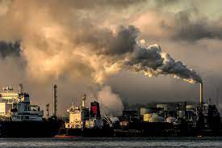**1. ice cream 2.haircut 3.Masmak Fort 4.artist 5.pollution 6.suitcase**

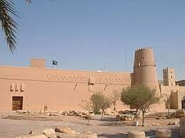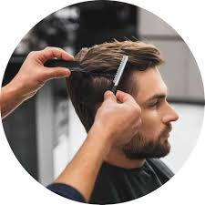

**( ) ( ) ( ) ( ) ( ) ( )**

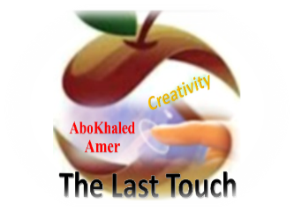**A) Match to form new words or expressions:**

**1. launch ---- a. come together**

**2. fast food ---- b. send into space**

**3. gather ---- c. restaurant**

**4. By the way ---- d. Used to say “Yes”.**

**5. day after day ---- e. Introduce new topic.**

**6. Certainly ---- f. Following the same pattern**

**End of Questions**

**Best of Luck** [**https://t.me/abokhaledamer**](https://t.me/abokhaledamer)