6
Q1-Composition:
Write a paragraph about ( Yourself ) use the answers of these questions:
1-What is your name?
2-How old are you?
3-Where are you from?
4-What is your nationality?
5-What do you do?
My Self

________________________________________________________________________________________________________________________________________________

6
Q2-Reading:
Read the passage and answer the questions:
My Father
I love my father. He is very kind. He is called Robert. He is 45 years old. He is an active person. He gets up Early to get ready for his work. He is an architect. He is always design high skyscrapers.

Answer the following questions:
A – Choose the correct answer:
1-His father's name is……. | a-Ahmad | b-Robert | c-Billy | d-Jaky
2-His father age ……. | a-55 | b- 45 | c-54 | d-44
3-He get up ………. | a-early | b-late | c-slowly | d-quickly
4-His father is very ……. | a-kind | b-happy | c-teacher | d-sad
( 1 )
B- Write ( T ) or ( F ) at end of each statement:
1-He is an active person ( )
2-He love his father ( )
7
Q3-Grammar:
A-Choose the correct words:

1-Do you have ……… brother. | a-any | b-some | c-yes | d-no
2-Is there a bedroom in the house? | a-yes, there is | b-yes, there have | c-no, there aren't | d-no, there haven't
3-I …….. from Saudi Arabia. | a-am | b-is | c-are | d-he
4-They…… father. | a-have | b-has | c-is | d-am
5-He ……. Ali. | a-are | b-is | c-am | d-were
6-This is …….. book. | a-he | b-my | c-she | d-it

B-Write the correct plural words:

1-Man ……...... 2- Book……………
3-Boy ………. 4-Key ………

C- Write the correct articles ( a – an – the ) :

1-………. Orange. 2-……..Pen
3-…….. Sea 4-…….. ice cream.

( 2 )

7
Q4-Vocabulary:
A-Match the correct word for each picture:
Grandmother – Pen – dolphin – Camera – Cat – Scissors – lamp – car

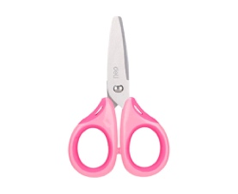

………………… ………………. ……………… …………………

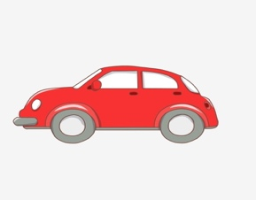 | 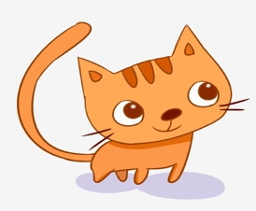 |  | 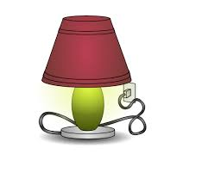

……………….. …………….. ………………. …………………

B-Match the following phrases with their meaning:

1- | You're welcome |  | a.a polite reply to"Thank you"
2- | Excuse me |  | b-an expression to get someone's attention.
3- | I've got |  | c-no. not very much
4- | Not really |  | d- I have

C-Choose the correct words:
1-Sit……, please. | a-up | b-down | c-over | d-on
2-My mam's sister is my …….. | a-nice | b-aunt | c-cousin | d-son
( 3 )
4
Q5-Orthography (Spelling ):
A-Choose the missing letters:
o - p - a - i

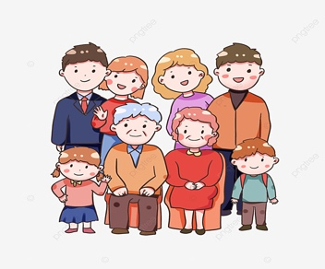 |  | 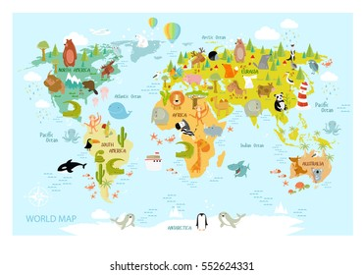 | 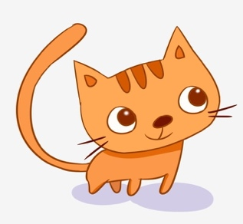

Fam….ly bo…..ks ma……. c….t

B-Choose the correct letter:

1-Carmen is a good w…..fe | a-( o ) | b-( i ) | c-( e ) | d-( y )
2-We treat our gran….parents with respct. | a-( u ) | b-( d ) | c-( a ) | d-( m )
3-you seem to be an honest m….n. | a-( e ) | b-( a ) | c-( s ) | d-( t )
4-The c…t would like to eat the mouse. | a-( t ) | b-( a ) | c-( k ) | d-( u )
5-I am have on v….cation. | a-( a ) | b-( f ) | c-( i ) | d-( e )
6-I will be ho…e early. | a-( m ) | b-( a ) | c-( u ) | d-( j )
7-We do not leave E….ypt. | a-( g ) | b-( u ) | c-( t ) | d-( a )
8-Even without makeup, she's very c…te. | a-( u ) | b-( p ) | c-( y ) | d-( e )

C-Copy this sentences :
1-The girl have a brother. 2-Camera
……………………………………………. ……………………………….
2-He is a doctor. 4-Read the book .
……………………………………………. ………………………………

( 4 ) Good luck | Tr.Maryam Alotaibi

