**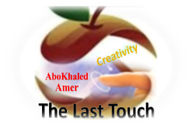****المملكة العربية السعودية**

**Kingdom of Saudi Arabia**

**Ministry of Education**

**------- Educational Directorate**

**------- Educational Schools**

**3rd grade intermediate 2022**

**1st Term – Final Exam**

**وزارة التعليم**

**الإدارة العامة للتعليم بن**

**مدارس م ن التعليمية**

**الصف الثالث المتوسط**

**الاختبار النهائي للفصل الدراسي الأول 1444هـ**

|  |  |  |  |  |  |  |  |
| --- | --- | --- | --- | --- | --- | --- | --- |
| **Total**  **written** | **5 spelling** | **4 Vocabulary** | **3 Grammar** | **2 Comprehension** | | **1 Composition** | **Q. NO.** |
|  |  |  |  |  | |  | **Mark Given** |
| **30** | **4** | **7** | **7** | **6** | | **6** | **Mark** |
| **ABOKHALEDAMER**  **0557325813** | | | **Reviser** | |  | | **Corrector** |
|  | |

**زمن الاختبار: ساعتان**

**اسم الطالب: ------------------------------------ رقم الجلوس: ------------- الصف الثالث المتوسط**

**6**

1) **Composition**

**1- Write a paragraph about “Your Hobby"**

**You may use these words: painting – drawing – picture – brushes – relaxing - ….**

…………………………………………

………………………………………………………………………………………………………………………………………………………………………………………………………………………………………………………………………………………………………………………………………………………………………………………………………………………………………………………………………………………………………………………………………………………………………………………………………………………………….

**6**

**2) Comprehension**

**2- Read the following passage then answer the questions:**

Mohamed and his family were in London last week. It was very expensive. They stayed in a hotel for three days. Then they took an apartment. Mohamed stayed there until Friday. He flew back home last night. His father is still there. His mother is with his father. Next week, Mohamed is going somewhere else.

**A- Put ( ) or ( x ):**

**1. Mohamed and his family were in Paris. ( )**

**2. Staying in London was cheap. ( )**

**3. Mohamed flew back home last night. ( )**

**4. Next month, Mohamed is going somewhere else. ( )**

**5. The apartment was cheaper than the hotel. ( )**

**B- Choose the correct answer:**

**1. He stayed there until (**Friday – Saturday – Sunday**).**

**2. Mohamed and his family were in London last (**year – week – day).

**3. They took an (**hotel – apartment – house**).**

**4. Next (**week – holiday – day**), Mohammad is going somewhere else.**

**C- Answer the following questions:**

**1. Where were Mohamed and his family last week?**

----------------------------------------------------------------.

**2. How long did they stay in a hotel?**

----------------------------------------------------------------.

**3. Who stayed in London?**

----------------------------------------------------------------.

**3) Grammar**

**7**

**A: Choose the correct answer:**

**1. I rarely (**drink – drinks – drinking**) coffee.**

**2. How (**old – many – often**) do you use your cell phone?**

**3. I (**am – were – was**) born in Najran.**

**4. When I was little, I (**uses to – use to – used to**) play with toys.**

**5. My friends are (**waited – waiting – wait**) for me at the airport**

**6. Maybe I (**was – am going to – will**) stay with friends.**

**7. How (**many – much – often**) bananas do you eat?**

**8. I don’t have (**something – nothing – anything**) for lunch.**

**B: Do as shown between brackets:**

**1. How (many) milk do you drink? (Correct)**

**------------------------------------------------------------------------------------------**

**2. I eat a little seafood. (Change into Negative)**

**------------------------------------------------------------------------------------------**

**3. What – doing – you – are – tonight? (Rearrange)**

**------------------------------------------------------------------------------------------**

**4. He is going to travel this year. (Make Yes/No Question)**

**------------------------------------------------------------------------------------------**

**5. His parents were (marry) in Tabuk. (Correct the verb)**

**------------------------------------------------------------------------------------------**

**6. Ibrahim constantly talks on the phone. (rarely)**

**------------------------------------------------------------------------------------------**

**4) vocabulary:**

**7**

**A- Write the number under its pictures:**

**Cellphone – tea – suitcase – infant – donate – exercise**

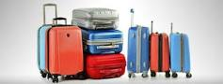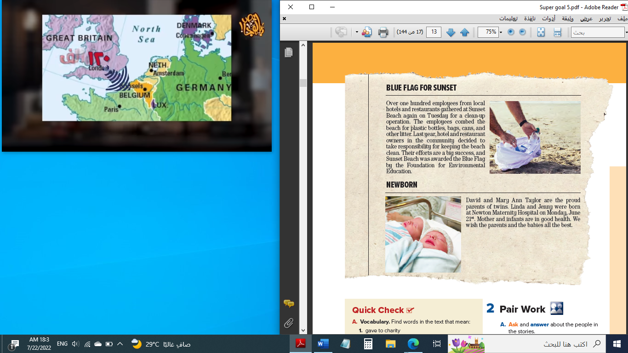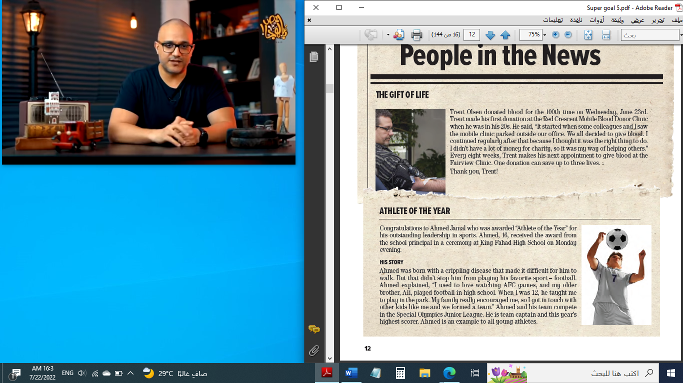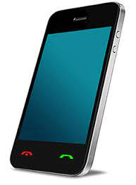

**( ) ( ) ( ) ( ) ( ) ( )**

**B- Match the answers:**

|  |  |  |
| --- | --- | --- |
| **a. in some ways / slightly** | **1. turn (someone) off** | ------ |
| **b. does not interest at all** | **2. kind of** | ------ |
| **c. a big city** | **3. big break.** | ------ |
| **d. important opportunity** | **4. I can’t wait.** | ------ |
| **e. I am very eager for something.** | **5. metropolis** | ------ |

**C- Circle the correct spelling:**

**1. gather - gother – gether**

**2. appont – appiont - appoint**

**3. tickit – tickete – ticket**

**5) Orthography**:

**4**

**A- Fill in the missing letters:**

**1. add__ct**

**z – o – i – r**

**2. bl__od**

**3. airpo__t**

**4. appeti__er**

**B- Choose the odd one out:**

**1. milk coffee school juice**

**2. nurse doctor meat dentist**

**3. always sleep usually sometimes**

**4. funny What When Where**

**End of Questions**

**Best of Luck https://t.me/abokhaledamer**

**ABOKHALEDAMER**

**0557325813**