|  |  |  |  |
| --- | --- | --- | --- |
| **المملكة العربية السعودية**  **وزارة التعليم**  **الإدارة العامة للتعليم بـن مدرسة مستقبل ن الابتدائية** | **بسم الله الرحمن الرحيم** **اختبار الفصل الدراسي الثالث**  **للعام الدراسي 1443 هـ**  **https://t.me/abokhaledamer** | **المادة** | **لغة انجليزية** |
| **الصف** | **الرابع** |
| **الزمن** | **ساعة ونصف** |
| **الفصل** | **----- /4** |
| **اسم الطالب رباعيا: .............................................................................................................**   |  |  |  |  |  |  |  |  | | --- | --- | --- | --- | --- | --- | --- | --- | | **السؤال** | **1** | **2** | **3** | **4** | **5** | **6** | **المجموع** | | **الدرجة** |  |  |  |  |  |  |  | | **الدرجة** | 4 | 5 | 6 | 6 | 5 | 4 | 30 | | **المصحح** |  |  |  |  |  |  |  | | | | |

**I- General Questions:**

**4**

**Q1: Answer the following questions correctly:**

**1. What's the weather like today? ---------------------.**

**2. Are you happy?**  **-------------------------.**

**3. What day do you like? ------------------**

**4. Do you have a pet? -----------------------------------**

**II- Controlled Writing:**

**5**

**Q2: A. Match the following:**

**1. Sunday, _________, Tuesday. a. name**

**2. The capital letter of "u" is ____ b. Monday**

**3. This is his parrot. His ____is Tim. c. U**

**Q2: B. Rearrange the following:**

**1. is – What – the – matter? ________ ___ ____ _________.**

**2. like – I – Friday. ___ ______ __________.**

**III- Grammar:**

**6**

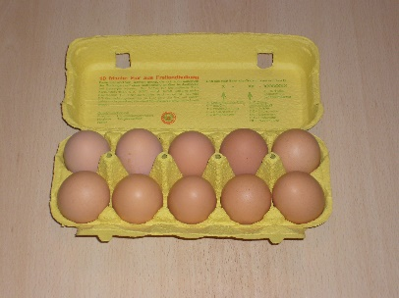**Q4: Choose the correct answer:**

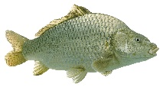**1- There are 10 ______. ( egg – eggs – an egg ).**

**2- I _____ ( is – have – am ) a fish.**

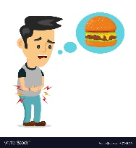**3- Do you have a pet? (No, I don't. – Yes, I am. – No, I am not.)**

**4- _____ you hungry? ( Is – Are – Am )**

**5- _____ ( What – How – Where ) old is Nora?**

**6. The ball is _____ the box. ( in – on – under )**

**IV- Vocabulary:**

**6**

**Q5: Write the number under picture:**

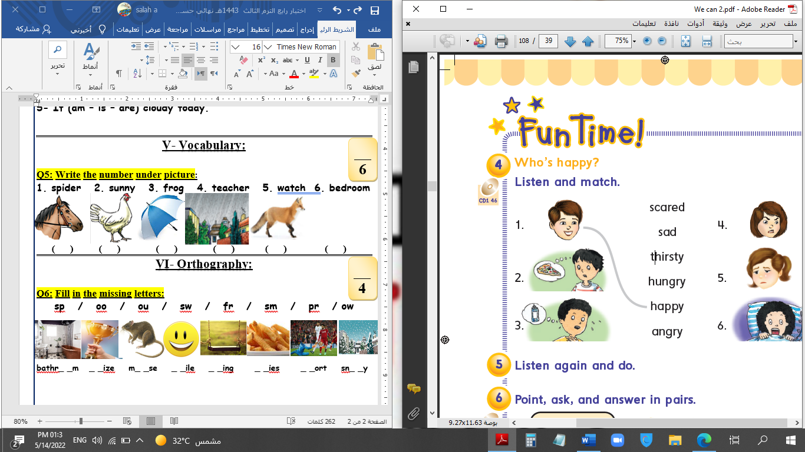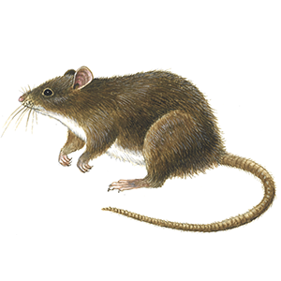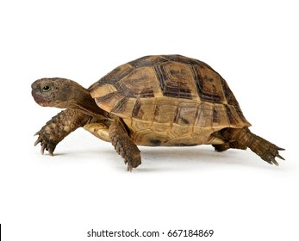**1.turtle 2.Tweet,tweet 3.happy 4.glasses 5.scared 6.mouse**



**( ) ( ) ( ) ( ) ( ) ( )**

**V- Reading Short Sentence:**

**5**

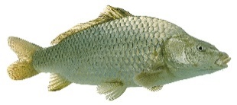**Q3: Match the sentence with the pictures:**

**1. The sound of a cow is Moo, moo.**



**2. The farmer has a horse.**



**3. I'm hungry.**

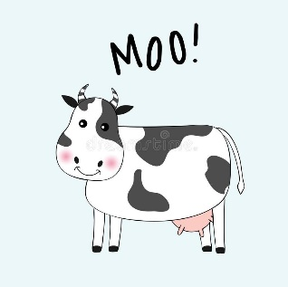

**4. It's rainy today.**

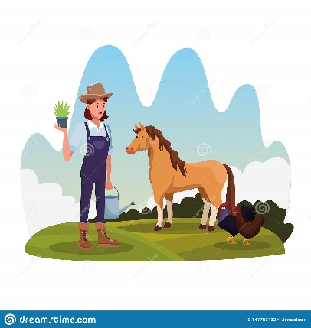**5. I have a fish.**

**VI- Orthography:**

**4**

**Q6: Fill in the missing letters:**  **( u – v – ch – t )**

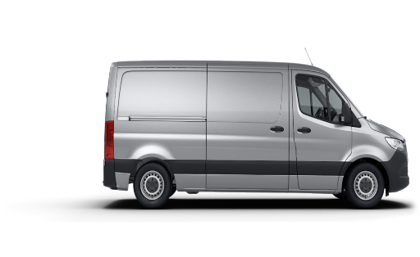****

**__iger __mbrella __an __ips**

**End of Questions**