**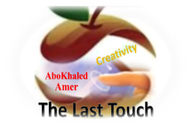****المملكة العربية السعودية**

**Kingdom of Saudi Arabia**

**Ministry of Education**

**------- Educational Directorate**

**------- Future Educational Schools**

**2nd grade intermediate 2022**

**3rd Term – Final Exam**

**وزارة التعليم**

**الإدارة العامة للتعليم بن**

**مدارس م ن التعليمية**

**الصف الثاني المتوسط**

**الاختبار النهائي للفصل الدراسي الثالث1443**

|  |  |  |  |  |  |  |  |
| --- | --- | --- | --- | --- | --- | --- | --- |
| **Total**  **written** | **5 spelling** | **4 Vocabulary** | **3 Grammar** | **2 Comprehension** | | **1 Composition** | **Q. NO.** |
|  |  |  |  |  | |  | **Mark Given** |
| **30** | **4** | **7** | **7** | **6** | | **6** | **Mark** |
|  | | | **Reviser** | |  | | **Corrector** |
|  | |

**زمن الاختبار: ساعتان**

**اسم الطالب: ------------------------------------ رقم الجلوس: ------------- الصف الثاني المتوسط**

**6**

1) **Composition**

**1- Write a paragraph about “How the Weather Affects you "**

**You may talk about the following words: Feel – rainy – window – spend – trouble**

…………………………………………

………………………………………………………………………………………………………………………………………………………………………………………………………………………………………………………………………………………………………………………………………………………………………………………………………………………………………………………………………………………………………………………………………………………………………………………………………………………………….

**2) Comprehension**

**6**

**2- Read the following passage then answer the questions:**

**Wonderful Vacation**

**Last vacation I went with my family to Egypt. At the beginning, we went on a cruise on the River Nile. We left Cairo on Friday morning and got back on Monday evening. It was a wonderful experience. Then we stayed in Cairo for five days. We went sightseeing and we visited the Egyptian Museum, too. There were so many interesting things to see there. We also visited the Pyramids in Giza and took lots of pictures. They were amazing! My parents and I also tried camel riding. It was lots of fun. I really want to visit Egypt again. It’s beautiful and there are many things to see and do there!**

**A- Put ( ) or ( x ):**

**1.Last vacation, they went on vacation to Egypt. ( )**

**2.They stayed in Cairo for seven days. ( )**

**3.They visited the pyramids and the museum. ( )**

**4.They all tried horse riding in the pyramids. ( )**

**5. They really want visit Egypt again. ( )**

**B- Choose the correct answer:**

**1. The family left Cairo on (**Monday – Sunday – Friday**) morning.**

**2. They went (**sightseeing – hang gliding – scuba diving**) in Egypt.**

**3. The vacation to Egypt was lots of (**fan – fat – fun**).**

**4. There were (**few – many – lot**) things to see and do in Egypt.**

**C- Answer the following questions:**

**1. Where did the family go last summer?.........................**

**2. Did they enjoy their stay there?...........................**

**3. What is the river they went on a cruise on? ..................**

**3) Grammar**

**A: Choose the correct answer:**

**7**

**1. He is (**go to – goes to – going to**) spend happy time.**

**2. (**What – Where – When**) are they going to leave for London?**

**3. Maybe, she (**will – am going to – have**) visit us next holiday.**

**4. What is the weather like today? (**He is – She is – It is**) sunny.**

**5. Can you (**clear – clears – clearing**) my way, please?**

**6. (**Let – Tell – Lets**) me help you with this box.**

**7. They (**waiting – were waiting – wait**) for the bus when it started raining.**

**8. We have (used – use – uses) all the toothpaste.**

**B: Chang into Negative:**

**1. We are going to brush our teeth.**

…………………………………………………………………………………………………………………………………………………………………………………………………………………

**2. He was feeding the fish.**

……………………………………………………………………………………………………………………………………

3. **She has spoiled all the nail polish.**

……………………………………………………………………………………………………………………………………

**C: Make Yes/No question:**

**1. They will set the table.**

……………………………………………………………………..……………………………………………………………

**2. They were washing the dishes.**

……………………………………………………………………………………………………………………………………

**3. I have finished all the cooking.**

……………………………………………………………………………………………………………………………………

**4) vocabulary:**

**7**

**A- Match the words with the pictures:**

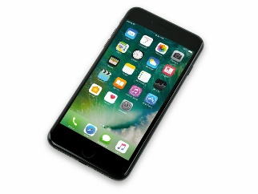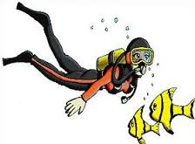**anaconda – cellphone – relaxing – snowy – scuba diving – safari**

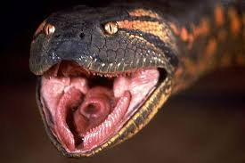****

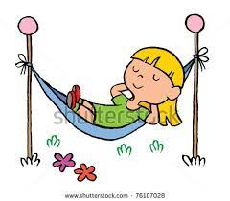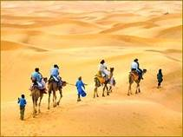

**……………. ……………. ……..……. ………..…… …………… …………..**

**B- Match the answers:**

|  |  |
| --- | --- |
| a. introduce news | **1. We went to the mountains for -------** |
| b. very cold | **2. Wild animals usually live in the --------** |
| c. cliff hanging | **3. How many months are there in a year? ---------** |
| d. jungle | **4. We say, " I hear " when we ---------** |
| e. twelve months | **5. The temperature is "below zero" means it is ---------** |

**C- Circle the correct spelling:**

**1. windy - widny – winyd**

**2. parot – parrat - parrot**

**3. wierd – weird – weired**

**5) Orthography**:

**4**

**A- Fill in the missing letters:**

**1- des__rt**

**p – s – u – e – t**

**2- zookee__er**

**3- ho__pital**

**4- pop__lar**

**B- Choose the odd one out:**

**1. can could will Ali**

**2. helped cleaned worked sleep**

**3. stormy parrot foggy snowy**

**4. scuba diving hang gliding cliff hanging doctor**

**End of Questions**

**Best of Luck https://t.me/abokhaledamer**