**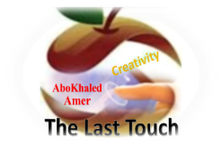****المملكة العربية السعودية**

**Kingdom of Saudi Arabia**

**Ministry of Education**

**------- Educational Directorate**

**------- Future Educational Schools**

**1st grade intermediate 2022**

**3rd Term – Final Exam**

**وزارة التعليم**

**الإدارة العامة للتعليم بن**

**مدارس م ن التعليمية**

**الصف الاول المتوسط**

**الاختبار النهائي للفصل الدراسي الثالث1443**

|  |  |  |  |  |  |  |  |
| --- | --- | --- | --- | --- | --- | --- | --- |
| **Total**  **written** | **5 spelling** | **4 Vocabulary** | **3 Grammar** | **2 Comprehension** | | **1 Composition** | **Q. NO.** |
|  |  |  |  |  | |  | **Mark Given** |
| **30** | **4** | **7** | **7** | **6** | | **6** | **Mark** |
|  | | | **Reviser** | |  | | **Corrector** |
|  | |

**زمن الاختبار: ساعتان**

**اسم الطالب: ------------------------------------ رقم الجلوس: ------------- الصف الأول المتوسط**

**6**

1) **Composition**

**1- Write a paragraph about “Your Favorite Clothes"**

**You may use the following words: favorite – cool – wear – home - weather- school-…**

…………………………………………

………………………………………………………………………………………………………………………………………………………………………………………………………………………………………………………………………………………………………………………………………………………………………………………………………………………………………………………………………………………………………………………………………………………………………………………………………………………………….

**2) Comprehension**

**6**

**2- Read the following passage then answer the questions:**

**Janadriyah Festival**

**Every year in Saudi Arabia, many people from all over the country and from abroad attend the Janadriyah national heritage and culture festival. The festival takes place in a village near Riyadh, and it is normally held between November and March when the heat is less extreme. The festival celebrates symbols of Saudi identity. There are camel races and horse races, displays of regional costumes, cuisines, and crafts such a carpet-weaving, and pottery. There are donkey rides, which are very popular with children. The festival lasts for two weeks.**

**A- Put ( ) or ( x ):**

**1.The text is about camel racing in Saudi Arabia. ( )**

**2.Only people who live in Saudi Arabia can attend the festival. ( )**

**3.The festival is usually held when the temperatures are cooler. ( )**

**4.Children like the donkey rides. ( )**

**5. The festival lasts for two weeks. ( )**

**B- Choose the correct answer:**

**1. Janadriyah is Every (**month – season – year**) in Saudi Arabia.**

**2. There are camel races and horse (**eating – races – graces**).**

**3. The festival celebrates symbols of Saudi (**flag – people – identity**)**

**4. The festival is between November and (**April – March – May**).**

**C- Answer the following questions:**

**1. What is the name of the festival?.............................**

**2. Where does Janadriyah take place?...........................**

**3. How long does the festival last? ..............................**

**3) Grammar**

**A: Choose the correct answer:**

**7**

**1. She is good at English. She (**can – can't – is**) speak it well**

**2. He (**don't like – doesn't like – isn't like**) to cook food.**

**3. They (**am – is – are**) going to sleep early.**

**4. I want to meet my neighbors. I don’t know (**them – him – her**)**

**5. We need (**to buy – buy – buying**) some snacks.**

**6. He (**was – were – are**) at home.**

**7. They (**went – goes – going**) to the beach last summer.**

**8. Did he play football? Yes, he (**is – did – didn't**).**

**B: Chang into Negative:**

**1. I can clean my room.**

…………………………………………………………………………………………………………………………………………………………………………………………………………………

**2. She is going to help her mom.**

……………………………………………………………………………………………………………………………………

3. **They watched TV at home.**

……………………………………………………………………………………………………………………………………

**C: Make Yes/No question:**

**1. She can cook lunch.**

……………………………………………………………………..……………………………………………………………

**2. They are going to study English.**

……………………………………………………………………………………………………………………………………

**3. He worked hard.**

……………………………………………………………………………………………………………………………………

**4) vocabulary:**

**7**

**A- Match the words with the pictures :**

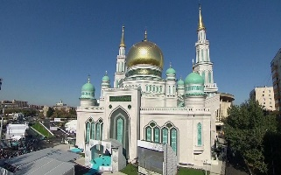**pizza 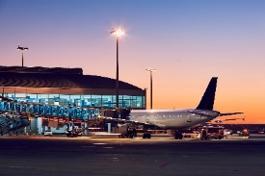– shoes – graduation – mosque – airport – exercise**



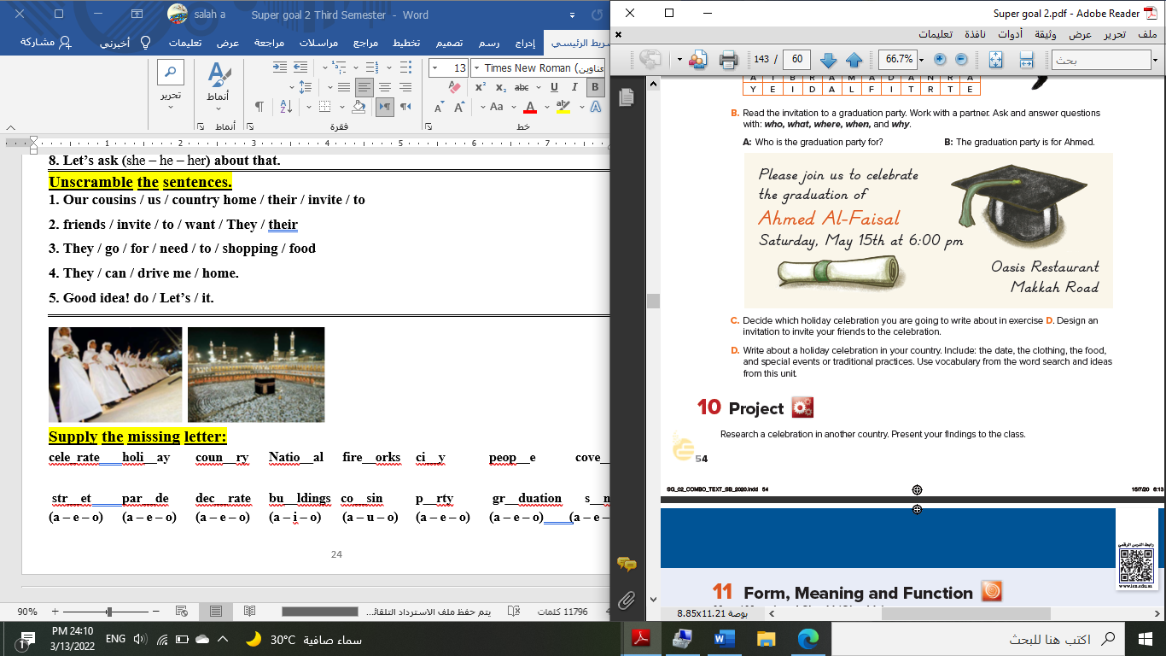****

**……………... ……………. ……..………. ………… …………… …………..**

**B- Match the answers:**

|  |  |
| --- | --- |
| a. National Day | **1. Visitors can sleep there. --------** |
| b. Vacation | **2. Women wear these formal clothes.** -------- |
| c. hotel | **3. In Saudi Arabia, people celebrate the -**------ |
| d. abayas | **4. Majed Ahmed Abdullah was a famous** ------- |
| e. footballer | **5. We traveled to Egypt during the summer ---------** |

**C- Circle the correct spelling:**

**1. moring - morning – marning**

**2. skyscraper – skyskraper - ckyscraper**

**3. celebote – celeprate – celebrate**

**5) Orthography**:

**4**

**A- Fill in the missing letters:**

**1- cl__thes**

**a – o – u – s – c**

**2- book__tore**

**3- par__de**

**4- pop__lation**

**B- Choose the odd one out:**

**1. shorts jeans pants TV**

**2. school restaurant gym eat**

**3. watched TV Played tennis helped Ali eat fish**

**4. footballer doctor scientist car**

**End of Questions**

**Best of Luck https://t.me/abokhaledamer**