**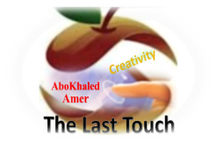****المملكة العربية السعودية**

**Kingdom of Saudi Arabia**

**Ministry of Education**

**------- Educational Directorate**

**------- Future Educational Schools**

**1st grade intermediate 2022**

**3rd Term – Final Exam**

**وزارة التعليم**

**الإدارة العامة للتعليم بن**

**مدارس م ن التعليمية**

**الصف الاول المتوسط**

**الاختبار النهائي للفصل الدراسي الثالث1443**

|  |  |  |  |  |  |  |  |
| --- | --- | --- | --- | --- | --- | --- | --- |
| **Total**  **written** | **5 spelling** | **4 Vocabulary** | **3 Grammar** | **2 Comprehension** | | **1 Composition** | **Q. NO.** |
|  |  |  |  |  | |  | **Mark Given** |
| **30** | **4** | **7** | **7** | **6** | | **6** | **Mark** |
|  | | | **Reviser** | |  | | **Corrector** |
|  | |

**زمن الاختبار: ساعتان**

**اسم الطالب: ------------------------------------ رقم الجلوس: ------------- الصف الأول المتوسط**

**6**

1) **Composition**

**1- Write a paragraph about “Your Favorite Place"**

**You may use 50 words:**

…………………………………………

………………………………………………………………………………………………………………………………………………………………………………………………………………………………………………………………………………………………………………………………………………………………………………………………………………………………………………………………………………………………………………………………………………………………………………………………………………………………….

**2) Comprehension**

**6**

**2- Read the following passage then answer the questions:**

**The Sports Center**

**I like to go to the sports center. I go there every weekend. At the sports center, you can do many things. For example, you can play golf or tennis. There is a pool, so you can also swim or relax by the pool. There is a beach next to the sports center. You can swim, water-ski, or windsurf in the ocean. You can also sail on windy days. There aren’t any fish near the beach, so you can’t snorkel. When I go to the sports center, I like to play volleyball on the beach. I also like to jog on the beach. I can’t swim well, so I don’t like to water-ski or windsurf.**

**A- Put ( ) or ( x ):**

**1. The writer likes the sports center. ( )**

**2. You can swim in the pool or in the ocean. ( )**

**3. People can windsurf in the pool. ( )**

**4. You can’t use a boat in the ocean. ( )**

**5. In the sports center, there aren't many things. ( )**

**B- Choose the correct answer:**

**1. There is a (**peach – beach – fetch**) next to the sports center.**

**2. There aren’t any (**fish – meat – fruit**) near the beach**

**3. He doesn’t like to water-ski or (**windows – doors – windsurf**).**

**4. You can also sail on (**rainy – snowy – windy**) days.**

**C- Answer the following questions:**

**1. Where does the writer like to go?.............................**

**2. When does he go?...........................**

**3. What does he play on the beach? ..............................**

**3) Grammar**

**A: Choose the correct answer:**

**7**

**1. She (**can – can't – does**) cook well. She is bad at cooking.**

**2. We (**don't like – doesn't like – isn't like**) to stay up for late hours.**

**3. She (**am – is – are**) going to visit her friends.**

**4. Ali is a nice guy. I want you to meet (**them – him – her**)**

**5. He wants (**to reads – to read – to read**) some books.**

**6. We (**was – were – are**) at home, waiting for you.**

**7. They (**eat – eating – ate**) a delicious meal last weekend.**

**8. Did you do your homework? No, I (**is – did – didn't**).**

**B: Chang into Negative:**

**1. They can play football.**

…………………………………………………………………………………………………………………………………………………………………………………………………………………

**2. He is going to dust his room.**

……………………………………………………………………………………………………………………………………

3. **We stopped at the supermarket to buy ice cream.**

……………………………………………………………………………………………………………………………………

**C: Make Yes/No question:**

**1. He can read English well.**

……………………………………………………………………..……………………………………………………………

**2. She is going to call her friend.**

……………………………………………………………………………………………………………………………………

**3. We visited our friends in Najran.**

……………………………………………………………………………………………………………………………………

**4) vocabulary:**

**7**

**A- Match the words with the pictures:**

****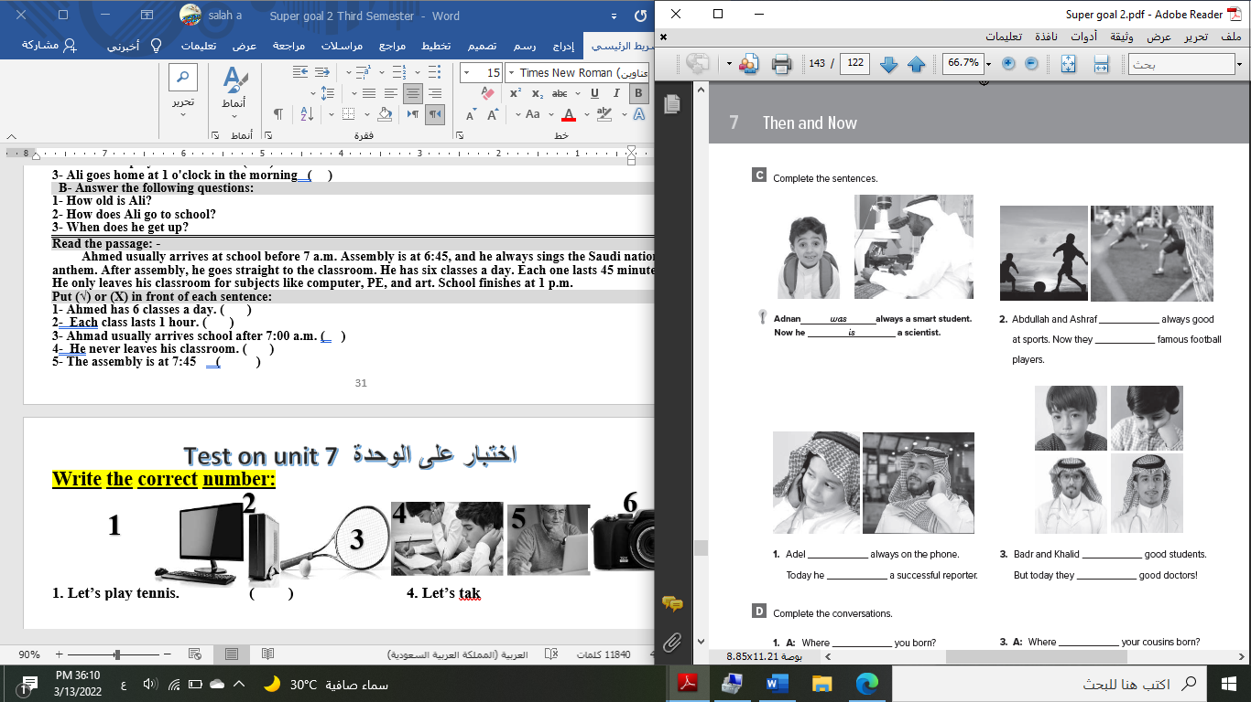**doctor - meal – shirt – bus stop – fireworks – beach**

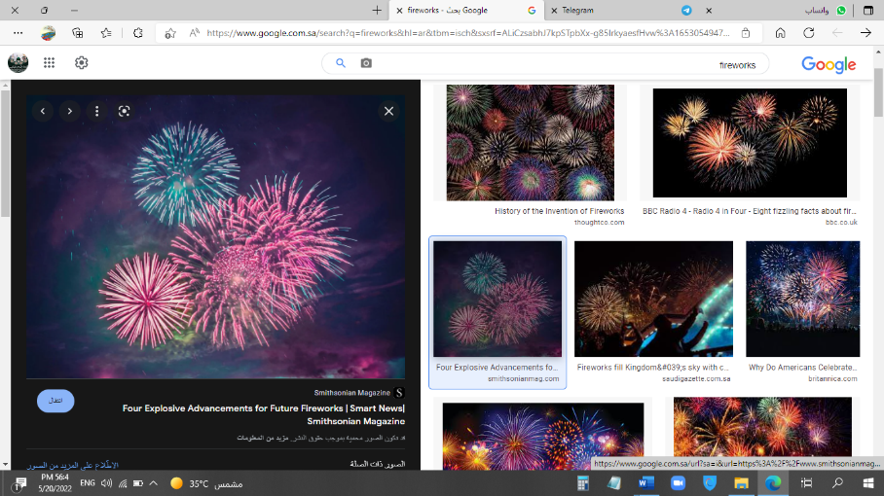

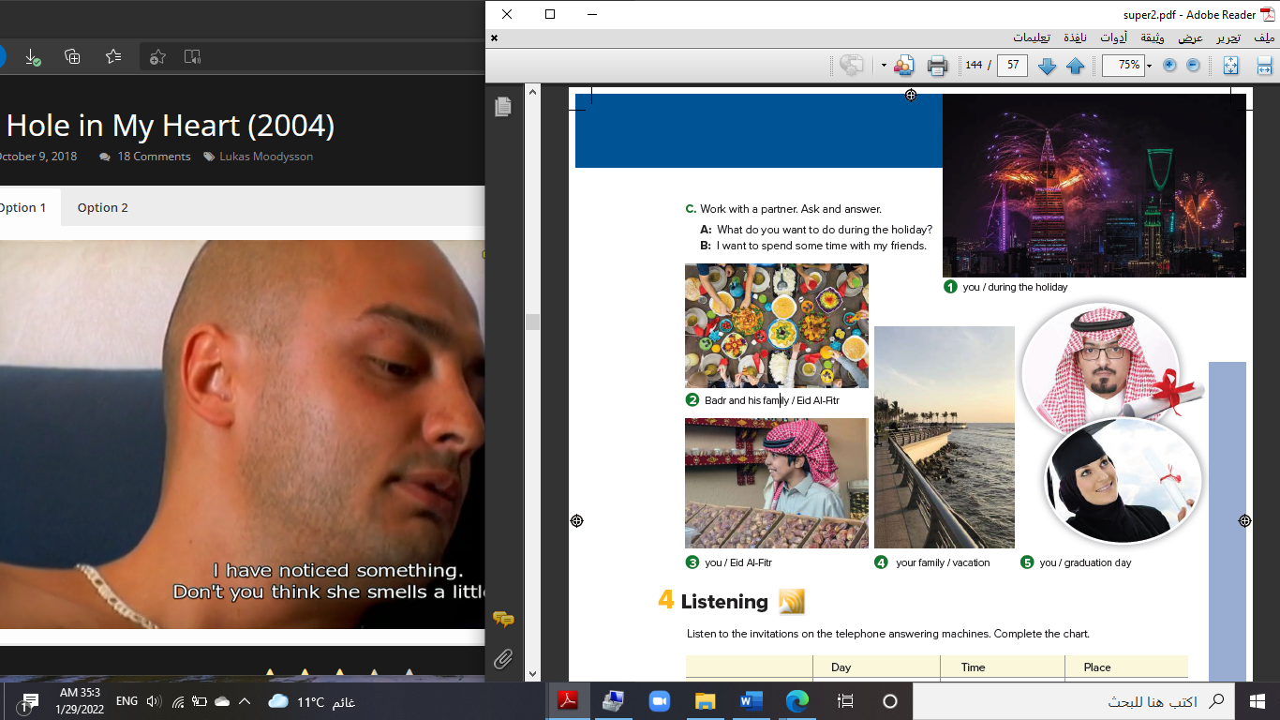****

**……………... ……………. ……..………. ……..…… ………… …………..**

**B- Match the answers:**

|  |  |
| --- | --- |
| a. green color | **1. You can open an account. ------** |
| b. Riyadh | **2. Men wear it for work. ------** |
| c. bank | **3. In Saudi Arabia, people decorate houses in ------** |
| d. thobe | **4. The King of Saudi Arabia is ------** |
| e. King Salman | **5. It was a traditional place then i**t **became the capital ------** |

**C- Circle the correct spelling:**

**1. natonial - nashional – national**

**2. house – huoes - hosue**

**3. yesteday – yesterday – yetserday**

**5) Orthography**:

**4**

**A- Fill in the missing letters:**

**1- buil__ing**

**p – u – r – o – s**

**2- cons__le**

**3- celeb__ation**

**4- air__ort**

**B- Choose the odd one out:**

**1. suit jeans tie abaya**

**2. watch school help eat**

**3. Emirates Kuwait under Oman**

**4. teacher morning afternoon evening**

**End of Questions**

**Best of Luck https://t.me/abokhaledamer**