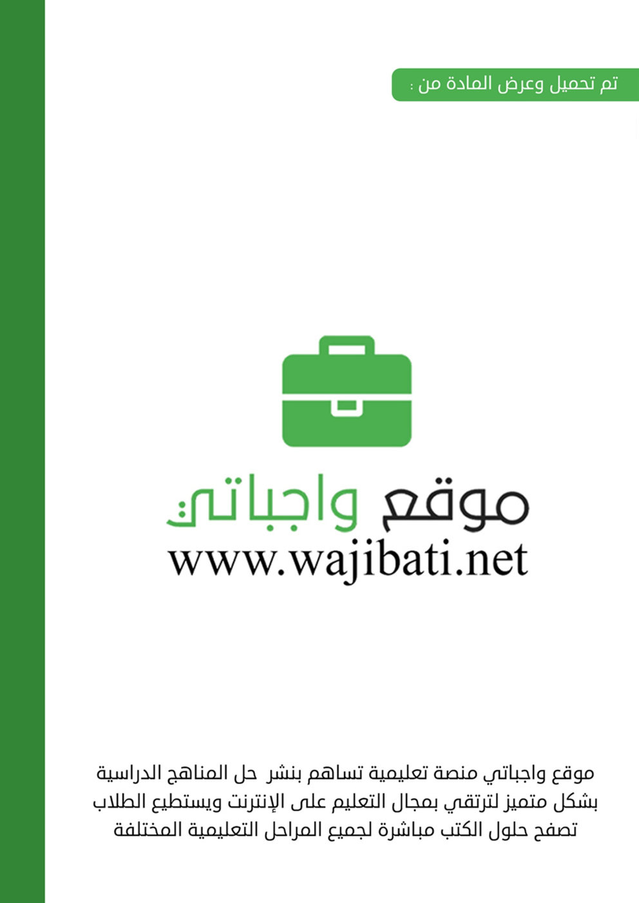
Kingdom of Saudi Arabia  Ministry of Education  …………… Intermediate  School in ……………….. | English Language  2nd Intermediate Grade  2nd Term Exam 1443 -2022  Time: 2 hours  The first session
Name/ …………………………………………………………… | Seat No./ ………………………

( اللهم لا سهل إلا ماجعلته سهلا وأنت تجعل الحزن إذا شئت سهلا )

Student’s Mark Written | Student’s Mark Number | Question |  | Number
 |  | Mark | Question
 |  | 6 | Writing | Q1
 |  | 6 | Reading Comprehension | Q2
 |  | 7 | Grammar | Q3
 |  | 7 | Vocabulary | Q4
 |  | 4 | Orthography | Q5
 |  | 30 | Total Written Tasks

عدد الصفحات : 4 صفحات

اسم المصحح وتوقيعه :
اسم المراجعوتوقيعه :
اسم المدقق وتوقيعه :

1

Q : 1 ( Writing )

6
Write a paragraph about ( your best friend) using the following words .
( name – age – math – science –green – rice )
My best friend is …………………… .She is ………… years old. She likes …………… subject, but she doesn`t like ………………… .Her favorite colour is ………….. . She likes to eat …………… . I love my friend.

6
Q : 2 ( Reading )
Read the following passage then answer the questions :
Mahais a student. She is 13 years old. She likes shopping. Her favorite mall is Al-Obaikan shopping center . It is in Taif . It is very big and there is a large parking. There are many dresses, flowers , and toy shops. Every Thursday, Maha and her family go shopping.
In the coffee shop , they drink cappuccino and have their lunch in the restaurant. She likes to eat beef burger. Shopping in Al-Obaikan mall is easy and interesting .
A - Answer:
1 – Is Maha a student ?
a – Yes, she is. b – Yes, it is. c – Yes, he is.
2 – How old is she ?
a –She is 10 years old. b – She is 13 years old. c – She is 15 years old.
B – Choose :
1 – She likes ( shopping – swimming – watching TV ).
2 – Her favorite mall is ( Al-Rashed – Riyadh – Al-Obaikan) mall .
3 – It is in ( Taif – Tabouk – Jeddah ).
4 – They drink ( coffee – cappuccino – tea ) in the coffee shop.
5 – They have their ( breakfast – lunch – dinner ) in the restaurant .
6 – She likes to eat ( chicken burger – beef burger ).
C – Put ( T ) or ( F ) :
1 – There are many dresses, flowers and toy shops. ( )
2 – Shopping in Al-Obaikan mall is not easy. ( )
2

Q : 3 ( Grammar )

7
A – Choose :
1 – The driver was sleepy, ( because – so ) he didn`t see the stop sign.
2 – You should( stay – staying ) home.
3 – They have a house. It is ( our – their ) house.
4 – Ahmad goes ( swim – swimming ) three times a week.
5 – You ( should – must ) see a doctor.
6 – Are these ( your – yours ) socks.
7 – Ali is ( tall – taller ) than Imad.
8 – I have ( so many – so much ) books on my desk.
B – Answer the questions :
1 – Whose backpack is this ?
a – It is my .b – It is mine.
2 – Which coat do you like ?
a – The green one. b – The green ones.
C – Put ( T ) or ( F ) :
1 – I have to do my homework. ( )
2 – I was scared, so he was driving too fast. ( )
Q : 4 ( vocabulary )

7
A – Put the feeling under its reaction:
( happy – sad – sleepy – angry – scared – worried )
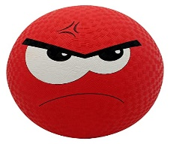
………………….. …………………… …………………… ………………….. ………………….. ……………………..
______________________________________________________________________________
3

B – Match the words with their meanings :
a – Witness. () 1 – payment for costs of an accident.
b – Insurance. () 2 – someone who saw an event.
c – Intersection. ()3 – hurt from an accident.
d – Injury. () 4 – Where two roads cross.
C – Match the illness with its symptom:
( headache – stomachache – earache – toothache )
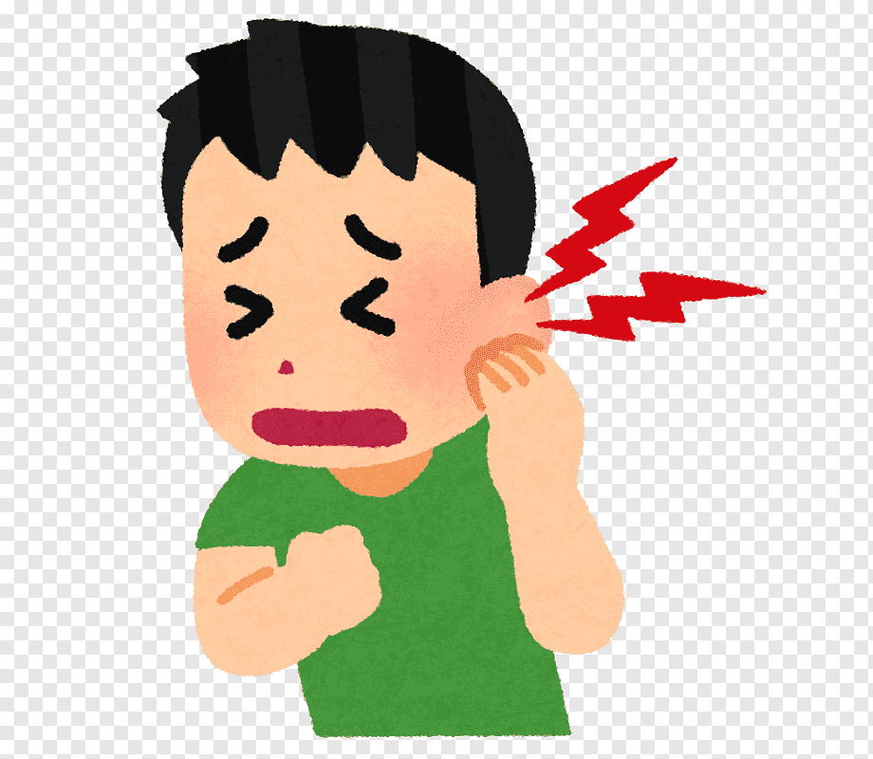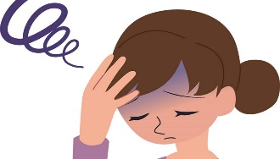
………………………………. ………………………………… …………………………….. …………………………….
-------------------------------------------------------------------------------------------------------------------------------

4
Q : 5 ( Orthography )
A : Write the missing letter :
1 - ……..ark. ( sh – ch – ph ). 2 – banan…. ( d – t – a ) .
3 - ……ale. ( n – s – q ) . 4 –bo…..ts . ( o – r – m ).
-------------------------------------------------------------------------------------------------------------------------------
B : Copy :
1 – You can break a diamond with a hammer.
……………………………………………………………………………………………………………………….
2 – The great star of Africa weighs over 540 karats.
………………………………………………………………………………………………………………………..
Good luck….
T.
(إجعل دقائق الإنتظار مليئة بالإستغفار )
4

