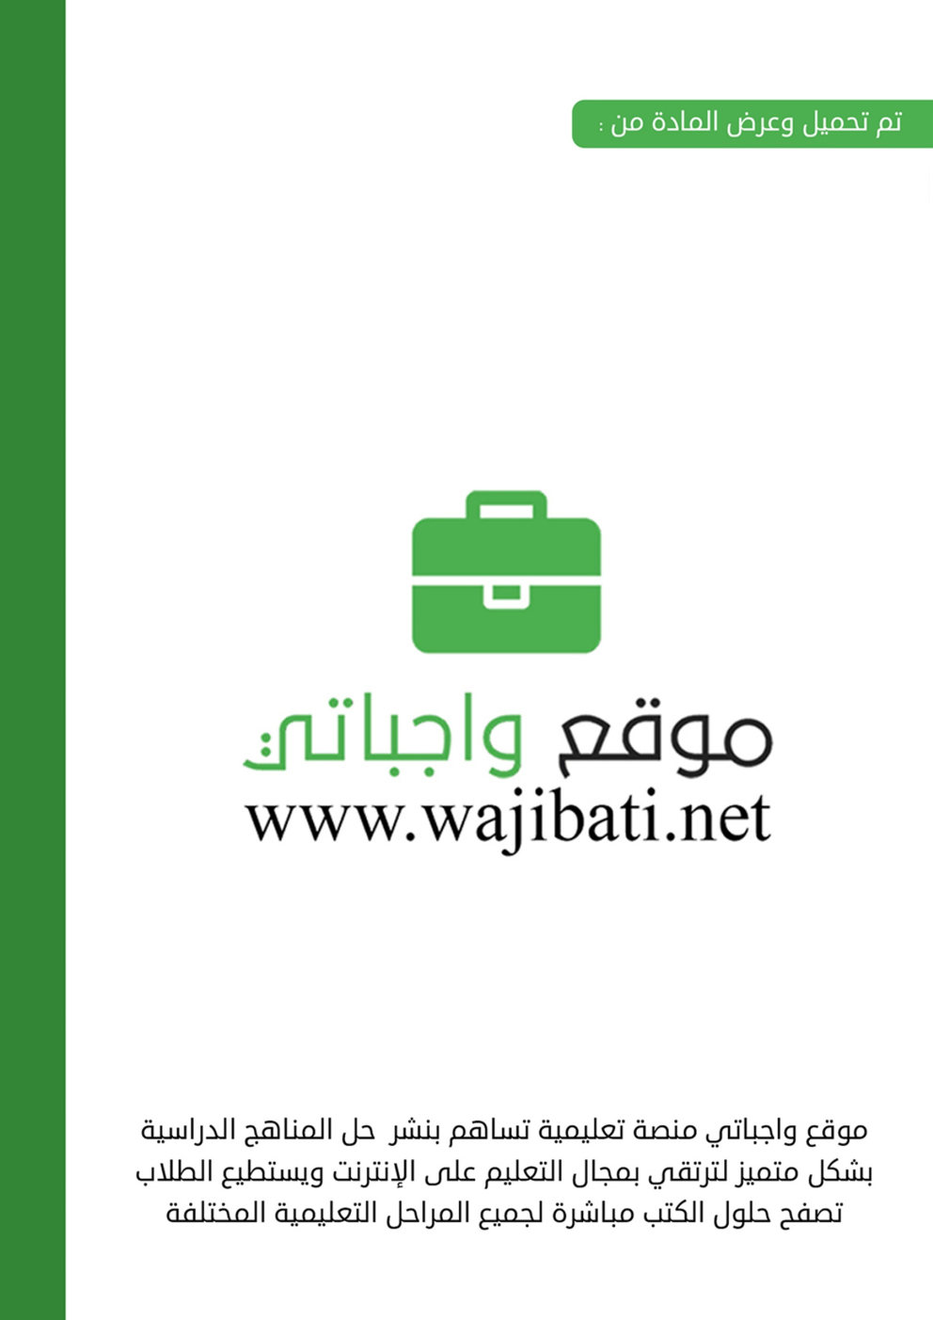
Kingdom of Saudi Arabia  Ministry of Education  …………… Intermediate  School in ……………….. | English Language  1st Intermediate Grade  2nd Term Exam 1443 -2022  Time: 2 hours  The first session
Name/ …………………………………………………………… | Seat No./ ………………………

( اللهم لا سهل إلا ماجعلته سهلا وأنت تجعل الحزن إذا شئت سهلا )

Student’s Mark Written | Student’s Mark Number | Question |  | Number
 |  | Mark | Question
 |  | 6 | Writing | Q1
 |  | 6 | Reading Comprehension | Q2
 |  | 7 | Grammar | Q3
 |  | 7 | Vocabulary | Q4
 |  | 4 | Orthography | Q5
 |  | 30 | Total Written Tasks

عدد الصفحات : 4 صفحات

اسم المصحح وتوقيعه :
اسم المراجعوتوقيعه :
اسم المدقق وتوقيعه :

1

Q : 1 ( writing )

6
Write a paragraph about ( colours ) using the following words:
( pink – red – brown – yellow – green )
I like to go to the park. It has ………….. grass. The sun is ……………… and shinny. It has a lot of
Different colours of flowers such as ……………….. and ……………. And the branches are ……………… like the chocolate.
Q : 2 ( Reading)

6
Read the following passage then answer the questions :
It is 9:30 in the morning . It is Sunday, the 11th of February. The police is looking for a missing girl. Her name is Fatimah. She is 9 years old. She weighs 35 kilos. She has brown eyes and black hair. She is wearing a red shirt and white trousers. She wears glasses.
A :Choose the correct answer :
1 – The police is looking for a missing ( boy – girl ).
2 – Her name is ( Fatimah – Mona )
3 – She is ( 7 – 9 ) years old.
4 – She weighs ( 40 – 35 ) kilos.
5 – She has ( brown – green ) eyes and ( blond – black ) hair.
B : Answer the following questions:
1 – What is she wearing ?
.........................................................................................................
2 – Does she wear glasses ?
a – Yes, she does b – Yes, it is c – Yes, they do
C : Put ( T ) or ( F ) :
1 – It is 9:30 in the afternoon. ( )
2 – It happens on Sunday , the 11th of February . ( )

7
3 : ( Grammar )
A: Choose :
1 – We`re really ( excited – exciting ) because our team is winning .
2
2 – The hotel is ( tall – taller ) than the office building.
3 – My room is the ( quiter – quitest ) room in the house.
4 – They are ( studying – study ) now.
5 – She ( would like – would like to ) a burger and fries.
6 – This is Ahmad.( He – She ) is my brother.
7 – She ( work – works ) at school.
8 – He`s tired ( so – because ) he`s taking a nap .
B : Answer :
1 – What are you doing ?
a – I do my homework. b – I am doing my homework. c – I did my homework.
2 – Do you speak English ?
a – Yes, I do .b – Yes, I am doing. c – Yes, I did.
C : put ( T ) or ( F ) :
1 – I don`t like to watch frightening films. ( )
2 – Khaled goes to school on car. ( )
4 : ( Vocabulary )

7
A : Match :
a – Active () 1 – Not boring.
b – Interesting () 2 – Athletic.
c –Smart ( ) 3 – Difficult.
d – Hard ( ) 4 – Intelligent.
B : What time is it ?( 6:45– 3:00 )
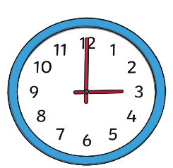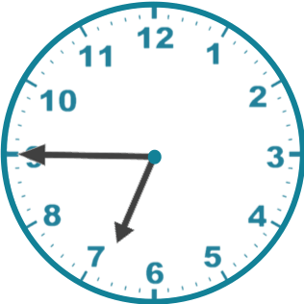
It is ……………………. It is …………………..
3

C : Put the correct word under its picture :
( bookstore – park – restaurant – subway station – supermarket – bank )
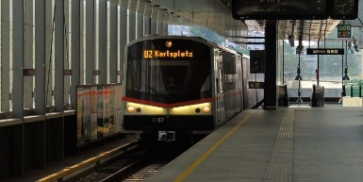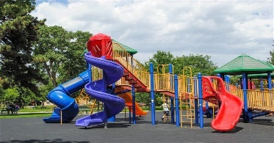
…………………………………. ………………………………… ……………………………….
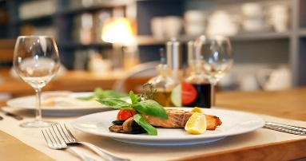
…………………………….. …………………………….. …………………………………
--------------------------------------------------------------------------------------------------------------------------------
D : Write the command under its sign :
( Go straight – Turn right )
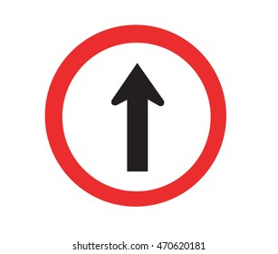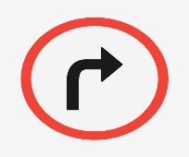
…………………………. …………………………

4
5 : ( orthography )
A : Write the missing letter :
1 – Ban…. ( o – m - k ) 2 – pharmac…...(d – y – t )
3 - …..otel. ( H – M – R ) 4 - ……olice. ( P – N – M )
B : Copy :
1 – My apartment`s on the second floor.
……………………………………………………………………………………
2 - There is a restaurant in the mall.
……………………………………………………………………………………
---------------------------------------------------------------------------------------------------------------------
Good luck….
T.
(إجعل دقائق الإنتظار مليئة بالإستغفار )
4

