Kingdom of Saudi Arabia English Language
Ministry of Education 3rd Grade Intermediate
…… Education Directorate 1st Term Exam 1439-2018
Name: …………………………………………………………………… |  |  |  |  |  |  | Seat No. ……… |  |  | Class: …… /………
Q1 | Q2 | Q3 | Q4 | Q  5 | Paper Mark | L. Q |  | Oral E. | Total |  | Written
5 | 5 | 5 | 5 | 2 | 22 | 4 |  | 4 | 30
Corrected by |  |  |  |  |  | Revised by
----- intermediate School Time: 3 hours

Q1 - Guided writing:

Write a description of a city/town you have visited for a school magazine.

• Give general information about the place (name, where it is, most interesting features).
• Write about some of the sights.
• Write what visitors can do there.
• Give your general opinion of this place.

-----------------------------------------------------------
------------------------------------------------------------------------------------------------------------------------------------------------------------------------------------------------------------------------------------------------------------------------------------------------------------------------------------------------------------------------------------------------------------------------------------------------------------------------------------------------------------------------------------------------------------------------
------------------------------------------------------------------------------------------------------------------------------------------------------------------------------------------------------------------------------------------------------------------------------------------------------------------------------------------------------------------------------------------------------------------------------------------------------------------------------------------------------------------------------------------------------------------------

Q2 - Reading Comprehension

Read the following passage and answer the questions below:

Every year in February, an important and very old Saudi celebration called Al-Janadriyah Festival takes place in Riyadh. It lasts for about two weeks and it is an excellent opportunity for people from other countries to learn about the amazing Saudi culture and tradition. During Al-Janadriyah Festival, visitors can enjoy a variety of events that have to do with art, poetry, culture, history, and many other topics. Talks, poetry readings, craft displays and many other activities are organized. Camel races are one of the most popular events of the festival and attract thousands of people. What is more, the festival is a great opportunity to taste the local food. Visitors to Saudi Arabia should definitely attend this festival, to get a taste of how culture and history are celebrated in a beautiful country. It’s for good reason that Al-Janadriyah is considered to be the Heritage and Cultural Festival of the area.

- Answer these questions:
a. Where does Al-Janadriyah take place?
………………………………………………………….…………………………………………………............
b. How long does Al-Janadriyah last for?
………………………………………………………….…………………………………………………............

- Write “T” for True or “ F” for False
1- Al-Janadriyah festival isn’t old. …………
2- It takes place every 3 years. …………
3- The festival is a great opportunity to taste the local food. ………….
4- Horse races are one of the most popular events. . …………
5- Camel races attract thousands of people …………
6- During Al-Janadriyah Festival, visitors can’t enjoy a variety of events. …………

- Choose :
- Al-Janadriyah takes part in ( January – February – March )
- The underline word “It” refers to ( Al-Janadriyah – Riyadh – Saudi )

Q3 – Grammar
A. Choose the correct answer:
1- My sister didn’t ( use – used ) to watch documentaries.
2-what is the(most – more) popular sport at your school?
3-The cook book ( which – who ) you bought is great.
4- That car has been here ( since – for ) yesterday morning. Is it yours?
5- That was a close shave, ( didn't / wasn't ) it?
6- Unless it (doesn't stop - stops - will stop ) raining soon, we will get wet walking home.
B. Rewrite the following sentence using the words given..
1- The striped shirt isn't as expensive as the spotted shirt. (than)
The spotted shirt ……………………………………………………………………………………

C. Complete with who, which, or where..

1. That's the boy ……………………cleaned my garage.
2. Here is the gallery……………………the exhibition was organized last year.

D. Complete with the present perfect simple:
1. …………………… you ……………………….. (finish ) playing that computer games?

Q4- Vocabulary

A. Write the correct word under the correct picture:
roots - leaves – thunder -- bicycle lane

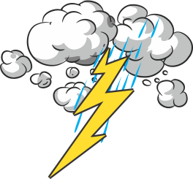 | 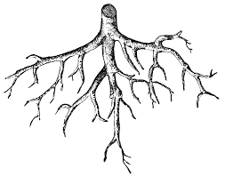 | 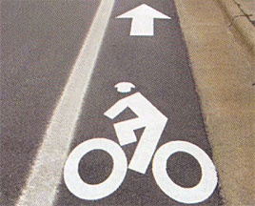

C. Complete the sentences with the words in the box.:
panic -- exhausted -- foreign -- cool

1. When I got home from my trip, I was _____________.
2. Have you ever been to a ___________ country?
3. If the food's too hot, leave it to ___________.
D. Choose the right answer

1. This shirt looks a bit( striped / baggy ). Maybe I need a smaller one.
2. Are you interested( in / with ) cooking?
3. The story was very (frightened / frightening) and my brother didn't like it.
4. Fortunately, we had ( evacuated / rescued) the building before it collapsed.

Q5- Orthography “Spelling”

- Complete the spelling of the words under the picture
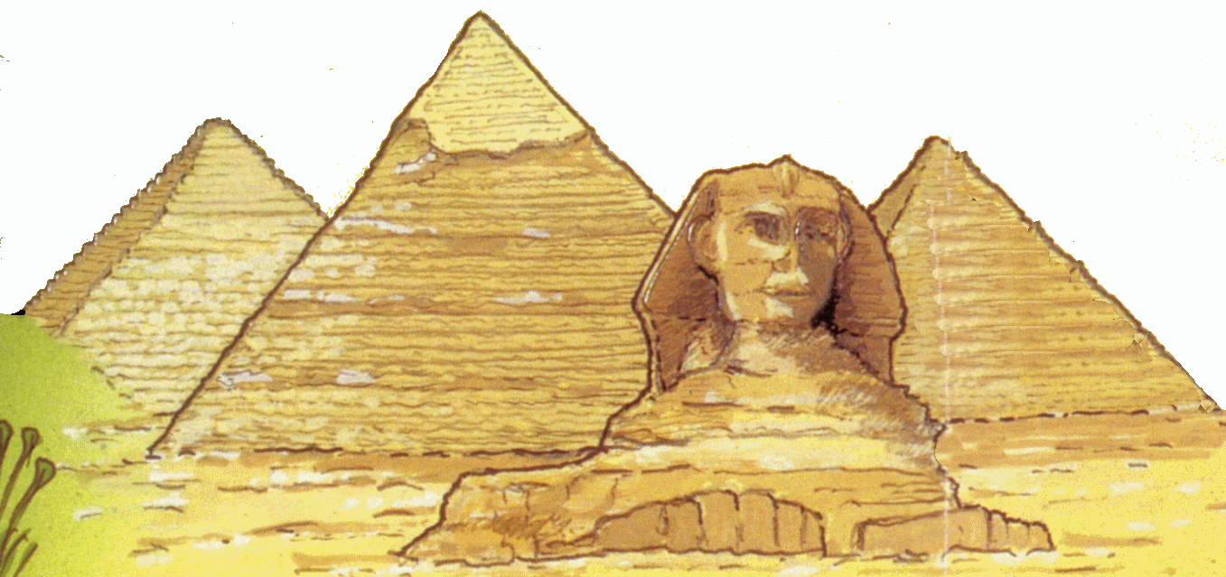

Pyra__id

p__ate

- Choose the correctly spelled word.
- ( bridge – brigde – brideg )

- Choose the correct letter:
- tab…..espoon ( q – n – l )

