|  |  |  |  |
| --- | --- | --- | --- |
| المملكة العربية السعودية  وزارة التعليم |  | ..........  20 | **اسم الطالبة : ..................................................... الصف : الخامس الابتدائي المادة : لغة إنجليزية** |

A. Match words and pictures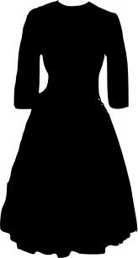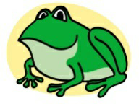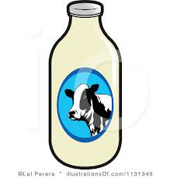

frog

milk

dress

grapes

pilot

B. Circle the odd word

meat cheese peas pen

March May Monday June

chair glasses gloves jeans

sleep swim small smile

farmer work teacher chef

C.Read and put a (√ ) or a ( × )

Children, sweets and crisps are bad for you

Eat fruit and vegetables

They are good for you

Sweets and crisps are good for you

Fruit and vegetables are good for you

D. Read the sentences, look at the pictures, and circle ( Yes ) or ( No)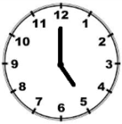

I get up at seven o'clock. Yes No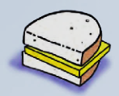

I like meat. Yes No

I work in a school. Yes No

That's a tree. Yes No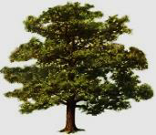

|  |
| --- |
| **اسم الطالبة : ............................................................ الصف : الخامس الابتدائي المادة : لغة إنجليزية** |

E. Match questions and answers

Do you like milk? ( ) Yes, I am

What do you have for lunch? ( ) Yes, I do

Are you wearing jeans? ( ) It's Monday

What day is it today? ( ) In a school

Where do you work? ( ) Rice and chicken

F. Write the missing letters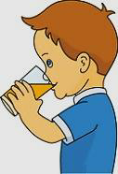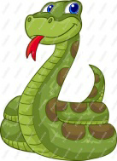

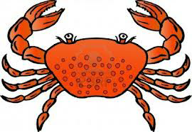

**c _ abs _ eeps _ nake _ ink**

G. Look at the pictures and write the missing words

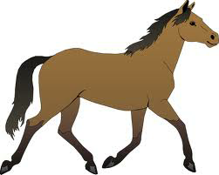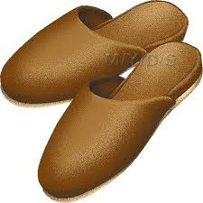

**……….... This is a ………………………… I have got**

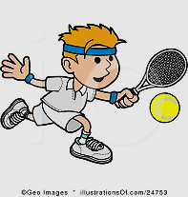

**He's playing……………………………… The ………………………… is red**



H. Copy the following letters

We play football at the park





**End of Questions**