**اسم الطالبة: ............................................................................................الصف:....................**

**المادة : اللغة الإنجليزية**

**الفترة : الثالثة**

**الصف: الخامس**

**المملكة العربية السعودية**

**وزارة التعلبيم**

|  |  |  |  |  |  |
| --- | --- | --- | --- | --- | --- |
| **رقم المهارة** | **المهارة** | **متفوق100%** | **متقدم90%-100%** | **متمكن 80%- 90%** | **غير مجتاز أقل من 80%** |
| **25** | **2- Ask about and tell the time ( o’clock only).** |  |  |  |  |

**Q 1: Draw the time:**

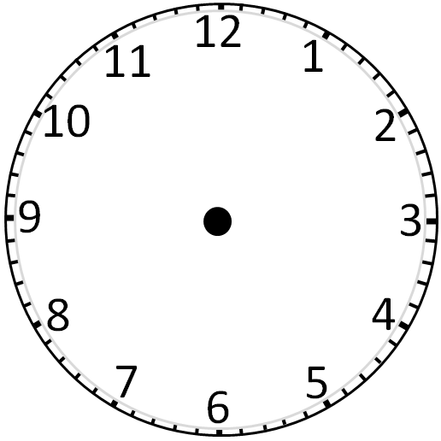

**It is 1: 30 It is 12 : 00 It is 5 :15**

|  |  |  |  |  |  |
| --- | --- | --- | --- | --- | --- |
| **رقم المهارة** | **المهارة** | **متفوق100%** | **متقدم90%-100%** | **متمكن 80%- 90%** | **غير مجتاز أقل من 80%** |
| **30** | **Identify prepositions of time (in, on, at)** |  |  |  |  |

**Q 2 : Choose:**

**1- It is 8 : 00 ( in – at ) the morning.**

**2- It is 10 : 00 ( in – at ) night .**

**3- I go to school ( in – at ) 7:00 in the morning.**

|  |  |  |  |  |  |
| --- | --- | --- | --- | --- | --- |
| **رقم المهارة** | **المهارة** | **متفوق100%** | **متقدم90%-100%** | **متمكن 80%- 90%** | **غير مجتاز أقل من 80%** |
| **9** | **Use the intensifier *very*** |  |  |  |  |
| **47** | **Link ideas with *commas* and *and*** |  |  |  |  |
| **45** | **Use the definite and indefinite article a/an, the** |  |  |  |  |

**Q 3 : choose :**

1. **Be careful it is ( very - and ) hot .**
2. **I have rice ( and - , ) salad ( and - , ) bread .**
3. **3- I have ( a – an ) egg.**

|  |  |  |  |  |  |
| --- | --- | --- | --- | --- | --- |
| **رقم المهارة** | **المهارة** | **متفوق100%** | **متقدم90%-100%** | **متمكن 80%- 90%** | **غير مجتاز أقل من 80%** |
| **23** | **Talk about food using adjectives hot/cold/….** |  |  |  |  |

**4- I have ( a - an ) banana.**

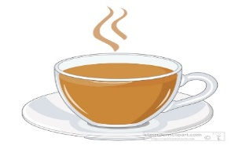**MCj04125100000[1]Q 4 : Circle the correct word :**

**hot hot salty salty**

|  |  |  |  |  |  |
| --- | --- | --- | --- | --- | --- |
| **رقم المهارة** | **المهارة** | **متفوق100%** | **متقدم90%-100%** | **متمكن 80%- 90%** | **غير مجتاز أقل من 80%** |
| **4-5-6** | **Recognize and produce some consonant blends *pl*, /gl/br/tr** |  |  |  |  |

**cold cold sweet sweet**

**Q 5 : Circle the correct sound:**

**1 - plane 2 - train 3 - glass 4 - brother**

**pl gl tr br pl gl tr br**