** وزارة التعليم الاسم /** ............................................................

**ادارة التعليم بمنطقة الجوف**

**ابتدائية**

**أسئلة الفتره الثالثة لمادة اللغة الانجليزية للصف الرابع ( )**

**اتقن لم يتقن**

1. [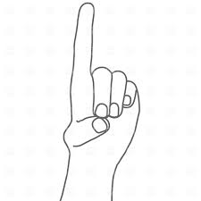](http://www.google.com.sa/imgres?safe=active&hl=ar&rls=GGLJ,GGLJ:2011-15,GGLJ:ar&tbm=isch&tbnid=S7ruCpa3z679qM:&imgrefurl=http://rfclipart.com/index-finger-sign-attention-735-vector-clipart.html&docid=_wcM7DBUrVFv7M&imgurl=http://mt-st.rfclipart.com/image/big/56-ef-32/index-finger-sign-attention-Download-Royalty-free-Vector-File-EPS-1344.jpg&w=1200&h=1200&ei=pw4eU8niGeiJywP_1YCoBA&zoom=1&ved=0CGMQhBwwBg&iact=rc&dur=649&page=1&start=0&ndsp=23)**[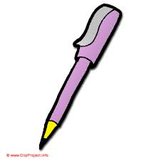](http://www.google.com.sa/imgres?safe=active&sa=X&hl=ar&rls=GGLJ,GGLJ:2011-15,GGLJ:ar&tbm=isch&tbnid=-gG-1qUjFZP1ZM:&imgrefurl=http://bestclipartblog.com/28-pen-clip-art.html&docid=nzebVoRaJXGkSM&imgurl=http://bestclipartblog.com/clipart-pics/pen-clip-art-4.gif&w=460&h=468&ei=TA4eU53aFYuBywPm1YG4DQ&zoom=1&ved=0CHUQhBwwDA&iact=rc&dur=1165&page=1&start=0&ndsp=23)Choose the correct answer** : قياس مهارة رقم ( 3 ) :

( Pen – Ben ) ( Vinger – Finger )

**اتقن لم يتقن**

[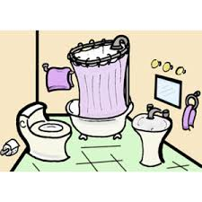](http://www.google.com.sa/imgres?safe=active&hl=ar&rls=GGLJ,GGLJ:2011-15,GGLJ:ar&tbm=isch&tbnid=SFMLgv2__8pApM:&imgrefurl=http://www.polyvore.com/full_version_bathroom_clipart/thing?id=57848694&docid=b1GZ34xgPvRFGM&imgurl=http://www.polyvore.com/cgi/img-thing?.out=jpg&size=l&tid=57848694&w=300&h=300&ei=rg8eU97LCcXOygOWqYKYBg&zoom=1&ved=0CIEBEIQcMBA&iact=rc&dur=761&page=1&start=0&ndsp=21)[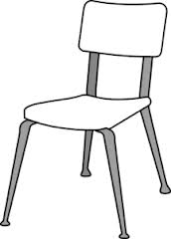](http://www.google.com.sa/imgres?safe=active&hl=ar&rls=GGLJ,GGLJ:2011-15,GGLJ:ar&tbm=isch&tbnid=7iO9QpukuPpxPM:&imgrefurl=http://www.clker.com/clipart-white-classroom-chair.html&docid=tMNym9XxizWZnM&imgurl=http://www.clker.com/cliparts/C/i/T/l/R/B/white-classroom-chair-md.png&w=216&h=300&ei=Gg8eU5vZCeTnygOz0ICACw&zoom=1&ved=0CHEQhBwwCg&iact=rc&dur=1274&page=1&start=0&ndsp=18)قياس مهارة رقم ( 4 ) :

[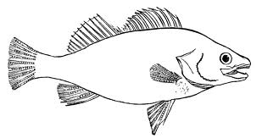](http://www.google.com.sa/imgres?safe=active&hl=ar&rls=GGLJ,GGLJ:2011-15,GGLJ:ar&tbm=isch&tbnid=xJRGysd_yNSM9M:&imgrefurl=http://bestclipartblog.com/21-fish-clip-art.html/fish-clip-art-1&docid=XP5y7TUIgFCaSM&imgurl=http://bestclipartblog.com/clipart-pics/fish-clip-art-1.gif&w=700&h=371&ei=hA8eU6qfO4XnywOqjYKoBw&zoom=1&ved=0CIQBEIQcMBE&iact=rc&dur=903&page=2&start=15&ndsp=17)

…….. air Fi……….. Ba…….room ( Ch - Sh ) ( sh - ch ) ( ch - th )

**اتقن لم يتقن**

[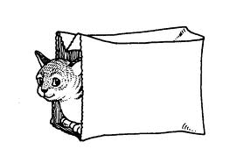](http://www.google.com.sa/imgres?safe=active&hl=ar&rls=GGLJ,GGLJ:2011-15,GGLJ:ar&tbm=isch&tbnid=BvdaOMR-U9fKZM:&imgrefurl=http://www.speakfrench.321doit.com/html/let_the_cat_out_of_the_bag.html&docid=W7GJKAbtFlnDLM&imgurl=http://www.speakfrench.321doit.com/assets/images/bag-cat.gif&w=896&h=616&ei=kxAeU7exGNGA7QbOsYDIAg&zoom=1&ved=0CFQQhBwwAA&iact=rc&dur=936&page=1&start=0&ndsp=14)قياس مهارة رقم ( 13 ) :

[](http://www.google.com.sa/imgres?safe=active&hl=ar&rls=GGLJ,GGLJ:2011-15,GGLJ:ar&tbm=isch&tbnid=jOpUpqqfY9IQAM:&imgrefurl=http://www.picturesof.net/pages/090105-180797-115048.html&docid=CjkKdBan1MbDLM&imgurl=http://www.picturesof.net/_images_300/Apple_On_A_Desk_Royalty_Free_Clipart_Picture_090105-180797-115048.jpg&w=300&h=286&ei=WRAeU5iwDvPA7AaF1IGIBw&zoom=1&ved=0CGwQhBwwCA&iact=rc&dur=2146&page=1&start=0&ndsp=12)

- The cat is ( in - on ) the bag . – The apple is ( in - on ) the desk .

**اتقن لم يتقن**

قياس مهارة رقم ( 18 ) :

[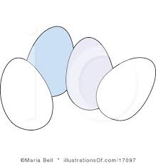](http://www.google.com.sa/imgres?safe=active&hl=ar&rls=GGLJ,GGLJ:2011-15,GGLJ:ar&tbm=isch&tbnid=cmTbJf38TC8ZkM:&imgrefurl=http://www.illustrationsof.com/17097-royalty-free-eggs-clipart-illustration&docid=5Ojaxt-Fm1179M&imgurl=http://www.illustrationsof.com/royalty-free-eggs-clipart-illustration-17097.jpg&w=400&h=420&ei=pBEeU-ixBqf17Abf1oDIBA&zoom=1&ved=0CLEBEIQcMB0&iact=rc&dur=907&page=2&start=20&ndsp=21)[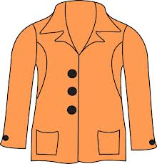](http://www.google.com.sa/imgres?safe=active&hl=ar&rls=GGLJ,GGLJ:2011-15,GGLJ:ar&tbm=isch&tbnid=H3k3jbMQGO6CCM:&imgrefurl=http://www.mycutegraphics.com/graphics/letter/jacket.html&docid=U_dzd30tVYIJLM&imgurl=http://content.mycutegraphics.com/graphics/letter/jacket.png&w=480&h=500&ei=QxEeU52NA-WQ7AbW2YEY&zoom=1&ved=0CFYQhBwwAQ&iact=rc&dur=1579&page=1&start=0&ndsp=14)[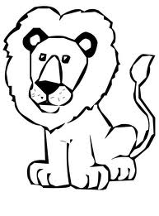](http://www.google.com.sa/imgres?safe=active&hl=ar&rls=GGLJ,GGLJ:2011-15,GGLJ:ar&tbm=isch&tbnid=LPfglTqPdVWCuM:&imgrefurl=http://animatedcliparts.net/lion-clip-art/&docid=hf_ViCHpSdI5TM&imgurl=http://animatedcliparts.net/wp-content/uploads/2013/02/lion-clip-art-AT-2.jpg&w=604&h=817&ei=exEeU9u7LYOv7AaJ1YDgBA&zoom=1&ved=0CFYQhBwwAQ&iact=rc&dur=757&page=1&start=0&ndsp=14)

( Jacket - Cat ) ( Apple - Lion ) ( Eggs - Shirt )

**اتقن لم يتقن**

[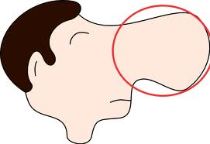](http://www.google.com.sa/imgres?safe=active&hl=ar&rls=GGLJ,GGLJ:2011-15,GGLJ:ar&tbm=isch&tbnid=x6uHxoGeXZWdZM:&imgrefurl=http://www.clker.com/clipart-nose.html&docid=vHP1myJqYm4I7M&imgurl=http://www.clker.com/cliparts/1/9/D/e/7/S/nose.svg&w=560&h=384&ei=CxUeU4igGuL8ygOt6YGgDg&zoom=1&ved=0CGAQhBwwBQ&iact=rc&dur=1663&page=1&start=0&ndsp=22)[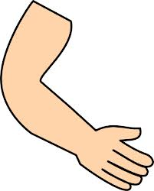](http://www.google.com.sa/imgres?safe=active&hl=ar&rls=GGLJ,GGLJ:2011-15,GGLJ:ar&tbm=isch&tbnid=FVky8KdX-FJ5rM:&imgrefurl=http://www.clker.com/clipart-arm-hand.html&docid=jkIsG3jlpVx-4M&imgurl=http://www.clker.com/cliparts/t/T/t/C/e/v/arm-hand-hi.png&w=480&h=596&ei=vhQeU8i-O-X8ygPvkoH4DA&zoom=1&ved=0CFEQhBwwAA&iact=rc&dur=894&page=1&start=0&ndsp=23)قياس مهارة رقم ( 26 ) :

( Arm - Erm ) ( Noose - Nose )

[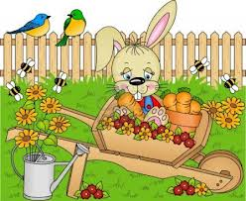](http://www.google.com.sa/imgres?safe=active&hl=ar&rls=GGLJ,GGLJ:2011-15,GGLJ:ar&tbm=isch&tbnid=gm0g_4_Rm6G34M:&imgrefurl=http://www.123rf.com/photo_12800189_carrots-in-clay-vase-garden.html&docid=yL_IdZbDYjL1OM&imgurl=http://us.123rf.com/400wm/400/400/socris79/socris791203/socris79120300003/12493781-rabbit-harvest-carrots-in-the-garden.jpg&w=1200&h=984&ei=nBYeU-FPgZrjBJyegIgE&zoom=1&ved=0COwBEIQcMDA&iact=rc&dur=966&page=3&start=33&ndsp=20)[](http://www.google.com.sa/imgres?safe=active&hl=ar&rls=GGLJ,GGLJ:2011-15,GGLJ:ar&tbm=isch&tbnid=_nZbZ1rpK2jVkM:&imgrefurl=http://openclipart.org/detail/64/rejons-head-by-rejon&docid=X7YsAaCfrup8wM&imgurl=http://openclipart.org/image/800px/svg_to_png/64/rejon_Rejon_s_Head.png&w=800&h=800&ei=4BYeU_uPE8aC4gSA1IGwBw&zoom=1&ved=0CLQBEIQcMB4&iact=rc&dur=1580&page=2&start=23&ndsp=24)[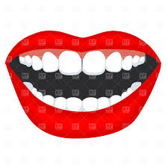](http://www.google.com.sa/imgres?safe=active&hl=ar&rls=GGLJ,GGLJ:2011-15,GGLJ:ar&tbm=isch&tbnid=u9rzd-QhLZmAFM:&imgrefurl=http://rfclipart.com/opened-mouth-with-teeth-765-vector-clipart.html&docid=jQXtjoIIjjVttM&imgurl=http://mt-st.rfclipart.com/image/big/5e-26-ab/opened-mouth-with-teeth-Download-Royalty-free-Vector-File-EPS-1403.jpg&w=1200&h=1200&ei=FhYeU6j9GIni4QSZmYC4Bw&zoom=1&ved=0CF0QhBwwBA&iact=rc&dur=684&page=1&start=0&ndsp=19)قياس مهارة رقم ( 34 ) :

**اتقن لم يتقن**

…….. outh Garde……… Hea………

( N - M - B ) ( r - n - o ) ( g - y - d )

**اتقن لم يتقن**

قياس مهارة ( 22 ) : 2- Complete :

10 - ………. - ……….. - 40 - 50 - ………. - 70 - ……….. - 90 - 100

قياس مهارة رقم ( 28 – 30 – 32 ) : 3- Copy the following sentence and numbers :

**اتقن لم يتقن**

Huda likes apples and oranges .

**42 35 10**

قياس مهارة رقم ( 33 ) : 4- Answer :

**اتقن لم يتقن**

How old are you ?

………………………………………………………………………..

قياس مهارة رقم ( 35 ) : 5- Correct the mistakes in the sentence :

**اتقن لم يتقن**

amal likes school

Fahd Alruwaili